Research Article

Variability in Attendance for Patients with Anxiety or Depression during SARS-CoV-2 at One Outpatient Clinic

Matthew E. Hauenstein DNP, PMHNP, RN¹, Theresa Galakatos PhD, DNP, MSW, MSN, RN^{2#}

¹Milford Center, Ohio USA
^{2#}Catherine McAuley School of Nursing, The Myrtle E. and Earl E. Walker College of Health Professions, Maryville University, Missouri, USA

#Corresponding author: Theresa Galakatos PhD, DNP, MSW, MSN, RN, Associate Professor, Online Lead for Advanced Health Policy, Catherine McAuley School of Nursing, The Myrtle E. and Earl E. Walker College of Health Professions, Maryville University, 650 Maryville University Dr, St. Louis, Missouri 63141, USA

How to cite this article: Hauenstein ME and Galakatos T (2021) Variability in Attendance for Patients with Anxiety or Depression during SARS-CoV-2 at One Outpatient Clinic. Int J Nurs & Healt Car Scie 01(07): 2021-40.

Submission Date: 08 June, 2021; Accepted Date: 16 June, 2021; Published Online: 23 June, 2021

Abstract

Purpose: Missed appointments due to time constraints, transportation problems, and cost concerns are a chronic problem that negatively impact the continuity of quality patient care, patient outcomes, and financial well being of clinics. The recent rapid transition from office visits to telehealth during the severe acute respiratory syndrome coronavirus 2 [SARS-CoV-2] pandemic highlighted the value-added benefits of telehealth yet exposed provider and patient limitations when using this virtual platform. The purpose of this study was to analyze the prevalence of missed appointments, telehealth, and office visits of patients diagnosed with anxiety or depression at one Midwest outpatient clinic to serve as a means for implementing sustainable solutions that best serve the community.
Background: Missed appointments are common due to frustrations with length of appointment, time of appointment, interference with work schedule, transportation issues, and financial costs. Telehealth provided an alternative to face-to-face appointments and offered effective, timely, and supportive care during the SARS-CoV-2 pandemic. Yet telehealth users reported lack of connectivity, freezing screens, and use of unsecure and overloaded platforms. Missed appointments cause disruptions to continuity of care and treatment that place patients with mental health disorders at greater risk for poor health outcomes. Proactive solutions to missed appointments can predict risk for non-attendance and strategies implemented can expedite care and treatment during a public health crisis.
Methods: A retrospective chart review was performed on 60 charts per month from March 1, 2020 through November 30, 2020 on patients diagnosed with anxiety or depression in one outpatient psychiatric clinic. Patients were categorized into groups: missed appointments, telehealth, or office visits.
Results: In April and May 2020, telehealth appointments peaked at 75% and 70%, office visits were at 0%, and missed appointments appeared at the lowest, 25% and 30%. When government restrictions relaxed in June 2020, telehealth appointments decreased, office visits increased, and missed appointments increased. Missed appointments during SARS-CoV-2 were comprised of telehealth and office visits; pre-SARS-CoV-2 pandemic, only office visits were counted.
Conclusions: In patients diagnosed with anxiety or depression, telehealth reduced missed appointments during the SARS-CoV-2 pandemic at one outpatient psychiatric clinic. Further research is needed to explore solutions to reason for missed appointments and develop predictive models to improve attendance and maintain a financially viable practice. For example, mobile telephone reminders can be used for patients who forget appointments; transportation services can be set up through insurance plans or vouchers when patients do not have transportation to their appointments; telehealth can be offered for patients at work to reduce absenteeism and expedite care; and financial stressors can be reduced by presenting cost effective medicines and payment plans for mental health visits.

Keywords: Anxiety; COVID-19; Depression; Missed appointments; SARS-CoV-2; Telepsychiatry

Introduction

During worldwide shutdown due to the severe acute respiratory syndrome coronavirus 2 [SARS-CoV-2], mitigation strategies included the mandatory use of personal protective equipment (PPE), social distancing, and quarantines to reduce the spread of the virus [1]. Further, the rapid transition to telehealth allowed providers to remotely manage and treat non-urgent patients, achieve patient outcomes similar to an office visit, and remain financially viable [1-7]. Initially, patients with anxiety or depression received limited access to mental health services then disruptions to care decreased with telehealth and outcomes improved, yet missed appointments continued to be a challenge [8-10].

One in five adults experience a mental illness in any given year and during the SARS-CoV-2 pandemic, some experienced new episodes of psychotic events, behavioral and mood alterations, emotional disturbances, suicide attempts, and domestic violence due to loss of autonomy, confinement, unemployment, and fear of viral contamination and potential death [4,8-12]. Challenges related to telehealth added to the growing list of barriers to care including connectivity issues and users unfamiliar with applications, and barriers to care pre-SARS-CoV-2 included forgetfulness, work commitments, longer appointment duration, timing of appointment (morning versus afternoon), transportation or distance issues, illness severity, therapist, and financial constraints [13-16]. Telehealth users are satisfied with the ability to interact therapeutically and meet treatment goals and outcomes from rural areas [1-3,9,17-20]. Further, scheduled appointments are successful when the patient shows willingness to attend initial visit, visits are kept short, and family members are informed of a good prognosis [15]. However, a strained healthcare system during the SARS-CoV-2 pandemic exposed the need for ongoing quality improvement processes to assess, implement, and evaluate strategies that reduce barriers to care and the associated health disparities.

The purpose of this study was to report on the prevalence of missed appointments, telehealth, and, office visits during the COVID-19 pandemic. Data trends identified can be used for healthcare leaders to further design and implement decision models and predict and reduce variability. A discussion of the findings can be used to initiate proactive solutions to barriers to care and cultivate a care delivery process that helps patients meet their healthcare goals.

Methodology

A retrospective chart review was used to identify the prevalence of missed appointments, telehealth, and office visits of patients with anxiety or depression at one outpatient psychiatric clinic during the SARS-CoV-2 pandemic. A total of 540 charts or 60 charts per month were evaluated from March 1, 2020 through November 30, 2020. The outpatient clinic’s psychiatrist and the Maryville University IRB committee granted approvals to complete this study.

Scheduled monthly appointments were reviewed for charts that met inclusion criteria. Inclusion criteria were comprised of patients older than 18 years of age and diagnosed with anxiety or depression. Data collection included whether the patient missed the scheduled appointment, used telehealth or an office visit, and whether additional anxiety or depression was noted from using telehealth. A numeric code was assigned to each chart. Individual descriptors on gender, age, race, and other institutional characteristics were not collected in order to avoid overgeneralizations and violating confidentiality of this dataset even if names are not attached to the results [21].

The total number of missed appointments, telehealth, and office visits were collected, entered into an Excel spreadsheet, and imported into the Statistical Package for the Social Sciences (SPSS) for analysis.

Discussion

Non-attendance was problematic before the SARS-CoV-2 pandemic, yet reached epic levels due to the mandatory government restrictions and lockdowns. Proactive, sustainable solutions can expedite continuity of care around pandemics or natural disasters and starts with accurate data. In this study, the prevalence of missed appointments, telehealth, and office visits were analyzed to illustrate patterns and trends (Figure 1). Further, percentages of missed appointments, telehealth, and office visits were used to illustrate the distribution of data and highlight variability (Figure 2). Additional findings are reported on the anxiety experienced by patients due to the use of telehealth.

In March 2020, there were 24 missed appointments, one telehealth visit, and 35 office visits (Figure 1). This clinic utilized one telehealth platform yet rapidly moved onto a second telehealth platform for better connectivity. In April and May 2020, government restrictions required the clinic to close and no office visits were permitted, telehealth visits increased to 45 and 42, and missed appointments decreased to 15 and 18 respectively. In June 2020, government restrictions relaxed, the clinic reopened, and there were 24 office visits, 20 telehealth visits, and 16 missed appointments. In July 2020, there were 18 office visits, 20 telehealth visits, and 22 missed appointments. In August 2020, there were 21 office visits, 16 telehealth visits, and 23 missed appointments. In September 2020, there were 28 office visits, 10 telehealth visits, and 22 missed appointments. In October 2020, there were 29 office visits, 7 telehealth visits, and 24 missed appointments. In November 2020, there were 25 office visits, 11 telehealth visits, and 24 missed appointments. The average for missed appointments was 20.89(3.59), ranging from 15 to 24, the average for telehealth visits was 9.44(15.12), ranging from 1-45, and the average for office visits was 16.89(12.33), ranging from 0 to 35. The use of telehealth as a new mode of patient management and treatment in this clinic reduced missed appointments in April and May 2020. Nonetheless, office visits and telehealth visits can support continuity of care where providers evaluate patients for their emotional well being (ability to socialize) and provide treatment for negative psychological well-being (disengaged or isolated).

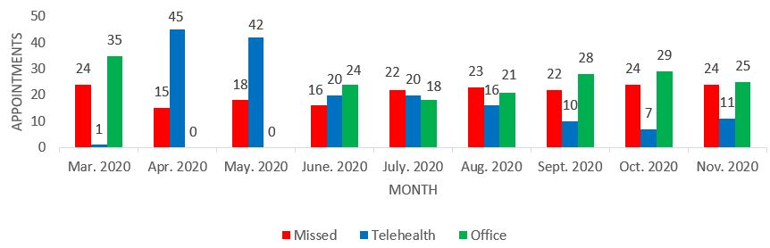

Figure 1: Prevalence of Missed Appointments, Telehealth, and Office Visit per Month (N=540).

In March, October, and November 2020, the percentage of missed appointments reached 40% (Figure 2). In April, May, and June 2020, the percentage of missed appointments decreased to 25%, 30%, and 26.7%, respectively. Nonetheless, in July, August, and September 2020, missed appointments increased to 36.7%, 38.3%, and 36.7%, respectively. The percentage of missed appointments appeared at the lowest levels during April, May, and June 2020. In June 2020, office visits resumed and telehealth visits continued yet the percentage of missed appointments increased. The percentage of missed appointments for office visits was 19% before SARS-CoV-2, telehealth was initiated in response to SARS-CoV-2 at this clinic.

The percentage of telehealth visits in March 2020 was 1.7%. In April and May of 2020, the percentage of telehealth visits increased to 75% and 70%, respectively. When government restrictions relaxed, in June and July 2020, the percentage of telehealth visits decreased to 33.3%. In August, September, and October 2020, the percentage of telehealth visits decreased to 26.7%, 16.7%, and 11.7%, respectively. In November, telehealth visits increased to 18.3%. The percentage of telehealth visits appeared at the highest levels during April and May 2020 while the percentage of missed appointments reached the lowest levels. On 2% of telehealth visits (four charts), providers noted the patients’ increased anxiety due to use of telehealth.

In March 2020, the percentage of office visits was 58.3%. In April and May 2020, during the government lockdown, the percentage of office visits was 0%. When government restrictions relaxed in June 2020, the percentage of office visits increased to 40%. In July, August, September, and October 2020, the percentage of office visits increased to 30%, 35%, 46.6%, and 48.3% respectively. In November 2020, the percentage of office visits decreased slightly to 41.7%. The percentage of telehealth visits decreased from June to October 2020 while the percentage of missed appointments increased.

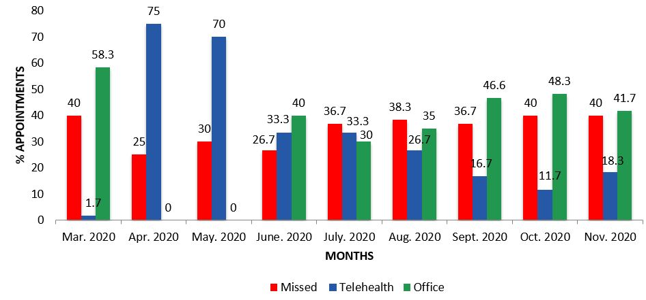

Figure 2: Percentage of Missed Appointments, Telehealth, and Office Visit per Month (N=540)

Social isolation and social distancing from friends and family changed routines and habits making patients more vulnerable or less tolerant to stress and change [8,10,22]. Further, the imposed lockdowns disrupted access to mental health services and continuity of care [1,10]. Providers at this outpatient psychiatric clinic introduced patients to telehealth with an impressive response at 70-75% while experiencing a missed appointment rate that fluctuated between 25-40%. The clinics average missed appointment rate was 19% pre-SARS-CoV-2. The new telehealth platforms posed a problem for providers and patients bringing connectivity problems, freezing screens, and system malfunctions that upended conversations, and delayed responses. The SARS-CoV-2 pandemic highlighted the need for an ongoing quality improvement processes to assess, implement, and evaluate solutions to barriers to care.

Conclusion

Missed appointments present a complex problem influenced by many factors yet solutions for each identified risk can impact attendance. For example, mobile telephone reminders can be used for patients who forget appointments; transportation services can be set up through insurance plans or vouchers when patients do not have transportation to their appointments; telehealth can be offered for patients at work to reduce absenteeism and expedite care; and financial stressors can be reduced by presenting cost effective treatment and payment plans for mental health visits. Studies show that providing solutions for time constraints, transportation problems, potential costs of care, and addressing connectivity issues, bandwidth deficiencies, and provider, staff, and patient training on the use of telehealth applications impact patient outcomes, continuity of care, and revenue. In April and May 2020, the rapid transition from office visits to telehealth positively impacted attendance of patients with anxiety or depression when telehealth was the only option yet once office visits resumed, non-attendance increased. Reasons for missed appointments were not recorded for office or telehealth visits at this outpatient psychiatric clinic.

Missed appointments disrupt continuity of care, worsen patient outcomes, increase risk for hospital admission, and loss in revenue. Before the SARS-CoV-2 pandemic, an unwillingness to adopt telehealth existed due to low reimbursement rates, regulatory concerns, electronic security, and confidentiality, dislike of the telehealth medium, aversion to viewing oneself online, and difficulties with patient engagement [1,5,22,23]. Nonetheless, providers who were staunchly opposed embraced telehealth under pressure to generate greater interconnectivity ecosystems that increased availability of evaluation and treatment to their patients [1,2,5,9]. In this study, missed appointments reached 40% during March, October, and November 2020 and averaged at 19% pre-SARS-CoV-2. Policy and practice changes intuitively planned can set the course for proactive use of reasons for missed appointments to predict risk, impact effective, efficient continuity of care, and head for a financial recovery [1,9,18-20,22-25].

One outpatient psychiatric clinic was used in this study limiting generalizability to other communities where resources may be more or less constrained. Demographic data was not collected in this study in order to avoid overgeneralizations and violating confidentiality of this dataset. A more in-depth study should examine the reasons for missed appointments as predictors of risk for non-attendance. Variability of attendance between mental health providers can be a predictor of nonattendance therefore should be considered when implementing solutions for missed appointments [13]. Finally, systemic health and social inequities should be examined to address the disproportionate disruptions in continuity of care placed on ethnic, minority, and disabled groups [1,5]. The momentum for innovation should be maximized in this clinic post-SARS-CoV-2 to develop an ongoing process of assessment, implementation, and evaluation to deliver policy and practice changes that connect patients to mental health services.

References

- Chen JA, Chung WJ, Young SK, Tuttle, et al. (2020) COVID-19 and telepsychiatry: Early outpatient experiences and implications for the future. General Hospital Psychiatry 66: 89-95.
- Cowan A, Johnson R, Close H (2020) Telepsychiatry in psychotherapy practice. Innovations in Clinical Neuroscience 17: 4-6.
- Goetter EM, Blackburn AM, Bui E, et al. (2019) Veterans' prospective attitudes about mental health treatment using telehealth. Journal of Psychosocial Nursing and Mental Health Services 57: 38-43.
- O’Brien M, McNicholas F (2020) The use of telepsychiatry during COVID-19 and beyond. Irish Journal of Psychological Medicine 37: 250-255.
- Talley RM, Brunette MF, Adler DA, et al. (2020) Telehealth and the community SMI population. Journal of Nervous & Mental Disease 209: 49-53.
- Tuerk PW, Keller SM, Acierno R (2018) Treatment for anxiety and depression via clinical videoconferencing: Evidence base and barriers to expanded access in practice. FOCUS 16: 363-369.
- Yellowlees P, Nakagawa K, Pakyurek M, et al. (2020) Rapid conversion of an outpatient psychiatric clinic to a 100% virtual telepsychiatry clinic in response to COVID-19. Psychiatric Services 71: 749-752.
- Alonzi S, La Torre A, Silverstein MW (2020) The psychological impact of preexisting mental and physical health conditions during the COVID-19 pandemic. Psychological Trauma: Theory, Research, Practice, and Policy 12(S1).
- Di Carlo F, Sociali A, Picutti E, et al. (2020) Telepsychiatry and other cutting edge technologies in COVID-19 pandemic: Bridging the distance in mental health assistance. International Journal of Clinical Practice 75.
- Moreno C, Wykes T, Galderisi S, et al. (2020) How mental health care should change as a consequence of the COVID-19 pandemic. The Lancet Psychiatry 7: 813-824.
- National Alliance on Mental Illness (NAMI) (2020) Mental health by the numbers. NAMI.
- National Institute of Mental Health (NIMH) (2020) Opportunities and challenges of developing information technologies on behavioral and social science clinical research.
- Firth N, Bone C, Holt R (2020) Health psychology attendance: A multilevel analysis of patient level predictors and therapist effects. Health Psychology 39: 945-955.
- Miller MJ, Ambrose DM (2019) The problem of missed mental healthcare appointments. Clinical Schizophrenia & Related Psychoses 177-184.
- Newfoh E, Aguocha CM, Achor J, et al. (2018) Missed post-hospitalisation clinic appointment in a psychiatric hospital in Southeast Nigeria. Mental Health, Religion, & Culture 21: 564-577.
- Ramlucken L, Sibiya MN (2018) Frequency and reasons for missed appointments of outpatient mental health care users in the uMgungundlovu District. Journal of Psychiatric Research 136: 1-4.
- Ben-Zeev D, Buck B, Hallgren K, et al. (2019) Effect of mobile health on in-person service use among people with serious mental illness. Psychiatric Services 70: 507-510.
- Bunnell BE, Barrera JF, Paige SR, et al. (2020) Acceptability of telemedicine features to promote its uptake in practice: A survey of community telemental health providers. International Journal of Environmental Research and Public Health 17: 8525.
- Gardner JS, Plaven BE, Yellowlees P, et al. (2020) Remote telepsychiatry workforce: A solution to psychiatry’s workforce issues. Current Psychiatry Reports 22.
- Lauckner C, Whitten P (2015) The state and sustainability of telepsychiatry programs. The Journal of Behavioral Health Services & Research 43: 305-318.
- Hughes JL, Camden AA, Yangchen T (2016) Rethinking and updating demographic questions. Guidance to improve descriptions of research samples. The International Honor Society of Psychology 21: 138-151.
- Smith AC, Thomas E, Snoswell CL, et al. (2020) Telehealth for global emergencies: Implications for coronavirus disease 2019 (COVID-19). Journal of Telemedicine and Telecare 26: 309-313.
- Adams SM, Rice MJ, Jones SL, et al. (2018) TeleMental health: Standards, reimbursement, and interstate practice. Journal of the American Psychiatric Nurses Association 24: 295-305.
- Rosswurm MA, Larrabee JH (1999) A model for change to evidence-based practice. Image: the Journal of Nursing Scholarship 31: 317-322.
- Schroeder RA (2020) Adaptation or revolution: Telemental health and advanced practice psychiatric nursing during COVID-19. Journal of the American Psychiatric Nurses Association 107839032097063.

