Review Article

Cycling Without Age: Offering Older Adults an Opportunity to Feel the Wind in Their Hair

Paula L. McNiel DNP, RN, APHN-BC#

College of Nursing, University of Wisconsin Oshkosh, Oshkosh, Wisconsin, USA

#Corresponding author: Paula L. McNiel DNP, RN, APHN-BC, Associate Professor, College of Nursing, University of Wisconsin Oshkosh, 800 Algoma Blvd., Oshkosh, Wisconsin 54901, USA

How to cite this article: McNiel PL (2021) Cycling without Age: Offering Older Adults an Opportunity to Feel the Wind in Their Hair. Int J Nurs & Healt Car Scie 01(05): 2021-30.

Submission Date: 28 April, 2021; Accepted Date: 03 June, 2021; Published Online: 10 June, 2021

Abstract

In 2015, a Midwest long-term care facility became the first elder care services provider in the United States to become a licensee and convene a coalition to launch the Cycling without Age program founded by Ole Kassow in 2012. Starting in Copenhagen, the program has grown worldwide. The program pair’s volunteers piloting trishaws and elders living in long-term care facilities and the community interested in going for a ride and spending time outside, with the logo “The Right to Wind in Your Hair”. This nursing led person-centered program provides an opportunity for older adults to experience a better quality of life. Program participants spend more time outdoors, enjoy touring the community in trishaws, and develop intergenerational relationships with volunteer pilots. The Cycling without Age program has created ties between residents and volunteers, effectively illustrating a model for sustainable collaboration between older care nursing facilities and the greater community. This program can be initiated through partnerships in communities working with long-term facilities to provide memorable experiences for older adults.

Keywords: Cycling; Cycling without age; Long-term care; Older adults; Recreation older adults

Introduction

A new international movement is literally pedaling across the United States to offer older adults an outdoor opportunity to enjoy nature, companionship, and intergenerational friendship through a biking experience. This new phenomenon, Cycling without Age (CWA), has created excitement and energy with elders, long-term care facilities, and communities. Ole Kassow began the CWA program in Copenhagen in 2012 for local long-term care older adults, with limited mobility, the opportunity to get out on a bike. His solution was to develop a trishaw or rickshaw and offer bike rides to the nursing home residents in his free time [1]. Kassow engaged the assistance of a local city consultant, and together they created the CWA program, which has spread throughout Denmark and beyond [1].

Though the CWA program is still relatively new, it is gaining tread as a global movement [2]. The program is organized as an international not-for-profit. As of 2021, there are 15 countries and 25 states within the United States participating in the CWA movement [1]. This author worked with Miravida Living of Oshkosh, the first facility in the United States to initiate the CWA program [3].Miravida Living is an elder care community that offers services of independent retirement living, assisted living, skilled nursing care, memory care, and rehabilitation services. The CWA program highlights the premise that aging is a universal experience, with a need for global conversation, to share new ideas and perspectives related to care for older adults [4].

Lessons and knowledge learned to date about CWA have helped to encourage growth and the start of many new community CWA programs. This article is designed to share key elements of the first CWA program in the United States, benefits experienced to date, and CWA resources for facilities working with older adults. Though this program was started by reaching out and working with nursing staff at long term care facilities, the author has also collaborated with local senior centers and assisted living facilities to initiate a CWA program for members at their locations.

Cycling without Age Background

Depression is a frequent mental health disorder in older adults [5] Among nursing home residents, depression is seen as a common diagnosis for those individuals with dementia [5,6]. In nursing home residents, the depression rate is three to four times higher than those older adults living in the community [5]. In many long-term care settings, the usual treatment for depression is medication; though, this does not need to be the only method of treatment [6,7] Nonpharmacological options may be feasible and used as alternative interventions [7].

Limited studies related to wheelchair biking were identified in the United States [7]. Those programs were designed to develop nonpharmacological approaches and evidenced-based practice guidelines for the treatment of depression for older adults. Currently, there are no physical or mental health disqualifiers for passenger participation in the CWA program. All elders are welcome to go for a trishaw ride based upon their personal preferences and desires. The author has witnessed participation from residents in nursing home settings, assisted living, and older adult rehabilitation units. Memory care residents have also participated successfully with family members in attendance as the second passenger.

A previous study by Buettner and Fitzsimmons [6] discussed the impact of therapeutic biking regimen for depression treatment in long-term care residents with dementia. The study findings showed a significant improvement in Geriatric Depression Scale scores, with improved sleep and activity engagement among the wheelchair biking passenger participants [6]. Another qualitative study conducted by Zander, Passmore, Mason, and Rissel [8] documented improved quality of life in older adults who participated in a targeted 12-week cycling promotion program as bikers not as passengers.

It is important for nursing to identify nursing strategies that can prevent and decrease depression and anxiety for long-term care residents to improve their well-being [5]. The CWA program is one example of a nonpharmacological approach to provide long-term care facilities with an intervention that can improve the well-being for all older adults, regardless of their diagnoses. Nursing staff can assist in identifying residents that might be appropriate for the CWA program or offer encouragement to those that are timid in trying this new activity. Nursing staff at Miravida Living also used this as an opportunity to assist with initiating conversations and memory reminiscing with the residents.

Cycling without Age Program Overview

The CWA program is designed to cycle older adults around community neighborhoods in trishaws [1,2]. The CWA program mission is to “Give elderly the opportunity to feel the wind rush through their hair.” [9]. The basic program objectives are to help enhance the quality of life and mobility of older adults in long-term care facilities and to create dialog for opportunities to improve intergenerational sharing [2]. The CWA program is open to all older adults in a variety of long-term care settings such as rehabilitation, assisted living, nursing home, and memory care residents. The program is also applicable to community settings, such as senior centers, senior day care and those older adults living at home with multiple chronic illnesses.

Six principles guide the CWA program to aid development and structure uniformity wherever the program might be launched: generosity, slow cycling, storytelling, relationships, without age, and volunteer design [1]. Generosity is based upon the idea that CWA is volunteer activity that is simple and available for anyone interested in taking an elder or two out for a bike ride. It is an act of kindness. Slow cycling demonstrates the importance of being present in the moment and allowing for curiosity, with stopping and talking along the bike route. Storytelling highlights the significance of the elders’ stories and life experiences. The bike ride provides an opportunity to engage in reminiscing and documenting these stories. The CWA program has the capacity to create new relationships. The CWA program has seen new relationships develop among the older adults, between pilots and the passengers, within families and long-term care employees, and among family members. The program offers an opportunity to expand intergenerational sharing and increased connections, with bond formation among all participants. CWA highlights the importance of allowing individuals to age in a positive context and allowing them to interact with their community. The program closely aligns with volunteerism and the importance of volunteer capacity to assist with pilot recruitment and sustainability to pedal the trishaws [10].

The CWA trishaw bike is a specially designed one-piece system. The bike includes a battery-assisted pedaling feature to assist the individual person pedaling, who is called the pilot [3,9]. The pilots are required to attend specially designed training sessions and practice prior to driving with older adults. The pilot completes a pre-ride checklist to ensure all trishaw components are in working order prior to each ride [11]. Nursing staff assist with transfers in and out of the trishaw. The trishaw system is designed slightly different from typically seen bike rickshaws. In the CWA design, the trishaw is attached in front of the bike handlebars and the pilot seated behind. This allows the passengers an unobstructed view of the road ahead. The aluminum trishaw allows for two passengers, with specially designed lights, footrest, optional canopy, and coverings to keep the passengers dry and warm [1]. A company vetted by CWA manufactures the trishaws, which costs approximately U.S. $7,300 [12].

The CWA program can be available seven days per week, with operational hours based upon volunteer availability and weather conditions. Each bike ride is person-centered. The resident helps decide where and how long the ride will be for them that day. Sometimes a ride may be a trip to the park, another time it might be longer, and they chose to ride in the neighborhood where they lived. The number of trishaws at facilities depends on funding, volunteer capacity, and storage. The facility discussed in this article has eight trishaws spread across the campus to aid in easier ride access and storage. This facility created a paid CWA Coordinator position initially funded by a grant from the State of Wisconsin to start the CWA program. A CWA work group was created. The work group consisted of members from the long-term campus, including representation from nursing home, assisted living, rehabilitation, nursing staff, activities department, development, and leadership office team members. Community members were represented from the local senior center, university, police department, city planning, regional planning, city businesses, community biking groups, and retired citizen volunteers. From the beginning, the CWA program also had representation from a long-term care resident, who became an internal CWA promoter among nursing home residents to an external fundraiser with local veteran groups for funds to assist with rickshaw purchase [3].

The CWA Committee objectives were to develop policies and procedures regarding the use and safety of the trishaws, assist with fundraising for trishaws, organizing a sign-up system and training program for volunteers to become pilots, and to help market the new activity on the long-term care campus. It took approximately 8-12 months to kick-off the program. Trishaw purchase and shipping need to be taken into consideration when planning due to potential order back log and shipping time of the trishaw which can impact the startup time of the CWA program.

The CWA Committee spent time discussing how to ensure the program would be sustainable through volunteer pilots versus paid staff providing trishaw rides. The CWA program is based upon engaging the local citizens and volunteer groups in the community to become trishaw pilots [2]. A free online sign-up system entitled Volunteer Spot (https://signup.com/volunteerspot/index) was introduced to simplify volunteer sign-up and reduce staff time for ride organization. The online sign-up provided a schedule to allow the pilots to choose their volunteer availability regarding days, times, and campus location. In addition, the system generated an automated confirmation and reminder. For those with limited computer access, sign-up could be completed through contacting the CWA coordinator at Miravida Living. Nursing and activity staff notify older adults and family members through word of mouth and posted bulletin boards of CWA ride availability.

The current program at Miravida Living has had over 120 individual participants from the nursing home, assisted living, memory care, independent living, and rehabilitation care. Since the trishaw has the capacity to provide rides to two passengers at a time, residents often ride with another elder or their spouse, son, daughter, or grandchildren. Hundreds of rides have been shared. The opportunity for rides has provided family members residing at different care levels within Miravida Living to get together in a trishaw for an extended ride about the town. This ride opportunity has been very powerful and meaningful for those residents that have a spouse in Memory Care. The overall frequency of trishaw rides is dependent upon weather, number of volunteers, and interested residents. Nursing staff has been essential in encouraging and identifying residents that would benefit from this type of activity.

The biggest barrier for CWA participation has been the concern of transferring safely in and out of the trishaw. Primarily, nursing and activity staff, with volunteer assistance, aid in the transfer process. Currently, quality improvement measures are underway to improve the trishaw design for ease in getting in and out of the trishaw. Another barrier to program engagement focused on pilot and passenger safety [2]. Some communities expressed concern for potential accidents; thus, the importance of pilot training programs, pre-ride checklists, and pilot background checks is required. Participating CWA facilities have explored insuring trishaws, and many utilize a waiver for employees and volunteers to assist with liability protection [11]. The CWA offers royalty-free licensing, which provides affiliate guidelines, branding, and other helpful information to start a CWA program [10]. The licensing fee is waived with the understanding that all trishaw rides are free and to benefit older adults [10].

CWA Benefits and Barriers

Two major benefits of the CWA program focus on improving the quality of life for older adult passengers and the value of program co-development for sustained collaboration and partnership building [2].To date, the author has not been able to identify any published qualitative or quantitative studies to validate the CWA program. Program impact has been positively documented anecdotally via personal experiences, case studies, and CWA leadership interviews [2,11,13,14]. Passengers share memories and stories and renew relationships with their fellow passengers, who may be another elder or family member [13,14]. The program has helped to reconnect older adults to others and to their environment by being out in the fresh air [15].

The CWA program has been used as an example of effective public and private collaboration that has spread globally [2]. The volunteerism sparked from this program has spread to engage individual long-term care organizations with the capacity to become a community focal point engaging multiple organizations [13,16]. The CWA work team at Miravida Living met biweekly to monthly depending upon CWA biking activities and participation in community events. The CWA program has participated at city farmers’ markets, holiday parades, and the local university alumni bike ride. These partnerships have fostered community and resident pride, brought positive media attention to the facility, and generated positive reactions from the long-term campus staff [2].

In addition, there are several other benefits to the organization related to the CWA program. The CWA program is an example of person-centered care, which highlights the approach of knowing the person, in this case knowing the specific preferences of each passenger, which can be added to the long-term care facility recreational questionnaires [17]. The CWA program benefits long-term care staff by adding another activity for residents without additional work pressure on nursing staff [2]. The intergenerational aspect of the program provides another opportunity for pilots and passengers to connect before, during, and after a bike ride. Pilots have come from local biking groups, community businesses, interested bikers, and college and high school students. The intergenerational aspect of the CWA program is mutually beneficial to both the passenger and pilot, as they can form new relationships through social interaction in a constructive activity [18].
-*
Several barriers were identified in the launching of the CWA program on the long-term campus. The major barrier was the initial investment to purchase rickshaws. The CWA work group leveraged resources and group strengths to identify and apply for funding resources through local and state grants, local club donations, and private contributions. Another barrier focused on breaking through the hesitancy of some long-term care residents regarding the CWA program and how they would safely ride in the rickshaw. The CWA work team member, who was also a long-term care resident, was a powerful advocate to support the program. He shared the stories about the “Internal Buzz” surrounding this new and unique venture. There is never a shortage of willing and available residents ready to go out for a ride.

Resources to Start a Cycling Without Age Program

There are readily available resources to aid facilities working with older adults on the steps to start their own CWA program. The international CWA organization can assist interested organizations in getting started with a CWA program at their facility. The international website (http://cyclingwithoutage.org/) provides free assistance and information on how to start a CWA program. The site also offers affiliate information and contacts with other CWA sites across the world and in the United States, so that interested parties may contact a local resource. The CWA organization offers a brand book and partnership guidelines to ease in policy development at a new facility location. For those facilities with limited social media capabilities, CWA has multiple resources to assist with reaching out and communicating in your community through Facebook, Twitter, LinkedIn, Flickr, YouTube, and Spotify [13].

The CWA leadership makes global trips, and they have assisted facilities with on-site training. In February of 2016, a CWA Academy was launched to assist those cities and nursing homes that qualify as a CWA site with training and resources on implementing the CWA program at their location [19]. The biggest steps for startup are to identify a leadership team and the approach to achieve trishaw funding. The current facility outlined in this article achieved funding from multiple resources. The original grant to initiate the CWA program in this community started with seed money grant from the local university creating a Stronger Community contest to initiate new creative community impact programs and then a grant from the State. The strength and goodwill effort this program generates has helped with fundraising efforts.

Implications for Nursing

The CWA program provides a person-centered approach for older adults in any type of long-term care setting. This non-pharmacological option provides older adults an opportunity to enjoy the outdoors in a safe and compassionate format. Nursing staff can engage residents to participate and engage in socialization and obtaining fresh air. The interaction with the pilot in planning the bike ride route and discussion on the ride aides in stimulating cognitive function and memory reminiscing.

In the experience with Miravida Living the CWA program highlights an opportunity for nurse educators and long-term care facilities to partner in clinical experiences that highlight geriatric care in a different paradigm. Clinical nursing students in this case had an opportunity to join the CWA working group, develop policies and procedures for safe transferring to the trishaw, creating a tool-kit packet to share with other organizations on how to develop a CWA program at their facility, and help train pilots on the use of the trishaw. These activities helped aid in decreasing the CWA program costs to the long-term care facility and provide valuable clinical experiences for nursing students. The clinical experiences highlight the nursing process of assessment, diagnosis, planning, implementation, and evaluation. Finally, the student involvement in the CWA program highlights the IOM Future of Nursing call for educating students on the importance of being change agents [20]. This program has opened the student’s eyes on how they can impact geriatric care and be an advocate. After learning about and being active in the CWA program, several students proposed the program at the long-term care facility where they were employed.

The CWA program has had many anecdotal successes recorded. Nursing research can take this to the next level in the assessment of the program efficacy. It is recommended that further research be conducted to confirm those anecdotal comments and leverage the global movement of this program. Potential outcomes that might be measured include resident quality of life, incidence of depression, cognitive function, and analysis of pharmacological use among those participating with the CWA program versus those refusing participation, appetite assessment, and socialization. The author is currently developing a research plan for further investigation.

Conclusion

Currently, the CWA program has been successful in achieving its initial goals. Program results to date highlight the positive aspects of CWA for older adult passengers, volunteer pilots, facility staff, and the local community [2]. In a time when facilities are encouraged to become more person-centered, community engaged, and focused on quality-of-life programming, the CWA program can be offered as one solution. This program provides an opportunity for nursing to spearhead a new unique experience for older adults to improve their quality of life and well-being.

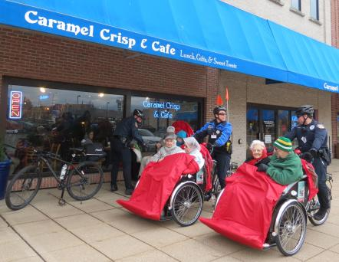

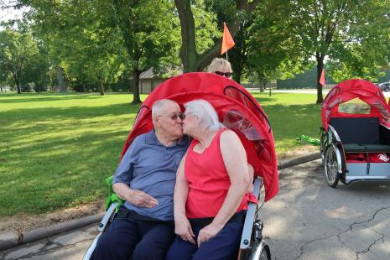

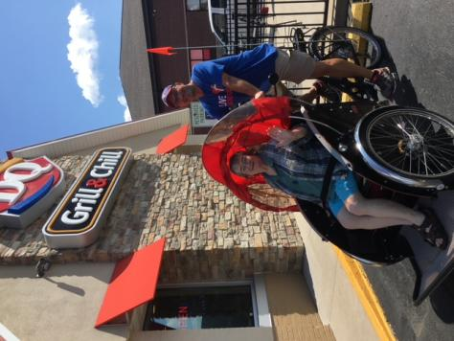

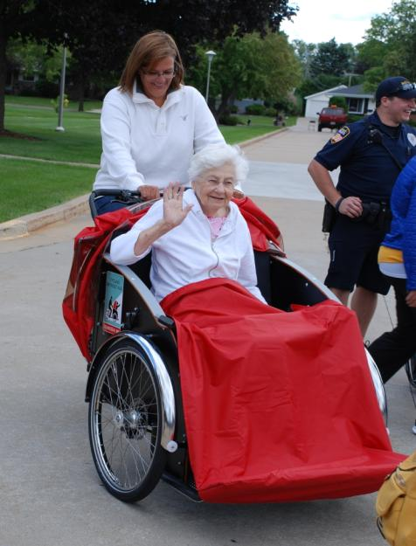

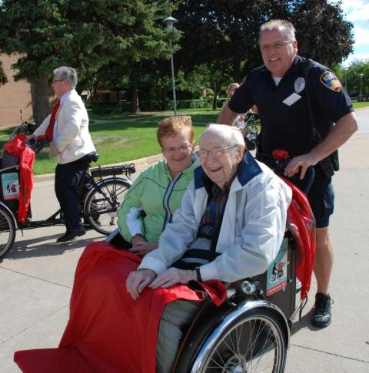

Acknowledgements

The author wishes to express gratitude to the Miravida Living of Oshkosh staff and leadership for sharing their stories, as well as Bonnie Behnke and Trish Soloman for their assistance.

Declaration of Conflicting Interests

The author declares no potential conflicts of interest to the research, authorship, and/or publication of this article.

References
- Cycling Without Age. (2021) About.
- Sørensen E, Torfing J (2016) Co-initiation of collaborative innovation in urban spaces.
- Jones M. (2015) Cycling program takes seniors on a ride back to their youth.
- Whittington FJ, Kunkel SR. (2013) Think globally, act locally: The maturing of a worldwide science and practice of aging. Generations: J Am Soc Aging 37: 6-11.
- Haugan G, Innstrand ST, Moksnes, (2013) UK. The effect of nurse-patient interaction on anxiety and depression in cognitively intact nursing home patients. J Clin Nurs 22:2192-2205.
- Buettner L, Fitzsimmons S (2017) AD-Venture Program: Therapeutic biking for the treatment of depression in long-term care residents with dementia. Am J Alzheimers Dis Other Demen 17: 121-127.
- Fitzsimmons S (2015) Evidence-based practice guideline: Wheelchair biking for the treatment of depression. J Gerontol Nurs. 37: 8-15.
- Zander A, Passmore E, Mason C, et al. (2013) exercise, enjoyment, getting out: A qualitative study of older people’s experience of cycling in Sydney, Australia. J Environ Public Health 1-6.
- Cycling Without Age. The pilot.
- Cycling Without Age (2016) Becoming a Cycling Without Age affiliate.
- Lutheran Homes of Oshkosh (2016) Cycling Without Age.
- Cycling without Age (2016) Getting a bike.
- Cycling without Age (2016) Social media.
- Cycling Without Age - Lutheran Homes of Oshkosh (2016) what is Cycling without Age (CWA)?
- Broom O (2015) Being 97 is no barrier to enjoying cycling in Copenhagen. The Guardian.
- Firman J (2014) Nine strategies to transform community service organizations that assist older adults. Generations: J Am Soc Aging 38: 60-66.
- Van Haitsma K, Abbot KM, Heid AR, et al. (2016) Honoring nursing home resident preferences for recreational activities to advance person-centered care. Ann of Longterm Care 24: 25-33.
- Bishop JD, Moxley DP (2012) Promising practices useful in the design of an intergenerational program: Ten assertions guiding program development. Soc Work in Ment Health 10: 183-204.
- Cycling Without Age. Cycling Without Age Academy.
- Institute of Medicine (2011) The Future of Nursing: Leading Change, Advancing Health. Washington, DC: The National Academic Press.

