Review Article

Counseling Best Practices: School Societal Landscape as Impacted by COVID-19 2020

Lily Tsuda, Ed.D#

Sanford College of Education, National University, California, USA

#Corresponding authors: Lily Tsuda, Ed.D, Associate Faculty, Department of Applied Behavior Analysis, School Psychology, & Educational Counseling, Sanford College of Education, National University, 11255 North Torrey Pines Road, La Jolla, California 92037, USA

How to cite this article: Tsuda L (2021) Counseling Best Practices: School Societal Landscape as Impacted by COVID-19 2020. Int J Comm & Publ Healt 01(04): 2021-22.

Submission Date: 17 November, 2021; Accepted Date: 13 December, 2021; Published Online: 18 December, 2021

Abstract

Background: In 2019, data was gathered and determined the occurrences of violence, crime, school shootings, and bullying on campus; majority of the students attending our public schools are from lower socio-economic status at the poverty level; and a large proportion of the students need mental health support constitute the nation’s public-school landscape. This landscape serves to validate the need to implement innovative schoolwide student support services in schools to improve student performance. A year later, COVID-19 emerged in 2020 and affected this landscape. The disruption of the pandemic on schools, daily lives of students, and services lost to students from lower socio-economic status led to the need for updated school landscape data. This paper is a comparison review of the landscape studied in 2019 and the resulting 2020 landscape as affected by COVID-19 pandemic. The review indicated school violence, crime, and bullying except for cyber bullying subsided due to school closure. Three major trends dominate the current school landscape. One is the need for student mental health support has increased in numbers and severity. Two is the majority of students attending public schools from lower socio-economic status at the poverty level are not only growing in numbers, but their poverty level is becoming more extreme. Finally, gaps in access to student support services resulting in disparate school experiences and school performance outcomes that exist between students from socio-economic classes and racial groups are widening. This disparity not only affects the students’ current academic lives but will have impact in all aspects of their lives in the future. The call for innovative evidence-based practices of implementing school wide academic recovery and social emotional learning development program is introduced to start the discussion in addressing this updated school landscape caused by COVID-19 pandemic.
Methods: A review of current journals, reports and research as related to school performance, including school policies and practices; latest finding in education best practices; recent research on coronavirus pandemic responses, inequities; and resulting impacts is conducted to validate an updated school landscape.
Results: This paper confirms the evidence for the second landscape, School Societal Landscape: COVID-19 2020. Supporting data of student achievement nationwide using data of high school diploma graduation and test scores provided the baseline for school performance and varying differences among socio-economic classes and racial groups. Comparison data of the original landscape of 2019 and current updated 2020 school landscapes substantiate the landscape changes in schools. The widening of pre-existing divides prior to COVID-19 and exacerbated by the pandemic is defended by the data presented in this report. The disparity of student services, school experience and school performance outcomes premised on social class and racial groups is real as presented by the data. Students in lower socio-economic status at poverty level and from ethnic minority groups makeup the majority of the students in public schools and rank lower in academic achievement than their affluent White peers. School closures due to COVID-19 isolated these students from their peers. They also suffer academic learning loss and social learning experiences. School-wide academic recovery and social emotional learning development programs are introduced to address the current landscape trends.
Conclusion: Three trends, increasing student mental health needs; large majority of students from lower socio-economic status at poverty level attending our public schools; and widening gaps of student differences in access to services and school experiences and performances are supported by data in this report to constitute the School Societal Landscape, COVID-19 2020. This study begins with establishing an academic baseline using a two-year comparison of California’s high school diploma graduation rate (pre-pandemic 2019 and pandemic 2020). Graduation rate stands at 85 percent for both years. Continuing with California, a minority majority state with a diverse population, the ethnic breakdown is Latinx make up the largest racial group at 54.90 percent and the majority White population stands at 22.40 percent. The data indicate ethnic minorities groups score lower on academic performance indicators, particularly in math. California schools mirror the gap as spoken that lower socio-economic minority students from poverty make up most of the student population. Disparities in inequity to access of services resulting in gaps of responses to school closure, instructional needs, resource funding, and education are displayed in this report. Like the research findings, California students at the poverty level attend under sourced schools that do not have books, credentialed teachers, counselors, extracurricular activities technology, and many other students support services like their affluent peers. Schools vary and differ on these aspects and are referred as high poverty/high performance, low poverty/high performing and high poverty/low performance schools.

Continual search for innovative evidence-based, best practices is necessary to address ongoing changing trends of our public school. With the emergence of COVID-19, due to school closure, the landscape has changed in which school violence, crime, and bullying except for cyberbully has subsided. Instead, updating this landscape resulted in the discovery of pre-existing student needs of mental health support, large numbers of students from poverty background attending public schools and disparity of access to services amongst the different social class and racial groups are now magnified given the pandemic. The mental health needs are more intense, the poverty more extreme and the disparity wider in the higher poverty schools. The divide between the social classes and racial groups are evident. Those who have means are able to mitigate COVID-19 consequences, they can continue to learn, keep social contact, and maintain some normalcy. Students without resources suffer learning loss and become more isolated. It is apparent the landscape in our public schools is comprised of the highest poverty students attending the highest poverty schools with the barest resources. For these schools, the search for innovative best practices includes school wide academic recovery and social emotional development program to mitigate the learning loss and social isolation caused by the response to COVID-19 in school closure and online learning.

Keywords: Access to services; Disparity; Flexible resources; High performing; High poverty; Low performing; Minority majority state; Marginalization; Underserved minority students, Racial groups; Socio-economic status.

Academic Picture

Graduation Rate: To begin with, in the state of California, high school diploma graduation rates did not change but it stay similar between the two years. In California, graduation rates remain within 2 percent for each of the Ethnic/Racial Designations. Among the students statewide who began high school in 2016, they were not impacted by distance learning. 84.3 percent graduated with their peers compared to the 84.5 percent, respectively. Dropout rates remain stable at 8.9 percent compared to 9 percent, respectively [1].

Nationwide, Figure 1 presents the fifty states and displays a fluctuation of 75 percent to 92 percent high school graduation rate. Two states received the lowest percentage of 75 and 78 percent. Forty states presented 80 to 90 percent graduation rate. Eight states have above 90 percent graduation rates. The U.S. average is 86 percent [2].

Academic Performance: In California only half of the students met English Standards and under half met Math Standards. In Los Angeles Unified School District, African American students are the furthest behind with 33 percent meeting standards in English and 20 percent meeting standards in Math. Los Angeles Times report a wide difference between the Compton District students versus the Brentwood District. The comment is to teach the Compton students like they teach in Brentwood (Figure 2).

Nationwide, New Times report two out of three children did not meet reading standards in 2019 on the National Assessment of Educational Progress, the nation’s report card. Only 35 percent of fourth graders and 34 percent of eight graders were proficient in reading. These scores drop from 37 percent and 34 percent in 2017, respectively. The average eight-grade reading score declined in more than half of the states while fourth grade reading scores decline in seventeen states from 2017. Math scores remain flat. White, black, Hispanic, Native Americans and multiracial groups all lost ground in eight grade reading. Education Secretary Betsy DeVos called this a “student achievement crisis.”

Graduation Rates of U.S. 50 States

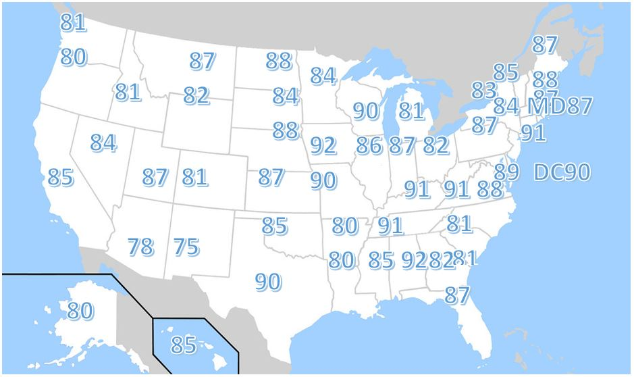

Figure 1: United States High School Graduate as Measure by Adjusted Cohort Graduation Rate (ACGR).

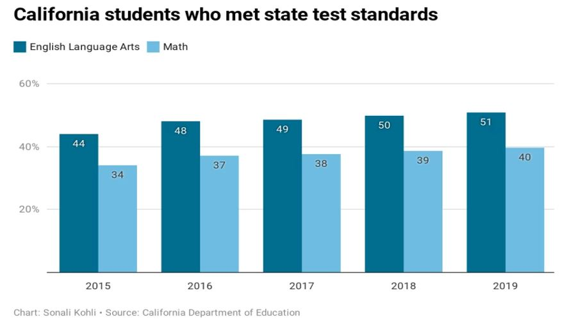

Figure 2: Academic Performance of California Students.

Organization Structure of California’s School System

California is a minority majority state in which the majority white population is a minority representing 22.40 percent of the state’s population as exhibited in (Figure 3) [1].

To gather data and learn the facts of California’s public school, one must know its organizational structure. In total California serves 6.6163,001 students according to the latest report by California Department of Education. The components of the organizational structure of schools, districts, county offices of education are depicted in the pyramid below in Figure 4. The bottom of the pyramid is 319004 schools that serve California’s student population of 6.6163,001 students. Next is the 1037 school districts for the 319004 schools. At the top of the pyramid is the fifty-two county offices of education that oversees the 1037 districts [1].

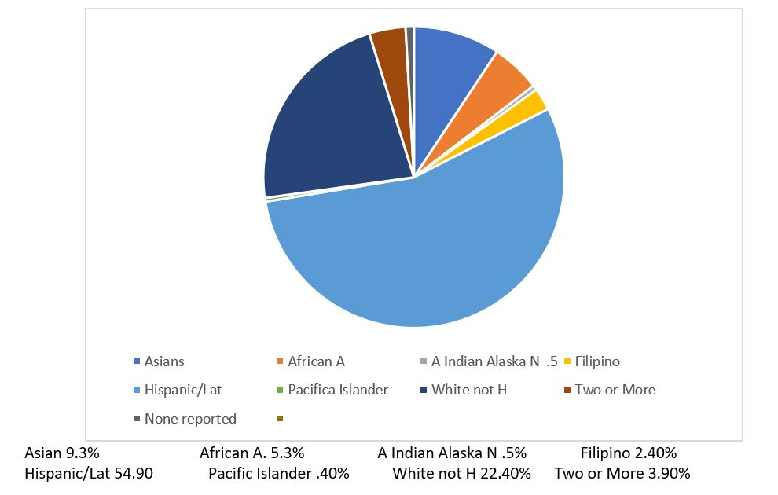

Figure 3: Ethnic Distribution of Public-School Students 2019-2020.

Organizational Structural of California Schools

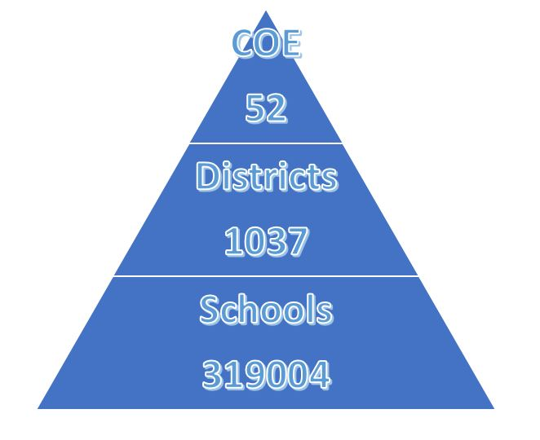
Figure 4: Pyramid Depicted of California Public Schools by California Department of Education, 2021.

Snapshot of Disaggregated Performance Indicators by School Samples

The snapshots below illustrate three types of schools, high performing, low poverty; low performing, high poverty; and high poverty, high performance with its variance and differences. Please note differences in credentialed teachers, student ethnicity and school performance. The highest performing school has a dominate White student population of 70.9 percent. The lowest performing school has the most diverse student population with a White student population of 1.6 percent. In this school, over one-third of their students are second language learners. The socioeconomically disadvantaged population for this school is 73 percent compare to 16.1 percent of the highest performing school. Their performance indicators were not reported. The third school reports twenty-seven languages are spoken in this school with ninety-two languages spoken in the district [3].

High Performing-High Socio-Economic (Low Poverty) (Table 1)

Teacher Credentials for Laguna Beach Unified School District |  | 2018-2019 |  | 2019-2020 | 2020-2021
With Full Credentials |  | X |  | X | 171
Without Full Credential |  | X |  | X | 0
Teaching Outside Subject Area of Competence |  | X |  | X | 0
2019-2020 Student Enrollment by Group
Group |  |  |  | Percent of Total Enrollment
Black or African American |  |  |  | 0.2
American Indian or Alaska Native |  |  |  | 0.2
Asian |  |  |  | 5
Filipino |  |  |  | 1.1
Hispanic or Latino |  |  |  | 13.2
White |  |  |  | 70.9
Two or More Races |  |  |  | 8.7
Socioeconomically Disadvantaged |  |  |  | 16.1
English Learners |  |  |  | 6.7
Students with Disabilities |  |  |  | 10.6
Subject | School 18-19 | School 19-20 | D82istrict 18- | District 19-20 | State 18-19 | State 19-20
ELA | 87 | N/A | 82 | N/A | 50 | N/A
Math | 80 | NA | 70 | NA | 39 | NA

Table 1: El Morro Elementary School, Laguna Beach Unified District.

Low Performance-High Poverty (Table 2)

Student Enrollment by Student Group (School Year 2019-2020)
Student Group |  | Percent of Total Enrollment
Black or African American |  | 8.6
American Indian or Alaska Native |  | 0.5
Asian |  | 4.5
Filipino |  | 5.3
Hispanic or Latino |  | 74
Native Hawaiian or Pacific Islander |  | 1.3
White |  | 1.6
Two or More Races |  | 4.3
Socioeconomically Disadvantaged |  | 73
English Learners |  | 37.4
Students with Disabilities |  | 8.9
Homeless |  | 2.3
Teacher Credentials
Teachers | School 2018-19 | School 2019-20 | School 2020-21 | District 2020-21
With Full Credential | 38 | 40 | 36 | 951
Without Full Credentials | 2 | 0 | 4 | 66
Teaching outside Subject Area of Competence (with full credential) | 1 | 2 | 0 | 49

Table 2: Burbank Elementary School Hayward Unified School District.

High Performing High Poverty, Elk Grove Unified School District (Table 3)

Ethnicity | Percentage of Total Enrollment
African American | 16
American Indian | 1
Asian | 37
Filipino | 6
Hispanic | 24
Pacific Islander | 3
Two or more races | 7
White | 7
Student Demographics | School | District
Enrollment | 2343 | 65448
English Learners | 293 | 9812
Language Spoken | 26 | 92
Students of Poverty | 1610 | 35207
GATE | 188 | 5788
Subject | Percent of Students Meeting or Exceedingly the
 | State Standards School
English Language Arts/Literacy (grades 3-8 and 11) | School |  | District |  | State
 | 2018-2019 | 2019-2020 | 2018-2019 | 2019-2020 | 2018-2019 | 2019-2020
 | 61% | NA | 56% | NA | 50% | NA
Mathematics (grade 3-8 and 11) | 34% | NA | 45% | NA | 39% | NA
Total Number of Teachers 107
Fully Teacher Credentialed 106

Table 3: Monterey Trail High School.

Schools Societal Landscape, Comparison Data of 2 Year (Table 4)

Before Pandemic, 2019 | COVID-19 Pandemic 2020:
Violence and Crime at School (Principal’s Report): During the 2015-2016 school year, 79 percent of public schools recorded those one or more incidents of violence, theft or other crimes had taken place, amounting to 1.4 million crimes. This translates to a rate of twenty-eight crimes per 1,000 students enrolled in 2015-16 (NCES, National Center Education Statistics) | Violence and Crime at Schools  Decreased during pandemic [4].
School Shooting: There were at least seventy-two incidents of gunfire on school grounds in 2019 resulting in an estimated three million American Children are exposed to shootings per year (everytownresearch.org) | School Shooting: It Took a Global Pandemic to Stop School Shooting, [5].
Teen Mental Health: Depression affects 20% of adolescents by the time they become adults. Teen suicide is the third in youth 10-24 years of age in the United States. Teen Depression is on the rise (John Hopkins Mental Health Review) | Teen Mental Health: Vulnerable kids who were never diagnosed or were underdiagnosed began to present with serious symptom (National Association of School Psychology (NASP)
Bullying Statistics: 14% of the kids who experienced cyberbullying developed an eating disorder. 25 % of the affected people engaged in self-harm. Suicidal thoughts clouded twenty-six%of people’s minds. Recovery from bullying is a life-long process (Psychology Today) | Bullying Statistics: Except for higher rates in cyberbullying, bullying decrease [4].
Poverty: More than 1 in 5 children in the U.S are living in poverty. 6.8 million children, or about 1 in 11 of all children in the U.S. live at 50 percent below the federal poverty line. Thirty percent of children raised in poverty do not finish high school (Childfund International) | Extreme poverty is expected to rise, pushing eighty-eight million in 2019 to 115 million to extreme poverty in 2020, it will push the 2021 million to 155 million (World Bank, 2020)
Disparity and Gaps in Access of Services
between socio-economic classes and racial groups of students

Table 4: Comparative societal school data based on variables studied the previous year reflect the following ().

Disparity and Gaps: Class and Race

Divide in American Schools: School experience in America differs vastly between the affluent and poor. The affluent have flexible resources to mitigate the impact of COVID-19 while the lower socio-economic student in poverty without resources continues to suffer loss of learning and social isolation. The research on underserved marginalized minorities and their consequences are well documented [6].

Many of those that are able have left the public schools or attend schools with robust resources to combat the impact of COVID-19. Funded by property tax, resources and services varied according to this formula. Students from lower socio-economic status, living in poverty attend under resourced schools with the barest services while the affluent students from a higher socio-economic level not only attend schools with adequate resources for their education needs, but they also have access to flexible resources to creatively mitigate effects brought on by the pandemic. Examples are transferring schools, creating pods to learn together during school shut down, pay for a tutor and/or even buy technology (Huffpost).

Response to School Closure: As reported by Wikipedia (retrieved August 2021), family choice around school education starkly contrasted across race. At the beginning of the school year in New York with 1.1 million school children, 84 percent of white public-school parents can send their child to attend in-person programs compared to 63 percent of Latinx parents and just 34 percent of Black parents. Caregivers with more money, mobility, and access are increasingly withdrawing from, rather than investing in the “commons” of school and public support. Many white high-income families are withdrawing from public education, to form private play pods or moving to another area. Other families with resources are withdrawing their children from public education and placing them in religious schools. Thus, public schools are comprised of a school population of poor students left in under-resourced schools with little academic options because they do not have the means to seek other others.

Instructional Needs, Technology: “We’re beginning to understand that technology is a basic right.” “You cannot participate in society in the 21st century without access to it”. (Fernando Reimers, GSE). Black and Hispanic households with school-aged children were 1.3 to 1.4 as likely as white students to face limited access to computers and the internet. More than two in five low-income households have only limited access. This is a problem with far-reaching consequences given that young students of color are much more likely to live in remote-only school districts. The issues extend beyond technology as it is a touchpoint to stay connected, checking in with kids, and addressing social emotional well-being. “If you lose connection, you lose the kid”. COVID-19 has made clear that a child’s school is social emotional support, it is safety, it is the food system, it is health care (GSE Dean, Bridget Long).

Resource Funding: Property tax is a primary source of school funding. A 2019 study found that predominately white districts get $23 billion more than their non-white counterparts. The inequities revealed by COVID-19 is serious and has disproportionately hurt low-income students, students with special needs, and school systems that are under-resourced. This carries throughout the education process from elementary school students through declining participation to higher education. Black, indigenous, and other minority majority areas were already facing inequality in everything from resources of books to counselors, to student-teacher ratios and extracurriculars. These children were already under challenging conditions that made it difficult to get a high-quality education (Education Redesign Lab, Harvard Graduate School of Education). The GSE research show all students have fallen behind, with children of color losing the most ground, particularly in math. Full time re-opening of schools and introduction of changes and remote learning offer opportunities for students to catch up. However, the limited digital access for households was 42 percent during last spring’s shutdown. Student enrollment in community colleges has also been impacted, the gateway for low-income students into professional classes has fallen in COVID-19 times.

Education: Two important conditions exist in the traditional education systems, the designed for in-person teaching and learning and existing disparities of access to services between the socio-economic classes The year 2020 challenge the world to a fast-evolving landscape as schools moved to virtual/hybrid/blended/teaching models and the disparities widens in the gap of services between the socio-economic classes of students. While there was increased social isolation and mental distress, institutions also made improvements in content and service delivery, they benefit the students who had received services and the underserved minority students was not reached and their needs increased. Advancement in technologies were made for virtual teaching, assessment, and service delivery in addition to increased proficiency of staff and faculty in utilizing the available technologies in an intentional manner. Again, the ones that were able to access this resource benefitted. The gap in technology in internet usage and internet penetration. Worldwide, it is 51.4 percent and 59 percent, respectively. Disaggregation of these figures indicate there was more than 90 percent internet penetration in Northern and Western Europe. North America was 88 percent. Close to 100 percent of individuals in high income middle eastern countries such as UAE, Bahrain, Qatar, and Kuwait have access to the internet while less than 20 percent of individuals in countries like Pakistan, Afghanistan, Angola, Zambia, Bangladesh, Chad, Niger, and others have internet. This data provides a clear picture of differential access to virtual learning opportunities worldwide. Even within each country, access to virtual learning is significantly impacted by race and socio-economic status. Even before COVID-19, racial and ethnic disparities in education are well-documented in the United States from academic achievement in elementary school to graduation rates in college.

Highlights and Results of the Disparities

Ethnic and racial disparities are associated with “limited access to educational and social capital resource, differential treatment of ethnic and racial minority students by educators and to differential responses to educational practices”.
Underrepresented communities such as Hispanic, Latinx, African American and Native American communities had fewer economic resources compared to their white peers before the pandemic. With pandemic related job losses, ethnic and racial disparities in education are on the rise as students from these communities are more likely to drop out of college than their counterparts [7].
Families who started off disadvantaged experienced more significant economic hardship globally because of COVID-19. Twenty-nine percent of respondents from low-income bracket reported job/income loss as compared to 19 percent of respondents from middle income bracket and 20 precent from high income bracket.
Students from low socioeconomic statuses are experiencing unprecedented barriers to education access due to virtual teaching [8].
It is difficult to make a space for a proper learning environment and have internet connection and electronics needed to access course content when students do not have enough food or proper healthcare and living in very small multigenerational homes [7], Director Academic Support Center and First Year Experience, American University of Sharjah.

Evidence-Based Best Practices

Children’s Cabinet” is already in place in thirty states. These nonpartisan groups bring together leaders at the city, town, and state levels to address children’s needs through schools, libraries, and health centers. A July 2019 Children’s Cabinet Toolkit on the Educational Redesign Lab site offers guidance for communities looking to form their own centers, with sample mission statements from Denver, Minneapolis and Fairfax, Virginia. Other efforts are underway such as Metro Nashville Public Schools have launched an innovative program to pair their students with navigators who are teachers, librarians, and instructional coaches to address their needs. The Principals Network is a forum for sharing ideas and addressing community issues. Viable answers have begun to emerge. GSE Dean Bridget Long an economist, Saris Professor of Education and Economics stressed the need to expand learning time by extending the school year. She also stated technology can help supplement what students are learning, giving them extra time, learning time, even tutoring time. (Reimers, UNESCO Commission on the Future of Education) urge all countries to keep education as a priority. The commission and its member are helping to identify good practices and to share them globally.

As it stands, kids will come back to school with such educational deficits that they may drop out of school. This will result in a generation of people who will be less educated. The full picture of student need is continually evolving and difficult to capture. As reported, the magnitude of need and the stark inequities with it will require structure changes and new investments over the long term.

Greater Student Needs: Students, communities and school districts that faced the largest challenges and inequities to begin with have lost the most in this pandemic and have the greatest needs to overcome [9].

- Academic Needs: NWEA, Renaissance and McKinsey estimates greater loss in math with findings that students of color experience the most loss. These losses are based on tests administered in school and is an underrepresentation of learning loss experienced by students in large urban school districts, who have been remote for most of the year.
- Social-Emotional Needs: National Association of School Psychologist (NASP) anticipates the percentage exhibiting social-emotional or behavioral concerns could double or triple because of COVID-19.

Cost per Supporting Student Needs: Districts with high concentrations of students who have been the most impacted by the pandemic need it the most. The cost implication is below [9].

1. Extended learning time will cost $9000 per pupil. It is the equivalent of extending the school year by two months for increase in annual operating costs.
2.Targeted academic acceleration intensive high dosage tutoring shows potential gains of one to two year of growth per year based on best practice implementation at local site a three-tiered strategy for academic recovery and social emotional support, a) broad academic support for all students through extended learning time, b) targeted academic acceleration for a subset of students though intensive “high-dosage” tutoring and c) increased investment in social-emotional supports for all students. Per pupil, it is $2500.
3. Research strategy based showing a year of daily tutoring at 50 minutes yields one to two years of learning points and recovering of half a year learning for 50 percent of the student body at $700 per-pupil.
4.The most promising strategies of SEL support are deeply embedded in core instructional models and involve the participation of staff schoolwide. Comparative data was used to analyze district spending on social workers, psychologists, and guidance counselors for their current investment in social-emotional supports with calculations of doubling or tripling that investment to spend on a combination of staffing, training, external support, other costs related to schoolwide social-emotional support. In using this formula and increasing support by 2.5X it will cost $600 per pupil annually.

In summary, the scenario highlighted in this three-tiered strategy addressing seven to eight months of learning loss and recovering an additional three to five months of learning loss for targeted groups with increased social emotional support for all students would cost $12,000-$13000 per-pupil over a course of five years, equating to $2500 per pupil per year. This investment could restore students to pre-pandemic learning levels.

The disparities that existed even before the pandemic must be considered. Pandemic vastly exceeded the recently emerging needs needing both attention and action. New analysis continues to shed light on learning loss. It may be years until it is known about the exact impact of COVID-19 on student learning and well-being, and long-term cost implications of districts. However, the magnitude of new and exacerbated needs is clear and district leaders have already begun to call for additional support [9].

Results and Discussion

The conditions of mental health needs, students in poverty, cyberbullying and disparities and gaps among socio-economic classes and racial groups all exist prior to COVID-19. These challenges faced in the school environment needed resolution. COVID-19 exacerbated these challenges increasing mental health needs in numbers and severity, more extreme poverty assistance and wider gaps to access services with greater disparities in opportunities, school performance and other aspects of life. COVID-19 made it evident the divide between the rich and poor, who have or not have status and access to means. The rich had flexible resources to mitigate the consequences caused by COVID-19. This impact all aspects of life, ranging from living everyday life to COVID-19 infection, to COVID-19 recovery, to staying on track with school learning or falling off and suffer learning loss, to finding means to socialize to total isolation, to eventual participation in society. As mentioned in the data review, innovative teaching practices occurred during COVID-19 time, but it was only the affluent that could take advantage and benefit.

The students in poverty suffered learning loss during COVID-19. There are others who have maintain status quote. The concern is the divide determine how the classes are faring. The divide is evident in our schools where affluent students continue to learn and mitigate their way through the pandemic. The lower socio-economic status student in poverty without means continue to do without. Our public schools are comprised of a large majority of these students left in these under-resourced schools without the services for academic options. The magnitude of the impact of COVID-19 is not over yet. As the data indicate, it may be years before we know the real impact on student learning loss and student emotional development. Evidence-based best practices of extended learning time, targeted academic acceleration, tutoring, Social Emotional Learning development are specific prescriptives for academic and social emotional needs, a first step in closing the many gaps.

This work provides a microscopic overview of the big picture of school performance impacted by a myriad of variable conditions affected by a dynamic evolving society. Each of the trends mentioned deserve laser-targeted pinpointed disaggregated study to draw significant knowledge and resolution to navigate our current school landscape. For example, the academic picture in this report integrated California data with national trends. California, a minority majority state, second highest in diversity after Hawaii, mirrors the gaps and performances of social and racial groups referred to in this work. Nationwide, within the fifty states, the baseline research is empirically set, yet the unique circumstances of each state must be factor in and considered for relevant resolution.

References

- Fingertip Facts on Education in California. (n.d.). California Department of Education.
- High School Graduation Rates (n.d.). Fast facts. National Center for Education Statistics.
- School Accountability Report Card (n,d.) 2019-2020 SARC summary. California Department of Education.
- Report on Indicators of School Crime and Safety (n.d.) Institute of Education Sciences.
- Koong L (2021) It took a global pandemic to stop school shootings. The New York Times.
- Arredondo P (2008) Counseling individuals from marginalized and underserved groups. Readings in Multicultural Practices p331-347.
- Ali M (2021). Educational disparities due to the COVID-19 pandemic. NACADA Academic Advising Today.
- Simon S (2021) Remote learning turned spotlight on gaps in resources, funding, and tech - but also offer hints on reform.
- Zhou T, Molfino T, Travers J (2021) The cost of COVID: Understanding the full financial impact of COVID-19 on districts and schools. Education Resources Strategies.

