Review Article

Application of Photovoice in Nursing Education - Systematic Review

Brandon H. Parkyn MSN, BSN, RN, CCRN, CRNP#, Klaudia Ćwiękała-Lewis PhD, MSN, BSN, RN, APHN-BC, Donna Surjnarine MSN, BSN, RN, CRNP, Jamie Carter DNP, RN, AG-ACNP

#The Stabler Department of Nursing, York College of Pennsylvania, Pennsylvania, USA

#Corresponding author: Klaudia J. Cwiekala-Lewis Ph.D., RN, PHNA-BC, Assistant Professor, The Stabler Department of Nursing, York College of Pennsylvania, 441 Country Club Rd, York, Pennsylvania 17403-3651, USA

How to cite this article: Parkyn BH, Ćwiękała-Lewis K, Surjnarine D, et al. (2022) Application of Photovoice in Nursing Education - Systematic Review. Int J Nurs & Healt Car Scie 02(07): 2022-127.

Submission Date: 07 June, 2022; Accepted Date: 30 June, 2022; Published Online: 05 July, 2022

Abstract

Background: Photography is considered commonplace in the world today. One of the important areas where photographs can be especially useful is with education. This includes education within formal schooling as well as education within the workplace.
Methods: An electronic database search was conducted of five electronic databases PubMed, CINAHL, Web of Science, Embase, and Google Scholar (January 2001 - November 2021) limited to English. Studies that presented the application of photovoice for teaching and learning were included.
Results: Twenty-Two (22) articles were chosen for final analysis. During this literature review, the authors noted three key themes: applications for students, applications for educators, and applications for both educator and student.
Conclusion: This paper presents an application of photovoice in nursing education.

Keywords: Application; Education; Nursing; Photography

Introduction

Application of Photography in Nursing Education Photography has been around, in one form or another, since the 1820s in France [1]. It initially started out as being a very slow method of continuous exposure of a mixture of chemicals to the object that they wanted to copy onto paper or parchment [1]. Photography has since then evolved heavily throughout the centuries and years from the use of film cameras to the use of digital cameras that were developed in the 1980s. Although digital photographs are easier to use and process, film cameras remained on the photography scene during this time. As more corporations, journalists and publishing companies slowly adopted digital cameras for use in magazines, newspapers and books, digital photography continued to evolve. Better cameras and techniques were developed and the general public slowly started to purchase digital cameras. Nevertheless, the sale of film cameras dominated the market until 2004. During that year more digital cameras were purchased than film cameras for the first time in history [2]. Photo documentation can make an important contribution to the medical record by documenting patient outcomes; for example, trends in wound healing [3] or forensic documentation of injuries. Photo can also be used to educated new nurses about importance of patient environment, safety of to allow visualization of important aspects of patient care, pathophysiology of the disease process [4] and cultural aspects of patient care. This is evident by the way of the formulation of a framework for the usage of photography through a cyclical phase system of acquiring photos, analyzing photos, creating instructional activities and through the communication of those activities [2]. To date, there is not a published systematic review of application of photovoice in nursing education. To close this gap authors decided to conduct this systematic review.

Methods
An electronic database search was conducted including PubMed, Cumulative Index to Nursing and Allied Health Literature (CINAHL), Web of Science, Embase, and Google Scholar. The search terms included: “Photography” or “Photovoice” AND “Nursing Education”. Articles from January 2001 to November 2021 that presented application of digital photography for teaching and learning purposes in the health care setting were included. The following inclusion criteria was followed when reviewing the abstracts: peer-reviewed reports of original research; articles published in the English language; articles included the use of photography for teaching in nursing. Studies that were excluded: abstracts, editorial, reviews, commentaries, an overview, not related to the topic, or if application of photography were not discussed.

Study Quality Score

The researchers used RE-AIM model as a framework to evaluate the extent of each study’s attempt to limit bias and extend internal and external validity to obtain an indicator of study quality [5]. The data from the chosen studies was evaluated according to the five components of RE-AIM: Reach (intended target population), Efficacy (effectiveness), Adoption, Implementation (consistency), and Maintenance (intervention effects) [5]. The RE-AIM model can be used to score both qualitative and quantitative studies as this scoring system is deemed effective for both. Three authors (KCL, DS and BP) independently assessed the studies using the RE-AIM checklist including the 5 dimensions of the framework. Criteria that were not applicable during reviews of individual articles were coded as NA and excluded from scoring [5]. Researchers then compared the scores at the end of the coding period showed high agreement (86.7%). Discrepancies in scores were rechecked and consensus achieved by discussion.

Results

The search of five databases yielded 157 articles for screening for potential inclusion. After removing duplicate articles and those not related to the topic, a total of 34 studies were reviewed in depth for eligibility. The articles were reviewed based on inclusion and/or exclusion criteria, yielding 22 articles included in this review. (Figure 1) illustrates study selection process. The conducted literature review has identified three key applications of PV in nursing education: applications for students, application for educators, and application for both educator and student.

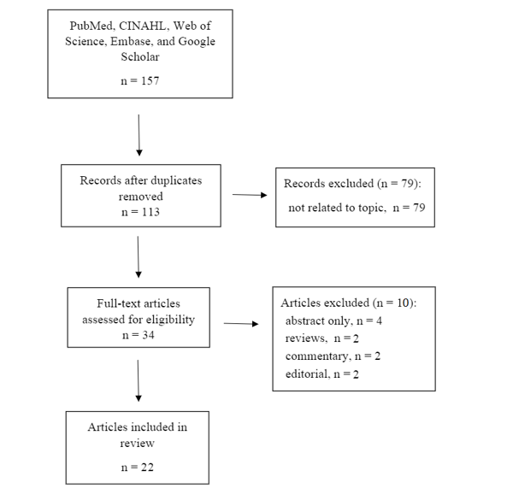

Figure 1: Study selection process.

Applications for Students

One main method for students to incorporate photography into the curriculum is called photovoice. Photovoice was developed by Wang and Burns [6] primarily for social studies and public health. Photovoice was originally developed for social change and representation and to show, from the camera holder's perspective, issues that are happening within the community [6]. Photovoice is the process in which people go into the community with cameras and take representative pictures of the issues surrounding that community [7]. Despite the original intent, the process of photovoice has expanded to other applications including student advocacy [8,9], showing health within a particular sub-community [10,11], as well as for usage within nursing research [12].

When used for education, students can take a subject they are passionate, or with which they are experiencing difficulty with communication and photovoice about it. They can then delve more deeply into the subject by showing different perspectives of the topic at hand [9]. Photovoice can be used to force the student to take a deeper dive into subject matter than would be possible with only a verbal explanation [9]. By using Photovoice the student is able to show issues happening in the community as well as other topics from their own point-of-view rather than being subject to a rigid structure for assignments [9]. This allows the student to show what they truly feel represents the topic at hand. One example of photovoice was performed with nursing students who submitted an assignment, “Challenges faced by patients with chronic illnesses,” [9]. To complete this assignment the student took a picture of three plates of food, representing three perfect meals a day that a diabetic should eat. The captioning of the picture showed the difficulties in diabetic patients to actually obtain three of those types of meals every day for the rest of their lives [9].

Leipert and Anderson [11] used a qualitative method of photovoice in their research. The results of this study proved that the application of Photovoice is imperative for fostering students' exposure to rural settings as well as their understanding of rural setting influence on nursing practice [11]. Likewise, Gallagher and colleagues [13] applied Photovoice as a teaching strategy in the community health clinical experience. Students that completed their assignments shared the photographs and explored the ways of developing sustainable community-based interventions that promote and protect health. The results of this study proved that Photovoice can be utilized successfully as a teaching strategy [13].

Braband & Warren-Mears [12] utilized Photovoice as a qualitative method to engage nursing students in exploring perceived barriers to wellness and to develop a conceptual framework of the environmental, ecological, and social realities influencing wellness at the university. During this study student implementation of photovoice was participatory action research [12]. This activity enabled students to critically examine campus environment wellness themes and realities, allowing them to propose recommendations for potential policy change and future campus wellness enhancements [12].

Nursing shortages are a vital issue for global health. Infant and child mortality rates as well as poor health outcomes are directly tied to nursing shortages. A study by Garner, et al. [9], discusses the various challenges that nurses face in their careers in India. India has one of the lowest nurse-to-patient ratios and pays its nurses a non-livable wage. Religious beliefs portray nurses as being polluted as they come into physical contact with the sick and dying. Cultural and religious depictions and beliefs of nursing keep many young men and women from pursuing a career in nursing. Many nurses choose to move to other countries after graduation where they are held in higher regard, are paid better, and are viewed in a higher social standing than in India.

Recognizing different religious and ethnic beliefs as well as the nurses role in society is essential the begin making an impact. A critical goal is to keep and enhance nursing practice in areas where they are needed the most. The study by Garner, et al. [9], used Photovoice as a medium by which to have nursing students understand the issues they face before they start to practice. Understanding the challenges and obstacles ahead of them allows for greater discussion, advocacy and policy change. Nursing students in this study were able to discuss their findings, their feelings regarding their chosen career, and were able to come to collective conclusions about the biggest issues they faced [9]. Discussion of their feelings and concerns would not have been as effective without visual representations evoking how deeply they felt regarding these issues.

Ryan, et al. [14], in their qualitative study, used Photovoice as a method to actively involve students to fuel reflection and creatively instill values associated with global health. This Photovoice project provided a unique moderator for reflection. The study findings revealed that students gained deeper reflection and understanding of global health. Furthermore, the study revealed discrepancies in student's understanding of social determinants of health and areas of commonality and privilege [14].

Application for Educators
Photovoice can also be used as an interactive teaching technology to support course engagement, foster experiential learning and to enhance the learning environment [13]. Utilized PV as a framework for engaging nursing students in research. PV was the framework utilized, allowing new nursing students to feel more engaged and increase their understanding of nursing research. This study concluded that PV empowered students to stimulate the participants' stories in a meaningful manner. During this research students were also exposed to critical inquiry and data analysis. In addition, during this research, students were exposed to critical inquiry and data analysis. Both of critical inquiry and data analysis are key elements to curriculum in the development of evidence-based nursing practice.

Garner [9] reveals how the current generation of nursing students already use photography daily to depict what is most important to them through social networking. The images capture both literal and emotional meaning depending on the user. Since photography is a normative behavior in this group already, the use of photographs in nursing education makes sense. While they may have to discuss the photograph to determine the underlying concepts inherent in them, it is in these discussions that patterns emerge. Students’ use of descriptive emotions in relation to the photographs tap into the human connection, evoking compassion and humanity [9].

According to Aranda, et al. [15], there are two means of using photography. The first includes showing photographs to students. After they see the photograph, students respond with what they are seeing, how it affects others from a nursing perspective, and their own personal views of the world captured on film. Participatory photography encourages students to go into their communities and take photographs. The second method is helpful for some in understanding where the issues lie. This method is dependent on the student’s ability to identify needs based on what they are seeing in the community. Students interact, think critically, develop an understanding of communities’ needs without physically needing to be there, and develop cultural sensitivity without presumptions or bias [15]. By having students engaged in the learning process, “it transforms learning from a stable capacity to one that is dynamic, multiple and changing” [15].

Nursing students need to be able to evoke critical thinking. Photography is a tool that enables them to be able to critically think about what may be going on, to be able to determine where the needs are and to whom they are directed. The authors Aranda, et al. [15] found that with the use of photographic images, nursing students were able to combine critical thinking skills using theories learned in class with how they were portrayed in the image. The study also found that those involved in the study were able to gain a better understanding of how they felt about the issues inherent in the images. This was enlightening for some students, while others felt insecure about sharing ideas that may not be popular with the class. “Images are now commonly acknowledged to involve deeply embedded interpretative processes that help constitute and generate the representation of reality” [15]. Photography helps nursing students to determine their own values based on culture and personal experience, while finding connections between cultures, groups and individuals.

In another article, Schell, et al. [16] describes the photovoice application in the classroom as beneficial. The authors emphasize the importance of engaging students with visual aids to encourage critical thinking [16]. The goals of utilizing photography and educating about the use of it is to help build self-esteem and promote feelings of security [16].

Aranda and colleagues [15], in their qualitative study, attempted to explore whether photography encouraged students to critically explore values and culture. Students were asked to take photographs to explore their own culture and values associated within their culture. Study results showed that photography was successful in promoting critical engagement with complex concepts fundamental to present-day mental health care. Results of this study prove that the experimental approach in mental health nursing education promotes transformational learning [15].

Raduenz and colleges [17] in the qualitative study with photographic research methods, used digital photographs of the medication system. Photographs were reviewed with research participants to obtain their perceptions and narratives of working with medications in the unit. Results of this study proved that disorganized and messy medication distribution storage can cause medical errors [17]. Clinical and classroom instructors could use images of disorganized medication carts and then have group discussion on how and why this should be prevented.

Application for Both Educator and Student

Photography can be used as an analysis tool to encourage students to interpret what they see in a specific scene or picture, and report on it. This can be completed by a project or on a volunteer basis where the educator can show a picture and ask the class to describe the picture in their own words. The description of the picture may be similar in terms of the physical aspects of what they see, however, the meaning for each student will differ. This learning experience can benefit students by showing varying perspectives on similar photos, while fostering open-minded thinking by students.

Transgendered individuals used photographs to depict how they experienced health care. The study included five Female to Male (FTM) individuals. Common themes included: invisibility, activism, perseverance, vulnerability, and provider competence. The men in the group found that they shared common concerns and were able to share their feelings about each theme. Three areas were identified for revision in the healthcare system. The men concluded that they needed health care providers to be knowledgeable about the special needs of the transgender population. They wanted to be included in the process of education and policy formation as it affected them. Finally, their discussions revealed the need for additional research focused on the transgender population.

Photovoice to capture the qualities and elements inherent in rural nursing. Pictures taken included open road, natural landscapes, as well as occupational symbols. Together, these elements depict the comforts and concerns of the rural nurse. They also show the differences inherent in rural nursing as opposed to urban nursing including challenges, rewards, and the people themselves. Photovoice was able to help nursing students understand as well as appreciate what makes rural nursing different and of high value. Much like the other articles, this study illuminates photography’s ability to draw out emotions, while telling a story. Once the story is dissected through discussion, new implications for change are developed. With the information and stories shared by the nurses in rural Canada, a book was published, giving legitimacy to rural nursing in Canada and beyond.

Besides giving validation to specific nursing specialties, Photovoice serves as an aid for online learning. Online instructors have the added responsibility of keeping a sense of community in their online classes. Some students struggle with online learning due to feeling isolated and disconnected. One way to tackle this is through interactive online activities such as Photovoice. Students participate in discussing their views of the images shown to them by the instructor, then give personal accounts of what the images mean to them.

An online instructor in a graduate course used Photovoice in her online classroom. Student feedback suggested the use of PV was effective in maintaining a connection, engaging in the coursework, and enhancing the online learning environment. With tools such as Photovoice, students can have personal connections with each other and the instructor, through their responses. Students stated that they enjoyed interacting in this manner, and many looked forward to the new image that was presented to them every week. Students learn in varying ways. Photovoice helps visual learners comprehend new concepts in nursing.

A study by Edmondson & Pini [18] presented a discussion about photovoice and the associated methodological issues that could enable nurse researchers’ cognizance of the method. Photovoice could also support the researcher in making informed selections about research methods and inspire researchers to utilize photovoice in health research to supplement collected data and support understanding of the data. The authors also suggested that the utilization of photovoice in nursing research may support the application of photovoice by researchers in the future [18].

Similar to other methods for integrating photography into the curriculum, Photovoice is already being utilized within the classroom. Helle [19] describes the usage of photo-analysis within medical school. Helle [19] describes the process of utilizing photographs in educating students in combination with the text. Photovoice allows students to tell the story of the picture, while learning various medical techniques and concepts inherent in the picture. Branda and colleagues [20] presented a similar idea. The authors created a project story board in order to create a consistent vision that was presented to several nursing and medical students. The results of this study confirmed that many nursing and medical students have preexisting assumptions about older adults. Presenting them with storytelling photographs allowed them to realize the presence of stereotypes. In uncovering these stereotypes, the students realized how other preconceived notions about the elderly may create barriers in understanding their patient’s true identity.

The authors of this paper on several occasions used pictures to educate staff, students and patients. (Image 1) was created in nursing setting to educate about importance on infection prevention. Participants, were asked to identify possible breaches in infection control, followed by discussion on how this could be prevented. (Image 2) was created to show the importance of non-verbal communication. Participants were asked to describe picture A, B and C followed by group discussion about the impact of non-verbal communication on the coworkers, patients, and their family. In the community course taught Dr. Lewis, nursing students were ask to collect environment pictures (photovoice) of perceived barriers to health noted by nursing students during their community assessment. Students were submitting two pictures with one paragraph explaining why picture was taken and what is their perceived barrier to health withing chosen community. (Image 3) is showing the example of student submitted picture and one paragraph. This activity was part of a larger study, and the results are not yet available.

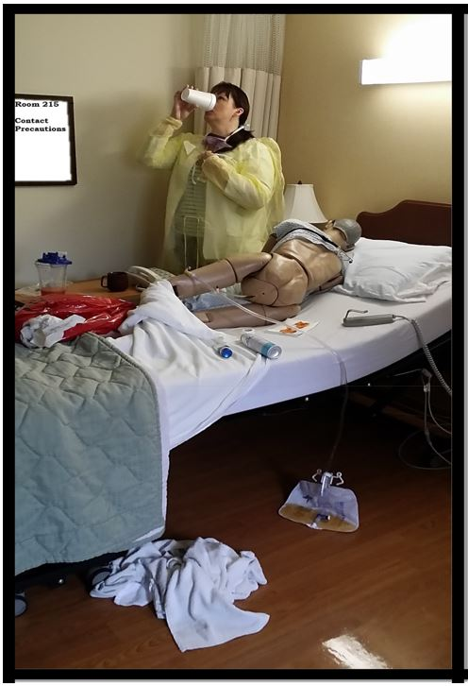

Image 1: Identify potential infection prevention breaches.

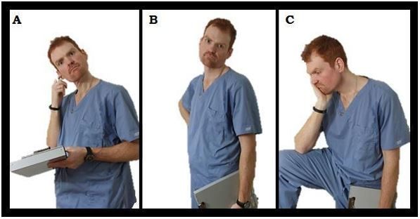

Image 2: Power of non-verbal communication. Describe what you see.

Image 3: Photovoice submitted by Madison Lewis and Theresa Brietzke in Fall 2018. Picture 1: Alcohol bottle laying in the grass in nearby playground. Barrier to health: Alcohol consumption may create potential addiction, bottle in the park may influence kinds negatively by setting a bad example, plus littering creates environmental health hazards and potential safety issue for your kids playing at the playground.

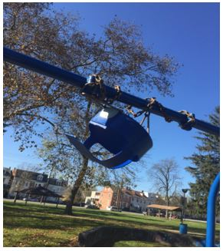

Picture 2: Unusable or broken swing in playground. Barrier to health: Kids are unable to play due to broken swing this may effects child wellness.

Discussion

The value of education in general is very difficult to truly measure [21]. As Topel and Lange [21] discussed, education does increase skills, but does not guarantee an increase the production of the individuals. It is difficult to truly place a value on education. However, in these authors’ opinions and personal history, education has been a great value to assist in obtaining better employment and more diverse skills. As described above with the learning pyramid, pure verbal lecture, without any other type of stimulation, has shown to have a 5% retention rate amongst students. Usage of audiovisual techniques increase that retention rate to 20% [22].

Nursing combines the humanities with physical sciences in a unique manner which encourages critical thought, while invoking compassion and relatability with patients. Nursing is a unique profession in which the outcomes of patients are directly related to the care provided by the nursing staff. The care provided by the nurse is influenced by his/her experiences and training, in addition to personal values and cultural influences.

The increase in retention through PV translates into a higher value of education. Photovoice gets students more actively involved in the learning process and thus, increases the retention of materials learned. As Masters [22] displays in the learning pyramid, practice by performing the action, could increase the retention rate of education to 75%, thus, showing a significant increase in learning by the student and increasing the potential for skills that these students can possess. Photovoice allows students to gain clinical exposure in the lab and classroom settings [19]. Some studies showed that photovoice can be use as moderator to illustrate student’s reflectiveness and knowledge gap when learning about global heath [14]. Educators and students may choose to use PV to supplement collected data and support understanding of the data collected during the research [18].

Clinical experience is a vital component of the nursing education system. Where lecture and laboratory settings are valuable in introducing evidence-based best practices and teaching important skills such as critical thinking, the clinical setting is where students implement the knowledge obtained into nursing action. Often programs have limited opportunity to provide clinical instruction due to scheduling and logistical considerations. Photographic images allow educators the ability to provide succinct and relevant information to their students. Students also become familiar with practical real-life practices before entering the clinical setting.

The recommended strategies for integration of photography into the classroom are relatively inexpensive from both the student and educator perspective. The initial cost for Photovoice depends on the approach of the instructor. Purchasing a digital camera can be costly for some programs however, the camera can be used for many years. Photography can also be obtained from other resources. Photography can be found in books, magazines, journals and on the internet.

With regards to availability of photography in nursing education, it is noted that most students have access to smart phones with digital photographical applications [23]. Nursing education can become more modern and relevant to younger learners. Older learners will be encouraged to embrace technology as a necessity to successfully achieve all nursing care practices [23]. Photovoice is not limited to the current generation of nursing students. Photography is inherent in our culture and in society.

This author would like to add that there are many ethical and legal aspects of implementation of photography in nursing education. Patient privacy and rights need to be upheld at all times. Photography should only be utilized in the lecture and laboratory settings. Nursing students are extensively educated on the important ethical requirements dictated by HIPPA regulations [24]. Students would still be instructed to refrain from utilizing their phones in the clinical setting. The purpose of applying photography into nursing education is to offer greater practical experience outside of the clinical setting. Before implementing photographs into the nursing curriculum educators should make sure to check workplace policy regarding copyrights and use of digital images in the classroom. This paper will not discuss any of the above legal and ethical implications, as that is not the objective of this article.

Conclusion

Photography has a diverse and rich history that has been changing and advancing since the late 1800’s. Digital photography allows the photographer to take hundreds of pictures with the push of a button. Although there is no specific history of photography being utilized in educational curriculums, there is evidence that it has been used in the classroom for a long time. Photography has substantive applications in the student nurse’s academic career. One of the greatest benefits is receiving relevant clinical experience in the lecture or laboratory settings. There are many different ways that photography can be integrated into the curriculum. This paper outlines three key applications of photovoice as Community-Based Participatory Research (CBPR) method use in nursing education.

Utilization of technology such as PV makes nursing education more readily available to younger students, while ushering older learners into the era of informatics-based competency. Analyzing photographs, discussing common themes and depicting key areas for improvement in the examples provided, was proven to be effective. Utilization of PV has few initial costs. Educational concepts as well as the self-reflective qualities of PV, is invaluable to students learning and to the progression of the nursing profession. Future studies could focus on the differences in approach from a generational standpoint.

References

- Gernsheim HR (2016) History of photography.
- Bull G, Thompson A (2004) Establishing a framework for digital images in the school curriculum. Learning & Leading with Technology 31: 14-17.
- Cortés OL, Alvarado PA, Rojas YA, et al. (2018). Digital Photography: a Tool for Nursing on the Assessment of Pressure Lesions. Investigación y Educación en Enfermería 36.
- Rennert R, Golinko M, Kaplan D, et al. (2009) Standardization of wound photography using the wound electronic medical record. Advances in skin & wound care 22: 32-38.
- Glasgow RE, Vogt TM, Boles SM (1999) Evaluating the public health impact of health promotion interventions: the RE-AIM framework. American Journal of Public Health 89: 1322-1327.
- Wang C, Burris MA (1994) Empowerment through photo novella: Portraits of participation. Health Education & Behavior 21: 171-186.
- Wang C, Burris MA (1997). Photovoice: Concept, methodology, and use for participatory needs assessment. Health education & behavior 24: 369-387.
- Goodhart FW, Hsu J, Baek JH, et al. (2006). A view through a different lens: Photovoice as a tool for student advocacy. Journal of American College Health 55: 53-56.
- Garner SL (2014) Photovoice as a teaching and learning strategy for undergraduate nursing students. Nurse education today 34: 1272-1274.
- Wang CC, Pies CA (2004) Family, maternal, and child health through photovoice.Maternal and child health journal 8: 95-102.
- Leipert B, Anderson E (2012) Rural nursing education: a photovoice perspective. Rural & Remote Health 12: 1-11.
- Braband BJ, Warren-Mears V (2017) A mentored partnership project using PhotoVoice in a nutrition nursing course. Journal of Nursing Education 56: 315-315.
- Gallagher MR, Stevens CA (2015) Adapting and integrating photovoice in a baccalaureate community course to enhance clinical experiential learning. Journal of Nursing Education 54: 659-662.
- Ryan M, Feld H, Yarrison R (2019) Reflection in Global Health Using Photovoice. American Journal of Pharmaceutical Education, ajpe7630.
- Aranda K, Goeas S, Davies S, et al. (2015) let’s go outside: using photography to explore values and culture in mental health nursing. Journal of psychiatric and mental health nursing 22: 306-315.
- Schell K, Ferguson A, Hamoline R, et al. (2009). Photovoice as a Teaching Tool: Learning by Doing with Visual Methods. International Journal of Teaching and Learning in Higher Education 21: 340-352.
- Raduenz AC, Hoffmann P, Radunz V, et al. (2010) Nursing care and patient safety: visualizing medication organization, storage and distribution with photographic research methods. Revista latino-americana de enfermagem 18: 1045-1054.
- Edmondson AJ, Pini S (2019) The pros and cons of using photographs in nursing research. Nurse Researcher 27.
- Helle A (2011) When the photograph speaks: photo-analysis in narrative medicine. Literature and medicine 29: 297-324.
- Brand G, Miller K, Wise S, et al. (2016) Depth of field: Using photographs and narratives to explore and reflect on ageing. Reflective Practice 1-5.
- Lange F, Topel R (2006) The social value of education and human capital. Handbook of the Economics of Education 1: 459-509.
- Masters K (2013) Edgar Dale's Pyramid of Learning in medical education: A literature review. Medical teacher, 35: e1584-e1593.
- Mastrian K, McGonigle D, Mahan WL, et al. (2011) Integrating technology in nursing education: tools for the knowledge era. Nursing Education Perspectives 32: 201-202.
- Guzik A (2013) Essentials for occupational health nursing. John Wiley & Sons.

