Research Article

Reducing Potential Adverse Drug Events during Transitions of Care between Hospitals and Skilled Nursing Facilities

Larry Garrett PhD, MPH, RN^{1#}, Kasey DeLynn Shakespear, MHA, MPH, MA²

^{1#}University of Utah, Utah, USA
²Southern Utah University, Utah, USA

#Corresponding author: Larry Garrett PhD, MPH, RN, Assistant Professor, College of Nursing, University of Utah, 670 East 650 North, American Fork, Utah 84003, USA

How to cite this article: Garrett L and Shakespear KD (2022) Reducing Potential Adverse Drug Events during Transitions of Care between Hospitals and Skilled Nursing Facilities. Int J Nurs & Healt Car Scie 02(09): 2022-144.

Submission Date: 05 September, 2022; Accepted Date: 14 September, 2022; Published Online: 20 September, 2022

Abstract

Background: Adverse Drug Events (ADEs) cause death or injury to nearly 1 million patients each year, with direct hospital costs of $3.5 billion annually in the United States. The transitions of care process between hospitals and Skilled Nursing Facilities (SNFs) are particularly prone to ADEs occurring. This report describes an innovative, systematic approach to monitoring and reporting Potential Adverse Drug Events (pADEs) and medication reconciliation outcomes that occur during transitions of care between hospitals and SNFs. This method involves the identification of pADEs within hospital discharge orders sets and the medication reconciliation and order clarification activities completed upon patient admission to a SNF. The identification, clarification, and subsequent correction of a pADE may reduce the actual number of ADEs.
Method: Data on pADEs were collected weekly via an online reporting system. Medications were categorized as: opioids, diabetic agents, anticoagulants, antipsychotics and other. The pADEs were reported weekly in REDCap (data management and research tool). Data were compiled, and results shared with 60 participating SNFs and hospitals. No personal identifiable data were collected to ensure patient confidentiality.
Results: During the 126-week period from Aug. 2, 2015 to Dec. 30, 2017, 28,770 transitions of care and their associated medication reconciliations were recorded. Of these, 6,644 (23%) had one or more medications requiring clarification. When the project started, 30.7% of all transitions had one or more pADEs. As of Dec. 30, 2017, the percentage dropped to 19.7%, for an overall 36% reduction. This reduction in pADEs was a direct result of improved hospital discharge orders, which was enabled by the data collection and feedback reports to hospitals and SNFs. The intervention improved patient safety by reducing pADEs, helped mitigate the high costs of ADEs, and in addition saved more than $163,625 in direct costs by reducing the number of discharge orders requiring staff and provider time to clarify.

Keywords: Adverse drug events; Medication reconciliation; Transitions of care

Introduction

Effective drug therapy requires balancing health benefits with potential side effects. Side effects range from mild to severe. Adverse Drug Events (ADEs) occur when a medication (or combination of medications) cause patient harm. The Centers for Disease Control And Prevention (CDC) estimates that annually ADEs cause more than one million emergency department visits, 280,000 hospital admissions, with costs exceeding $3.5 billion [1]. Additional studies show the prevalence of ADEs and potential ADEs (pADEs) is higher in the Medicare population than other populations due to the prevalence of multiple chronic conditions and polypharmacy in this population [2]. A pADE, for the purposes of this report, is defined as any discrepancy or needed clarification of the a medication order(s) during a transition of care between a hospital and a Skilled Nursing Facility (SNF). The identification of pADEs may reduce the number of ADEs. This is because a pADE is the proactive identification of a medication issue and Addressing It Beforehand reduces the probability of an ADE.

The magnitude of ADEs in the Medicare population requires additional work to yield new, evidence-based interventions as many current strategies lack a formalized data collection system that is necessary to assess outcomes. The purpose of this quality improvement project was to design an effective community-based reporting system to detect pADEs targeting high-risk medications (i.e., opioids, diabetic agents, anticoagulants and antipsychotics) that put Medicare beneficiaries at risk, and engage stakeholders in effective partnerships to improve medication order sets associated with transitions of care between hospitals and SNFs.

Methodology and Intervention

Two independent factors contributed to the development and ultimate success of this quality improvement initiative. First, a large payer group in Utah, desiring to improve outcomes of their clients in SNFs, required each SNF to implement a quality improvement initiative if they desired to remain within the approved panel. The second was HealthInsight (now Comagine Health) the state’s Quality Innovation Network - Quality Improvement Organization (QIN-QIO) was working with SNFs to improve the quality of care in SNFs. The QIN-QIO was specifically targeting ADEs associated with high-risk medications.

Intervention

The main method used was to assist the SNFs with the implementation of INTERACT (Interventions to Reduce Acute Care Transfers). This quality improvement program focuses on the management of an acute change in a resident’s condition. It includes clinical and educational tools and strategies for use in everyday practice in long-term care facilities [3]. Moreover, INTERACT incorporates a medication reconciliation process for all patients admitted from a hospital which help identify pADEs and other issues related to medication orders. If a SNF implemented INTERACT it was determined this met the quality improvement requirement for the payer group; data submission became the de facto measurement of engagement in the payer’s quality improvement initiative.

Participants

Seventy SNFs (69% of all SNFs in the state) received training and implementation assistance with INTERACT; 60 continued to participate throughout the timeframe associated with this report. SNFs received 12 hours of instruction, divided into two sessions. A total of 36, two-part trainings were conducted over eight months. There were challenges associated with the implementation of INTERACT with the greatest being the high turnover of staff within the SNFs. In the 28-month data collection period we observed a 65% turnover rate, resulting in additional training and on-site visits.

Design and Implementation of the Reporting System

As each SNF implemented INTERACT they were invited to contribute to the community-based reporting system to detect pADEs. The reporting system was based upon accepted informatics principles [4] to help ensure accurate and timely reporting (Table 1). Early in the development of the project we recognized the need for an automated data collection system with an embedded data management tool to avoid spending a disproportionate amount of time tracking facilities that did not report their weekly data. This eliminated the need for heavy administrative support throughout the scope of the project. We selected REDCap for this purpose. REDCap is an open-source, secure web application for building and managing online surveys and databases [5]. We used several PDSA cycles to ensure system integrity and confirm ease of data entry.

Concept: A “business case” in place to encourage data collection and submission.
Rationale: There must be a useful or required need for these data.
Concept: Data captured once but used multiple times.
Rationale: Reduces data entry time and possible data entry error.
Concept: Only needed data collected and used.
Rationale: Data collection is expensive. Data collection for the sake of collection is a waste of resource and shows lack for forethought of data usage.
Concept: Data entered directly by those with a vested interest improves the quality of data.
Rationale: Data entered on behalf of others is suspect as those entering the data usually have limited interest with the results.
Concept: Data collected from single sources using standard methodologies.
Rationale: Single source data collection eliminates data translation and decreases data cleaning activities.
Concept: Timely feedback encourages participation.
Rationale: Data that has been turned in to usable information encourages additional data collection.

Table 1: Reporting system components to ensure accurate and timely reporting.

Throughout the project, an automated email was sent weekly to each participating facility with a reminder to report data. The data entry process was streamlined to ensure the time associated with data entry was minimal. Any medication identified as problematic through the INTERACT medication reconciliation was reported as a pADE. Additional data associated with verbal reports (i.e., warm handoffs) between the hospital and SNF and the completed discharge summary were also collected, but these data are part of an intervention package beyond the scope of this report. A listing of collected data elements is shown in (Table 2). These data were compiled on a community-wide level and subsequently used to identify patterns and track outcomes of interventions designed to reduce the number of pADEs associated with transitions of care.

Admission date and time: The date and time the patient was admitted to the skilled nursing facility. [date and time field]
Hospital or facility: The name of the facility from which the patient was transferred. If the patient was admitted from home, then facility is home. [drop-down listing]
Categorization of drug associated with the pADE or ADE: This is a one-to-many option with each medication in question having its own categorization. [checkbox - opioid, diabetic agent, anticoagulant, antipsychotic, other]
Was a verbal report received from the transferring facility: Did the nurse assigned to receive the patient get a verbal report from the nurse discharging the patient from the previous facility? [checkbox: yes/no] *
How was the verbal report made: This question was only displayed if yes to question #4. [checkbox - you notified the hospital/the hospital notified you] *
Was a completed discharge summary received from the transferring facility: Was a completed discharge summary received from the transferring facility at the time of patient admission - Note: These are not transfer orders. [checkbox - yes/no] *
*These data are part of an additional intervention package that are beyond the scope of this report.

Table 2: Data elements on each admission of a patient from a hospital.

Reports and Feedback

Facility specific and community-wide reports were generated. These reports were sent to the individual SNFs and hospitals. Eleven participating hospitals were recruited from communities where the SNFs were located. The community-wide reports were reviewed in three separate coalition meetings held in various locations in the state on a quarterly basis. Data use agreements were in place as well as data sharing agreements that allowed for the aggregate data to be shared. Reports were used to generate new ideas on improving specific types of medication orders and to provide a longitudinal measure of outcomes of these interventions.

Analysis

Due to the non-experimental nature of this project, descriptive statistics and control charts were used in both the project design and analysis. Control charts were used to detect if the results were indicative of an actual change in the number of ADEs [6]. The initial 15 weeks of data were used to construct a standard control chart around the percent of patients who needed medication clarification; the average was used as the center line and three standard deviations for the upper and lower control limits.

Results

Between Aug. 2, 2015 and Dec. 30, 2017, 28,770 transitions of care and their associated medication reconciliations were recorded; of these, 6,644 (23.1%) required clarification on one or more medications, for a total of 12,434 medications defined as pADEs. Upon initiation of the project, 30.7% of all transitions had one or more pADEs. As of Dec. 30, 2017, the percentage dropped to 19.7% (a 36% decrease). Interestingly, while the overall percentage of medications reported as pADEs dropped, the overall distribution by type of medication remained relatively constant.

The results showed when a pADE was reported, 11.6% [n=1,440] had three or more medications needing clarification, 25.5% [n=3,172] had two medications needing clarification, and 53.4% [n=6,643] had one medication needing clarification. Medication type, by category, was also tracked. Excluding “other” the analysis revealed the most common types of identified pADEs were associated with opioids (35% [n=1,231]), diabetic agents (31% [n=1082]), anticoagulants (23% [n=788]) and antipsychotics (11% [n=394]).

We used the Nelson decision rules [7] associated with statistical process control (SPC) to analyze these data. SPC utilizes control charts to detect systems that are out of control. A system that is out of control reveals either a positive or negative result of an intervention and in this case a negative result would coincide with a reduction of pADEs. A control chart has a central line representing the baseline or average, and an upper and lower control limit which represent three standard deviations from the baseline. We established the baseline utilizing the first 15 weeks of data.

The control chart (Figure 1) show that by week 36 (May 1, 2016) all data points were below the baseline which signifies a downward shift, or put another way there was a reduction in the rate of reported pADEs. This downward trend continued until the data became relatively stable fluctuating around three standard deviations below the original baseline at week 61 (Jan.8, 2017). All data points in the final 15 weeks (Sept. 16, 2017) are associated with a 36% reduction in pADEs.

Additional analysis confirmed that the system was out of control and the downward direction confirmed that there was a reduction in the number of reported pADEs. For example, in the 68-week span between September 2016 and the end of December 2017 there were 22 individual weeks where the reported number of pADEs was at or greater than three standard deviation below baseline. Moreover, there were multiple incidences where four out of five consecutive weeks were in a downward trend. These events indicate an out of control system when utilizing the Nelson decision rules in SPC. IAs previously noted a system that is out of control in a negative manner shows that the intervention coincided with a reduction of pADEs.

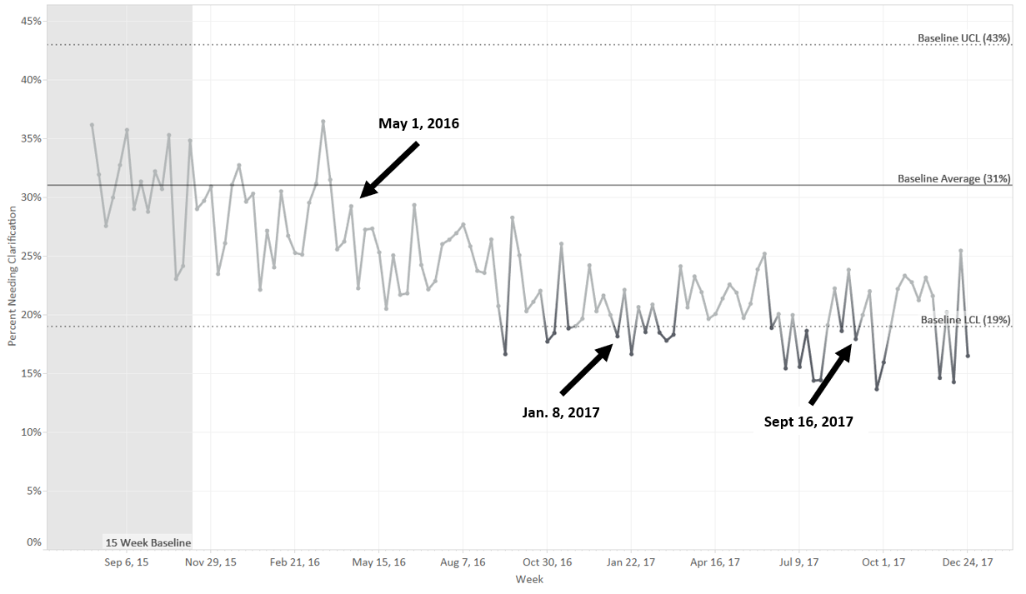

Figure 1: Control Chart: Weekly Percent of Patients Needing Medication Clarification. Week 1-15 were used to calculate control limits. Dark grey points indicate points greater than three standard deviations below center line (average percentage of 15-week baseline period). Starting with week 36 (May 1, 2016), all data points are below the center line, indicating a downward shift in the data.

This project not only reduced pADEs but saved the health care system over 2,750 hours of medical staff time. This finding is based upon our assumption that it takes 75 minutes to correct a pADE. This assumption is based upon the following:

Registered Nurse (RN) or Licensed Practical Nurse (LPN) identification of pADE
RN/LPN determination of corrective action (may need to research issue)
Telephone call placed to medical provider for clarification
Medical provider reviews request
Medical provider calls RN/LPN
RN/LPN writes telephone order (introduces another possibility of a pADE)
RN/LPN enters new order into the electronic health record
RN/LPN sends new order to pharmacy

Assuming a RN in the U.S. is paid $32 per hour [8], and a general practitioner (GP) is paid $110 per hour [9], each pADE may cost up to $59.50, based on an 80/20 RN to GP cost division. As such, the activities associated with the identification and correction of pADEs saved approximately $163,625 in health care related costs.

Discussion

This quality improvement initiative reduced the aggregate probability of a pADEs by 36% between participating hospitals and SNFs. Extrapolating this reduction, approximately 2,200 pADEs were prevented. This resulted in a reduction in ADEs, but to quantify this reduction is difficult, as not all pADEs result in an ADE. Identifying and correcting pADEs before administering medications is one method to prevent an ADE from occurring.

Using data to identify factors potentially leading to an undesired event (e.g., ADE) presents potential ethical implications and responsibilities. These results were discussed during quarterly meetings with three separate community groups that included hospitals and SNFs. Data use and sharing agreements allowed for discussion among all participants. Prior to disclosures, all participants were reminded of agreements and given the ability to withdraw from the discussion. No agency, provider or participant withdrew consent. Agreements were updated annually. No personal identifying data were collected to avoid any HIPAA conflicts and/or violations.

The results of these types of community group discussions have a positive impact upon the relationships between hospitals and SNFs and facilitate additional interventions that further reduce the number of medications needing clarification. For example, the findings associated with diabetic agents have critical patient safety issues and several local communities are exploring interventions.

Limitations

Medications identified as pADEs were categorized into five types. No interrater reliability testing was performed to determine if proper categorization occurred. The “other” category also represents a disproportionate number of identified pADEs. To address this, future activities may involve the utilization of representative sampling to determine which medications are in this category and to look for patterns that may lead to additional interventions.

Conclusion

Reducing pADEs can improve patient safety and outcomes. An active medication reconciliation process during transition of care can improve medication safety and reduce ADEs. A systematic approach to these reconciliations, including processes associated with INTERACT or other quality improvement projects, must be in place to ensure they are conducted in a consistent manner. Documenting reconciliation outcomes and using findings in community-based health care settings can reduce adverse drug events.

Acknowledgement

This project was supported by Comagine Health, formerly HealthInsight, the Medicare Quality Innovation Network -Quality Improvement Organization for Nevada, New Mexico, Oregon and Utah, under contract with the Centers for Medicare & Medicaid Services (CMS), an agency of the U.S. Department of Health and Human Services. The contents presented do not necessarily reflect CMS policy.

References

- Centers for Disease Control and Prevention. Medication Safety Program.
- Mueller SK, Cunningham S, Kripalani S, et al. (2012) Hospital-based Medication Reconciliation Practices: A Systematic Review. Archives of Internal Medicine 2012, July 23 172: 1057-1069.
- Ouslander JG, Bonner A, Herndon L, et al. (2014) Interventions to Reduce Acute Care Transfers (INTERACT) Quality Improvement Program: An Overview for Medical Directors and Primary Care Clinicians in Long-Term Care. Journal of the American Medical Directors Association 15:162-170.
- O’Carroll PW, Yasnoff WA, Ward ME.et al. (2003) Public Health Informatics and Information Systems.
- Harris PA, Taylor R, Thielke R, et al. (2009) Research Electronic Data Capture (REDCap) - A Metadata-Driven Methodology and Workflow Process for Providing Translational Research Informatics Support. Journal Biomedical Information 42: 377-81
- Minitab 17 Statistical Software (2010) State College, PA: Minitab, Inc.
- Nelson, Lloyd S (1984) the Shewhart Control Chart-Tests for Special Causes. Journal of Quality Technology.
- Nurses Salary by State (2017) U.S. Department of Labor, Bureau of Labor Statistics.
- Hamblin J (2015) What Doctors Make. The Atlantic.

