Research Article

Using the Intercultural Effectiveness Scale to Measure Changes in Cultural Awareness of Short-Term Study Abroad Program Participants

Cassandra M. Godzik, PhD, APRN^{1#}, Laurel Skinder Gourville, MSN, CPNP, RN², David A. Crisci, EdD³, Lisa McAdam Donegan, EdD³, Betiana Inés Antonietti⁴, Karen Noval⁵, BArch, Genny R. Komar, MS, RD, LD⁶, Blandine A. Yacinthus, DNP, APRN²

¹Department of Psychiatry, Dartmouth-Hitchcock Medical Center and Dartmouth College, New Hampshire, USA
²Young School of Nursing, Regis College, Massachusetts, USA
³Global Education Partners, Greater Boston Area, Massachusetts, USA
^{4,5}Universidad de Congreso, Mendoza, Argentina
⁶Johnson & Wales University, Charlotte, North Carolina, USA

#Corresponding author: Cassandra M. Godzik, PhD, APRN, Department of Psychiatry, Dartmouth-Hitchcock Medical Center and Dartmouth College, 46 Centerra Parkway, Aging Centers at Dartmouth, Lebanon, New Hampshire 03766, USA; Email: cassandra.m.godzik@dartmouth.edu

How to cite this article: Godzik CM, et al. (2023) Using the Intercultural Effectiveness Scale to Measure Changes in Cultural Awareness of Short-Term Study Abroad Program Participants. Int J Nurs & Healt Car Scie 03(05): 2023-211.

Submission Date: 06 February, 2023; Accepted Date: 17 February, 2023; Published Online: 22 February, 2023

Abstract

Purpose: This study examines the effectiveness of a short-term study abroad program on cultural awareness and competencies in student and faculty participants.
Methods: All participants took part in Intercultural Effectiveness Scale (IES) surveys prior to and immediately after the completion of the study abroad program to measure individual growth in intercultural sensitivity. The resulting IES scores and generated IES profiles were then evaluated for group significance using the related-samples Wilcoxon Signed Rank Test (rank sum test) and the independent samples Mann-Whitney U Test. Tests were run comparing student scores, faculty scores, and student to faculty scores.
Results: Although there was individual growth indicated by some of the participants’ IES scores, the parametric and non-parametric tests run did not show any significant findings across the cohort.
Conclusion: Despite positive individual IES profile changes, the study produced inconclusive results in group cultural competency changes. This could be a result of the small sample size of participants as well as the lack of a structured daily group debrief. In the future, the study should therefore be completed with a larger cohort and require group discussions and individual reflective journals with structured debriefing to ensure continuous awareness of the goal to increase intercultural effectiveness and consequently acceptance and understanding of other cultures.

Keywords: Cross cultural study; Global engagement measurement scale (GEMS); Global learning opportunities; Intercultural effectiveness scale (IES); Internationalization; Motivation to study abroad (MSA); Short-term and long-term study abroad; Study abroad

Background and Purpose

Global learning opportunities “are attractive mainstays of many conventional undergraduate institutions [that] push students out of their comfort zones, afford them an authentic environment in which to practice a foreign language, and lend context to concepts learned in the classroom” [1]. These experiences may include interactive university courses which immerse students in international policies and affairs as well as short-term and long-term study abroad programs.
Study abroad programs continue to grow in popularity as an exciting way to gain international exposure which will help students navigate impending diversity thus rendering them more desirable candidates to future employers [2-4]. Unfortunately, long-term programs which last for a full semester or entire academic year are costly if the target institution does not offer sufficient financial aid to their students, which poses a barrier to study abroad for students from historically underrepresented communities including those from universities outside of the United States with no option for federal financial aid [5,6]. Financial resources limit the ability for some student populations to forgo long-term study abroad programs, because they need to work in addition to attending school [7]; another important consideration is for students in health sciences where clinical preceptorship in their respective regions is required (i.e., nursing, nutrition, social work) [8]. Despite limitations, there are positive benefits for students to obtain these global experiences, including cultural safety, where students can understand that a diverse patient population and workforce requires unique considerations particularly when it comes to health [9].

Institutions have developed short-term study abroad programs to meet the needs of students who might not otherwise be able to participate in long-term programs; these programs often take place between terms, quarters, or semesters, to provide students with a more affordable global learning experience and offer increased flexibility with degree or curriculum plans [10]. Flexibility results from institutional common practice to offer credit as electives, for classes that typically would not be part of a degree program like nutrition. Because students have more options to participate in shorter programs, attention has shifted to focus on increasing cultural immersion experiences to improve access to students so that they receive a comparable cross-cultural experience during a shorter timeframe [3]. In a study by Wi Mahmoud and Schuessler [11], nursing students who participated in a 23-day study abroad program “were able to report caring and cultural diversity behaviors in a different environment [suggesting] that study abroad programs may facilitate the students’ appreciation of the universality of caring and cultural diversity.” This also supports the concept that short-term programs create an opportunity for important growth in cultural awareness, but it remains unclear which aspects of the program design facilitated growth. Because of this ambiguity, “universities that face the challenge to cultivate global citizenship through study abroad should review their educational content to determine whether students are achieving the goals set in their policies” [12]. The growing need to increase opportunities for global learning experiences poses higher education with the challenge of demonstrating tangible changes or improvements in students’ learning, that is not otherwise captured by academic assessments in the classroom [13].

Tangible benefits related to intercultural effectiveness can be measured using valid and reliable survey instruments that includes the Intercultural Effectiveness Scale (IES) which requires that participants complete a survey to score their cultural awareness in three cultural competency areas: continuous learning, self-awareness, and exploration. 1 - Continuous learning refers to an individual’s active self-motivated journey to expand knowledge about other cultures; 2 - Interpersonal engagement is the desire to form constructive relationships with people of other cultures and walks of life; and 3 - Hardiness is the ability to withstand stressors and unfavorable situations without suffering long-term or permanent emotional setback. Results of IES surveys can be used to guide the test-takers in creating a personalized action plan for their growth with the goal of increasing intercultural sensitivity and learning in weaker, or their less competent areas, of their cultural awareness. In fact, some undergraduate programs have used the IES to evaluate students’ intercultural effectiveness, including health professions students in a short-term program with no significant findings; however, to date, the IES has not been used in an inter-cultural exchange program where students from two countries spend time in each country, respectively and simultaneously [14,15].

This current study utilizes the Intercultural Effectiveness Scale to measure changes in cultural awareness in a group of students and faculty members participating in a cross-cultural, short-term study abroad program. Results of IES surveys were used to evaluate significance across the entire cohort to determine the overall effectiveness of the program design impact on cultural competency.

The expected outcomes included observable and measurable intercultural sensitivity growth at both an individual and the cohort levels for students and faculty because of the intensive nature of this program branching across two countries and cultures.

Methods

Setting and Participants
Participants in this study included both students and faculty who participated in the 100,000 Strong in the Americas program in 2019 that included Regis College, Johnson & Wales University, and the University of Congreso. There was a total of twenty-three participants: five students from the University of Congreso in Argentina, ten students from the United States (USA) (five from Regis College and five from Johnson & Wales University), six faculty (two from each of these institutions), and the two study abroad group leaders who designed the program. Students were all traditional undergraduates earning bachelor’s degrees in nursing, nutrition, economics, culinary arts, and psychology. All the students were female while the faculty participants consisted of two males and six females. While in Argentina, students from the United States stayed with host families from Argentina in the city or suburbs of Mendoza; there were two USA students per host family. The faculty from the USA, when in Argentina, stayed in an extended stay apartment. Upon their return to the United States, both the USA and Argentinian students stayed in the dorms at either Regis College or Johnson & Wales University along with the faculty from Argentina while the faculty from the USA stayed in their own homes.

Data Collection and Interpretation

All study participants took an online IES pre-test before beginning the program and then repeated the IES survey at the end of the program to determine whether there had been any changes in cultural awareness. IES survey scores were generated for each individual and displayed in a horizontal bar graph to show changes in the three major IES competency areas as well as the two dimensions included within each area (see example in (Figure 1) in Results section). Each area is given a competency score ranking between 1 and 7; with 1 and 2 rank as low-, 3-5 as mid-, and 6 and 7 as high competency. Continuous learning, interpersonal engagement, and hardiness scores were then used to create two IES profile triangles (see example in (Figure 2a, 2b) that easily show each participants’ growth in cultural awareness.

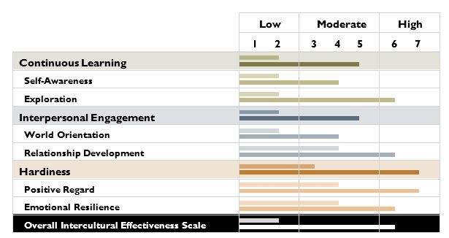

Figure 1: Example of IES scores for a single participant. Scores shown are prior to cross-cultural exposure (top bars) and after (bottom bars) in each of the 3 main competency areas as well as in the two-dimensions measured within area.

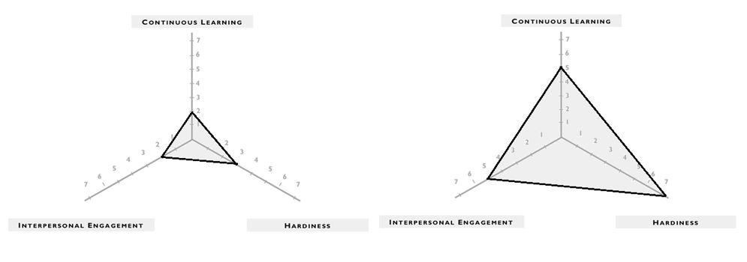

Figure 2(a, b): Example of an IES profile triangle created from the original IES scores (left-hand side of figure) and after cross-cultural exposure (right-hand side). Only the 3 main competency areas are included in the profile triangle. The dimensional measures can be used to create an action plan per individual to improve scores.

Changes in IES scores of all study participants were then compiled and compared using the Related-Samples Wilcoxon Signed Rank Test and Independent Samples Mann-Whitney Test to determine whether cultural competencies increased significantly across the entire cohort. These tests were run comparing participant results from the three IES competency areas as well as the two dimensions related to each area. Tests were completed for student comparison, instructor and, finally, student to instructor comparison. All participants were also asked to voluntarily take part in a 60-minute Zoom interview after the short-term program had ended to discuss their experiences and provide further insight into the study results. Only five of the twenty-three total participants took part in the individual interviews. Two students and three faculty members participated; the interviews were recorded and transcribed for analysis.

Results

Intercultural Effectiveness Scale surveys generated individual scores from 1 to 7 for all participants in the areas of continuous learning, interpersonal engagement and hardiness as well as the dimensions of self-awareness, exploration, world orientation, relationship development, positive regard and emotional resilience. (Figure 1) shows an example of one student’s scores from pre- and post- program surveys, displayed in a horizontal bar graph. This participant shows increases in all cultural competencies and dimensions.

This result is even clearer upon generation of an IES Profile Triangle containing the scores from the three major cultural competencies. The IES Profile Triangle in (Figure 2) with the post-program IES scores is clearly much larger than the profile created with the pre-program scores, indicating this participant experienced significant growth in cultural awareness. Unfortunately, once tests for group significance were run, we found that only about half of the cohort shows positive changes in their IES scores, with some producing lower scores at the end of the short-term study abroad program.

Survey scores were tested for group significance using the Related-Samples Wilcoxon Signed Rank Test and the Independent Samples Mann-Whitney U Test. “The goal of [both tests] is to determine if two or more sets of pairs are different from one another in a statistically significant manner” [16]. These non-parametric tests base conclusions around the null hypothesis that the median of difference between two pairs or groups is equal to zero. In this study, the two pairs or groups refers to pre- and post-IES survey scores of students and faculty members. If the significance of change between the two scores is too low, the null hypothesis must be retained, and results are denoted as inconclusive. Sample evaluations in this study involved student score comparison, faculty score comparison, and student-score to faculty-score comparison. Tests were run in each scenario with either the Wilcoxon and/or Mann-Whitney U Test and repeated using score changes in all three cultural competencies (continuous learning, interpersonal engagement, and hardiness) and their two included dimensions (respectfully, self-awareness and exploration, world orientation and relationship development, and positive regard and emotional resilience). The Wilcoxon Signed Rank Test, or Rank Sum Test, assumes samples are dependent upon one another while the Mann-Whitney U Test assumes independence between the two groups tested. The Mann-Whitney U Test is comparable to the statistical t-test and is used in this study only when calculating score comparisons for the entire group (i.e., student to faculty comparison). We can assume sample dependence when calculating changes in student scores separately from faculty scores rendering the Wilcoxon Test the more appropriate statistical test for these parameters. Both tests calculate the level of significance change in group scores to either reject or retain our null hypothesis. “The shortcut to the hypothesis testing of the Wilcoxon signed rank-test is knowing the critical z-value for a 95% confidence interval (or a 5% level of significance) which is z = 1.96 for a two-tailed test and directionality” [17]. (Figure 3) shows student IES score changes under the continuous learning competency for the Wilcoxon Signed Rank Test. Expected outcomes of this study were that all or most of the participants would increase their cultural competencies. However, there were approximately the same number of positive (8) and negative (10) changes in continuous learning IES scores.

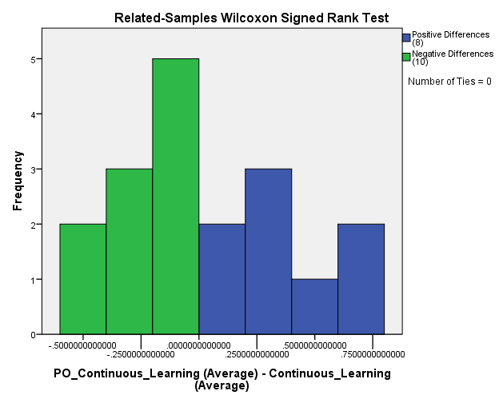

Figure 3: Bar graph of the change in student IES continuous learning scores and the frequency of positive and negative changes calculated with the Wilcoxon Signed Rank Test. This is an example of scores from only a single competency area. Scores from all other competencies and dimensions produced comparable results.

Similar results were found for all student competencies and dimensions and the average of all area scores can be seen in (Figure 4). Overall, 11 participants experienced positive changes in cultural awareness while 7 experienced negative changes. The bar graph in (Figure 5) was created using the data in (Figure 4) to determine overall significance of changes in student IES scores for all three competencies and six dimensions. The asymptomatic significance score of .327 indicates no overall significance is score change for students during the entirety of the shot-term abroad program.

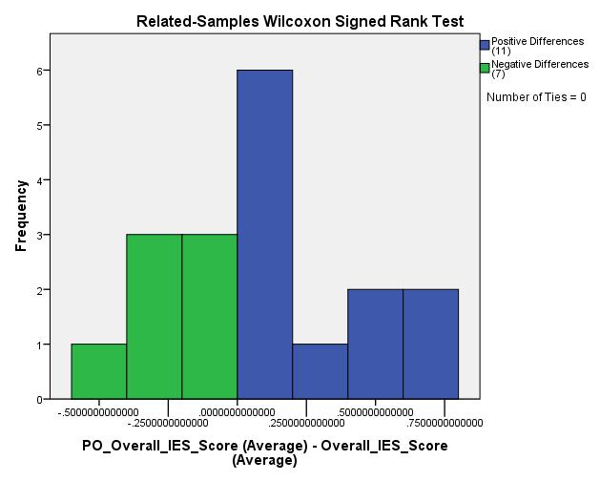

Figure 4: Bar graph of the average change in student IES scores for all competencies and dimensions and the frequency of positive and negative changes calculated with the Wilcoxon Signed Rank Test.

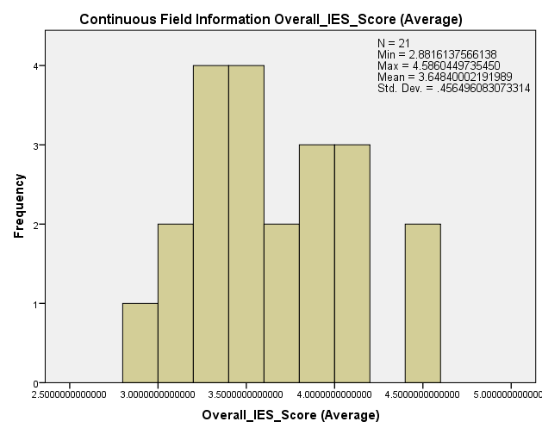

Figure 5: Bar graph of average change in all student IES scores plus calculations from the Wilcoxon Signed Rank Test.

Results for faculty were generated with the Wilcoxon Signed Rank Test using, showing similar results to those of the students. Average faculty scores show three positive and two negative changes and produced an asymptomatic significance score of .225.

Scores comparing all program participants were tested for significant change between student and faculty scores using the Mann-Whitney U Test (because they are two independent groups). (Figure 6) depict this comparison in a split horizontal bar graph and show results of our calculations of significance in score changes. Asymptomatic significance and overall significance were calculated as 1.0 which again is less than a z-value of 1.96 and therefore forces us to retain the null hypothesis that there is no significant change in group scores before and after program completion. The Wilcoxon Signed Rank Test was also run under these conditions for control but as expected, did not indicate significant results. Although some of the participants did experience increased cultural awareness, this result was inconsistent across the entire group of participants.

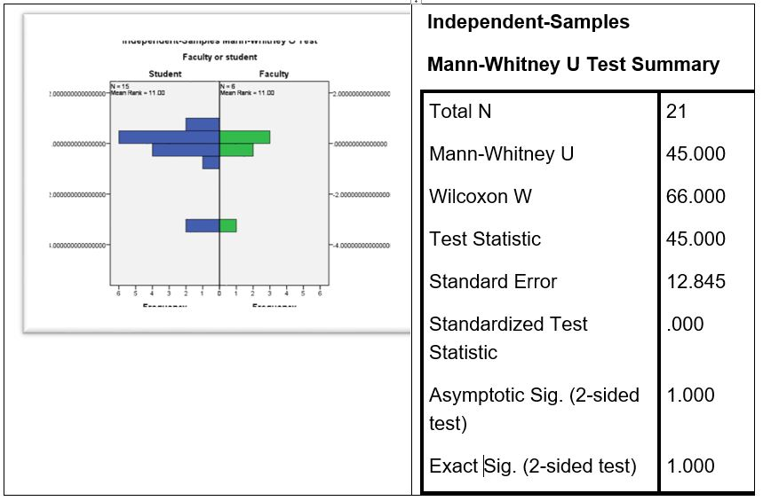

Figure 6: Split horizontal bar graph comparing average changes in all student IES scores to changes in all faculty IES scores plus calculations from the Independent Samples Mann-Whitney U Test.

Discussion

Overall, this short-term study abroad program was extremely successful from an educational perspective. Design of this inter-cultural program allowed for students from unique majors (i.e., nursing, nutrition, business) to participate in the exchange between two countries, the United States of America and South America. Each university included local culture as part of their syllabi to ensure cultural immersion in the classroom. However, each institution had separate syllabi for their respective students, which meant that the three groups of students had completely different homework assignments and resulted in limited immersion inside of the classroom. The inconclusive results shown in this study might be caused by various factors including a small sample size involving twenty-three participants, as well as the lack of consistent structure group activities between students and faculty from all three universities. Participants were required to write a daily blog, but this was likened to busy work by some of the faculty members as opposed to developmental self-reflection. In a successful IES study involving short-term study abroad students in Japan and Korea, the students “were required to complete some extensive readings, internet researching….they were also mandated to keep a daily journal throughout their journey and participated in a 2-hour post-trip meeting and submitted two final projects once they returned” [18]. These requirements ensured that students were continuously reminded of the goal to increase their cross-cultural awareness and results of the study showed increases in intercultural sensitivity. In our study, one participant discussed reflective practices of the program. While they found the faculty reflections successful (they met each day to discuss their experiences), they agreed that structured student reflection was lacking and suggested group round tables and daily reflective practice journals, which have been found to help increase cultural competence in another study [19]. Another participant suggested daily group discussions to help navigate common issues of culture shock, self-identity, language barriers and any negative cross-cultural interactions.

Another potential limitation of this study is the self-report process of the IES surveys. IES results are subjective in nature, where each participant rates their growth and development. Their responses could be impacted by something as seemingly inconsequential as the participant’s mood while taking the survey. For example, one participant saw a decrease in their hardiness competency and both of its included dimensions of positive regard and emotional resilience. During the individual interview, the participant attributed this negative result to the fact that they became medically ill for part of the short-term abroad program. This caused them emotional and psychological fatigue. A similar study provides a potential solution to the subjective nature of the IES survey, suggesting the survey should be taken by both the individual whose cultural awareness growth is being measured and an observer who views the participant’s interactions. “Results may be different if a qualitative study were conducted where [participant and observer] answered questions immediately following [a cross-cultural] interaction” [20-24].

Participants who agreed to interviews did, however, suggest possible program modifications that would aid in cultural immersion and potentially increase overall IES scores. Most of these recommendations involve having participants spend more time together, as an entire cohort, instead of breaking into university-specific groups. By end of the program, students and faculty developed sustainable and lasting relationships, but immediate cross-cultural exposure at time of first in-person interaction and pre-departure meetings would potentially improve cultural awareness since there would have been more opportunities to share each other’s perspectives. To ensure inter-collaboration for members of the program, interviewees suggested Regis College, Johnson & Wales University, and the Universidad de Congreso change syllabi to develop a joint course/classroom for all program participants. Requiring the same readings, class-related activities, and homework assignments would allow for students to connect in an organic manner and ensure they are forming relationships with each other both inside and outside of the classroom. Another idea was to develop activities in community engagement that would include active interaction with both exchange and host students, rather than simply having exchange students assume the shadowing/observation role at health clinics.

A study attempting to increase intercultural effectiveness in students across two countries should consider inclusion of a daily structured, entire group debrief, in addition to smaller group round tables collaborations, and one on one faculty-student discussions. Another aspect that might improve positive changes in cultural awareness growth is through requirement of maintaining a daily reflective journal to encourage and facilitate development. Three pre-departure Zoom meetings took place with all students and faculty members for all participants to “meet” before the program began, but some participants reported that would have liked to know others in the program more intimately (including those from their respective institutions) to increase their comfort and familiarity, increasing openness within the group, to ultimately benefit a cultural exchange. Participants also described wanting additional anticipatory guidance and preparation; a pre-abroad discussion allowing program participants may be helpful to individuals who have never experienced cultural exchange (i.e., dealing with homesickness, eating different foods, and living with someone from a different culture).

Conclusion

Although approximately half of the participants saw increases in IES scores, the study produced inconclusive results in group cultural competency changes. This could be a result of the small sample size, insufficient group interaction inside and outside of the classroom, lack of a structured daily group and individual reflections, or simple error due to the subjectiveness of the IES survey. It is important that program design includes ways in which students and faculty can actively engage in all activities and in the community cultural immersion experiences. A similar study should be repeated with a larger cohort, require group discussions and individual reflective journals, implement a classroom pre-departure meeting (virtual) that includes all program participants, and involves anticipatory guidance for students. Study abroad programs should be routinely evaluated and revised accordingly to ensure that goals are reached, including promotion of positive intercultural interactions and consequently acceptance and understanding of other cultures.

Ethical Considerations

The study was reviewed and approved by the Regis College Institutional Review Board (IRB). All participants were required and signed an informed consent.

Funding

Dr. Godzik’s work is supported by the Health Resources and Services Administration (HRSA) of the U.S. Department of Health and Human Services (HHS) as part of an award T32HP32520 totaling $2,496,422 (2021-2026) with 0 percentage financed with non-governmental sources. The contents are those of the author(s) and do not necessarily represent the official views of, nor an endorsement, by HRSA, HHS or the U.S. Government.

References

- Rodriguez C, Parks R, Parrish J (2018) Authentic Engagement: Deepening Students’ Experience in Short-Term Study Abroad Programs. College and University 93: 24-38.
- O'Donnell, O'Brien C, Markey B, et al. (2022) Transatlantic Collaborations: Baccalaureate Nursing Students’ Experiences of Participating in a Semester-Long Study Abroad Program. Nursing Education Perspectives 43: 357-362.
- Alissa R, Brewis, Alexandra, et al. (2018) Long-Term Benefits of Short-Term Research-Integrated Study Abroad. Journal of Studies in International Education 23: 102831531878644.
- Whatley M, Canché MSG, Robust A (2022) Estimation of the Relationship Between Study Abroad and Academic Outcomes among Community College Students. Res High Educ 63: 271-308.
- Nghia TLH (2019) Motivations for Studying Abroad and Immigration Intentions: The Case of Vietnamese Students. Journal of International Students 9: 758-776.
- Johnstone, Christopher, Edwards, et al. (2019) Accommodations, Accessibility, and Culture: Increasing Access to Study Abroad for Students with Disabilities. Journal of Studies in International Education 24: 102831531984234.
- Soria, Krista M, Weiner, et al. (2014) "Financial Decisions among Undergraduate Students from Low-Income and Working-Class Social Class Backgrounds, "Journal of Student Financial Aid.
- Kent-Wilkinson A, Leurer MD, Luimes J, et al. (2015) Studying abroad: Exploring factors influencing nursing students’ decisions to apply for clinical placements in international settings, Nurse Education Today 35: 941-947.
- Mkandawire-Valhmu L, Doering J (2012) Study Abroad as a Tool for Promoting Cultural Safety in Nursing Education. Journal of Transcultural Nursing 23: 82-89.
- Whatley M, Landon AC, Tarrant MA, et al. (2021) Program Design and the Development of Students’ Global Perspectives in Faculty-Led Short-Term Study Abroad. Journal of Studies in International Education 25: 301-318.
- Mahmoudm RM, Schuessler J (2017) Caring and Cultural Diversity Behaviors of U.S. Nursing Students on A Study Abroad Program. Journal of Nursing Practice Applications & Reviews of Research 7: 29-39.
- Take H, Shoraku A (2018) Universities’ Expectations for Study-Abroad Programs Fostering Internationalization: Educational Policies. Journal of Studies in International Education 22: 37-52.
- Shadowen NL, Chieffo LP, Guerra NG (2015) The Global Engagement Measurement Scale (GEMS): A New Scale for Assessing the Impact of Education Abroad and Campus Internationalization. Frontiers: The Interdisciplinary Journal of Study Abroad 26: 231-247.
- Richards CA, Doorenbos AZ (2016) Intercultural competency development of health professions students during study abroad in India. J Nurs Educ Pract 6: 89-98.
- Yilmaz M, Sari HY, Daghan S (2020) An exploratory study of intercultural effectiveness scale in nursing students, Heliyon 17: e02769
- Sidney S (1956) Non-parametric statistics for the behavioral sciences. New York: McGraw-Hill 75-83.
- Kerby, Dave S (2014) The simple difference formula: An approach to teaching nonparametric correlation. Comprehensive Psychology 3: 11.
- Lee J, Negrelli K (2018) Cultural Identification, Acculturation, and Academic Experience Abroad: A Case of a Joint Faculty-Led Short-Term Study Abroad Program. Journal of International Students 8: 1152-1172.
- Markey K, Okantey C (2019) Nurturing cultural competence in nurse education through a values-based learning approach, Nurse Education in Practice 38: 153-156.
- Portalla, Tamra, Guo-Ming Chen (2010) The development and validation of the intercultural effectiveness scale. Intercultural Communication Studies 19: 21-37.
- Bates A, Rehal DA (2017) Utilizing the Intercultural Effectiveness Scale (IES) to Enhance International Student Travel. International Research & Review: Journal of the Phi Beta Delta Honor Society for International Scholars 7: 44-53.
- Mann, Henry B, Whitney, et al. (1947) On a Test of Whether one of Two Random Variables is Stochastically Larger than the Other. Annals of Mathematical Statistics 18: 50-60. .
- Nguyen A (2017) Intercultural Competence in Short-Term Study Abroad. Frontiers: The Interdisciplinary Journal of Study Abroad 29: 109-127.
- Wilcoxon, Frank (1945) Individual comparisons by ranking methods. Biometrics Bulletin 1: 80-83.

