Review Article

The Effect of an Educational Program on Nurse Knowledge of Wound Care and Application to Practice in the Outpatient setting A Quality Improvement Project

Lu Ann Reed, DNP, MSN, CRRN, BC-RN, LNHA, WCC, DWC#, Donna Green, PhD, MSN, RN, C-EFM, Deborah Schwyzter, DNP, MSN, RN

#College of Nursing, University of Cincinnati, Cincinnati, Ohio, USA

#Corresponding author: Lu Ann Reed, DNP, MSN, CRRN, BC-RN, LNHA, WCC, DWC, Assistant Professor, College of Nursing, University of Cincinnati, 3110 Vine Street, Procter Hall, Cincinnati, Ohio 45219-2068, USA

How to cite this article: Reed L, et al. (2023) The Effect of an Educational Program on Nurse Knowledge of Wound Care and Application to Practice in the Outpatient setting A Quality Improvement Project. Int J Nurs & Healt Car Scie 03(04): 2023-204.

Submission Date: 06 February, 2023; Accepted Date: 14 February, 2023; Published Online: 20 February, 2023

Abstract

Purpose: To test the effectiveness of an educational intervention program on nursing assessment performance and documentation of diabetic foot and venous leg ulcers.
Participants and Setting: Nurses (n=9) employed at two Midwestern, suburban, community hospitals with outpatient, wound-healing centers were invited to join the study.
Approach: The combination of the Donabedian theory and PDCA provided the basis to identify quality issues and development of an educational plan.
Outcomes: There were statistically significant increases in knowledge level in knowledge and performance in assessment and documentation.
Implications for Practice: Nurses’ knowledge of diabetic foot ulcers and vascular leg ulcers increase with education. Approach to evaluation and education can be applied to other Nursing topics.

Keywords: Assessment; Comprehensive foot exams; Conceptual framework; Diabetic foot ulcers; Evidence-based education program; Healthcare quality; Leg ulcers; Quality Payment Program; Venous disease

Introduction

Background & Significance

Chronic lower-extremity wounds, which include diabetic foot ulcers and venous stasis ulcers, are responsible for $7 billion per year in annual health-care costs worldwide [1]. The prevalence of venous leg ulcers in individuals 65 and older is as high as 1 to 2% of the United States population (492,000 to 984,000 individuals). With an average cost of $16000 per treatment this results in billions of dollars spent on this wound condition alone [1]. Additionally, Diabetes Mellitus (DM) and diabetic foot ulcers are an escalating health concern within the population. The rates of patients with DM were estimated at 285 million in 2010 and are projected to exceed 360 million people at risk for or with a chronic wound by 2030. Based on these estimates, an approximate 15% of patients (or 54 million people) with DM will suffer from a diabetic foot ulcer during their lifetime [2,3].

Venous leg and diabetic foot ulcers are the most prevalent of the conditions that are classified as chronic wounds and require specific care to promote optimal outcomes. Chronic wound care is defined as “care of wounds that are difficult to heal or have complicated healing cycles either because of the nature of the wound itself or because of complicating metabolic and/or physiological factors [4,5].”

Evidence-based care aims to provide the most effective care that is available with the goal of improving patient outcomes [6]. Guidelines have been developed to reduce the risk of foot ulceration both and nationally [10,11]. And internationally [9]. Wound care nurses can provide a vital service in implementing guidelines to identify the high-risk condition and prevent the occurrence of foot ulcers and other complications.

Meeting the healing needs of the population of patients with chronic-wound conditions requires the wound-care nurse to accurately assess, intervene, and communicate evidence-based wound-care practices. Managing wounds successfully requires a comprehensive, accurate patient evaluation, assessment, and documentation in the health record.

In the specialty area of wound-care nursing, educational deficits can result in missed care where there is a failure to recognize early signs of infection or wound deterioration. These missed care occurrences can result in patients needing additional and costly treatments, antibiotics, or readmission to the hospital for inpatient treatments. To minimize missed care occurrences, it is essential that qualified wound-care nurses have adequate knowledge related to best practices in chronic wound care and that they integrate this knowledge accurately into all aspects of the patient-management process, including documentation in the Electronic Health Record (EHR). To achieve this level of patient care and documentation, the wound-care nurse must be knowledgeable about common wound types (i.e., venous stasis ulcers and diabetic foot ulcers) and their typical and atypical characteristics. These actions will lead to the identification of the correct treatment guidelines and appropriate interventions to optimize healing outcomes for the patient.

Review of the Literature

A comprehensive literature review of wound care, nursing competence, and educational interventions was conducted. Qualitative and quantitative research, discussion articles, literature reviews, and reports related to lower extremity wound care and nursing competency were reviewed. The research was conducted through CINAHL, Pubmed, and Scopus. Keywords included leg ulcers, venous disease, diabetic foot ulcers, comprehensive foot exams, assessment, quality payment program, healthcare quality, evidence-based education program, and conceptual frameworks. Articles meeting inclusion criteria were peer-reviewed, available in full-text, and published in English. Articles published prior to 2012 were excluded. The exceptions were articles that the authors consider to be sentinel contributions.

Wound management encompasses all elements of wound care, including assessments, treatments, and documentation. Furthermore, wound management includes the control of complications during the healing process and the management of the patient's comorbid conditions. These conditions frequently include management of sepsis, infection, disturbance of bodily function, dietary and nutritional issues, and procedures directly related to wound management [5]. Chronic wound care further embodies the promotion of comfort and dignity, the relief of suffering, and the improvement of quality of life [5]. Nurse-knowledge deficits in wound-care management have been associated with poor patient outcomes such as infection, tissue necrosis, gangrene, periwound dermatitis, periwound edema, osteomyelitis, hematomas, dehiscence, and even death [7-9]. In their literature review, Ylonen, Stolt, Leino-Kilpi, & Suhonen [10] identified that gaps in knowledge about the integration of evidence-based practice for the nursing care provided to patients with diabetic foot ulcers or venous stasis ulcers have a significant impact on the progression of wound healing and overall patient quality of life. This overall finding indicates a need for ongoing educational programs for nurses in the wound-care practice setting.

Purpose of the Quality Improvement Project

Literature identified gaps in knowledge have an impact of the quality of care, it is expected that an education-based intervention would work to address that problem. To address the problem, this quality improvement project examined the effect of chronic-wound education and documentation training on nurse knowledge of wound-care content, self-assessment of knowledge, and EHR documentation practices. The PICOT question for this project asks:

Among outpatient wound care nurses, does formal education on diabetic foot ulcer and venous stasis ulcer standards of patient care impact nurse knowledge and application to documentation practices across three months?

The goals of this multisite project were 3-fold: to increase the knowledge of the nurses regarding diabetic and vascular wound assessment, increase the accuracy of the documentation of the assessments and introduce national guidelines.

Approach

The setting for this Quality Improvement (QI) project was wound-healing centers at two Midwestern, suburban, community hospitals. The population focus for this quality improvement project study was Registered Nurses (RN) and Licensed Practical Nurses (LPN) practicing in the identified outpatient wound-care centers (Phase I: n= 9, and in Phases II and III: n=9). There were no exclusion criteria. This study was unfunded and therefore study participants were not compensated. Participation in this project was identified as voluntary and was not related to the assessment of individual workplace performance. The organization's management was not notified of the individual's participation within the project and was not informed of the participant's performance. The sample size was limited by the number of nurses working at the facilities. The University of Cincinnati Institutional Review Board granted the project exempt status on July 19, 2018, and the Mercy Health Institutional Review Board granted the project exempt status on July 26, 2018. Written permission was obtained from studied institutions. The author would like to acknowledge the cooperation of the nursing staff of the facilities. The study purpose and method was explained to the eligible nurses and their informed consent was obtained.

All data obtained during this study was de-identified with a participant number, was coded, and was stored in a locked cabinet in a locked office. The Primary Investigator (PI) maintained the list for the duration of the project and shredded it upon completion.

Implementation Model & Theory Application

The quality improvement model identified to guide this project was the Donabedian Model of Structure, Process, and Outcome approaches [11-13]. The Donabedian Model has been used in the practice areas of evaluation and examination of comprehensive wound care and documentation programs via a learning management system [14].

In this project, the structure had three parts. The facilities or setting part of the structure used in this project were two Midwestern, suburban, community hospitals with wound healing centers. Annually, these facilities treat approximately 1800 newly diagnosed lower-extremity wounds. The second part of the structure consisted of the material resources of equipment and dressing supplies. The structure’s third part included human resources (the number of and qualifications of the professionals, including their education, training, and experience).

Treatment was provided by approximately nine nurses that the facilities employed. Treatments were based on evidence-based standards of care [15-18]. The Donabedian Model defines the process measures as the things that are involved in the giving and receiving of care and includes both patients’ and health care professionals’ activities related to diabetic foot ulcers and venous stasis leg ulcers and treatment measures. The majority of the quality measures used for public reporting are process measures. These reporting measures include but are not limited to control of hemoglobin A1c, screening for tobacco use, assessing appropriate footwear in diabetic patients, wound measurements, and wound-healing percentage. These outcome measures are used to evaluate and reflect the impact of wound-care center interventions on patient health outcomes.

The Donabedian Model examines the problems and outcomes but does not address interventions that are necessary to make changes to the three approaches. The Plan, Do, Study, and Act (PDSA) model was used. The PDSA cycle for testing a change by developing the plan to test the change (Plan), carrying out the test (Do), observing and learning from the consequences (Study), and determining what modifications should be made to the test (Act).¹⁹ In this project, the plan was complete needs assessment and the nurse’s learning preferences. The project was carried out by the PI. After collecting the data, modifications will be made and rolled out to remaining wound-care centers in the system. The Standards for Quality Improvement Reporting Excellence (SQUIRE) V.2.0 [20] were used to ensure completeness of reporting this Quality Improvement (QI) work.

Program Implementation

The educational program was developed in alignment with evidence-based practice guidelines for vascular and diabetic foot-ulcer care. The leadership of the facility reviewed the plan for alignment with policies and practice of the wound healing centers. This education program was delivered as part of a planned nurse-education day for wound-center employees. A pre-intervention/post-intervention design was used to evaluate outcomes of this QI project related to nurse knowledge and documentation application in the EHR. The education project was implemented across six months in three phases.

During the Phase I of this project, a letter explaining this QI project, invitation to participate, and informed consent form was emailed to all nurses employed by the project sites. Only those nurses who agreed to participate in this project received the evaluation tools for completion during this project. Nurses who agreed to participate in this project were provided with a web-based platform link to access and complete the Knowledge Self-Assessment: Chronic Wounds & Clinical Practice Survey based on Benner's Novice to Expert theory [21] (Figure 1). As part of the pretest, nurses were asked to rate their current knowledge in assessing diabetic-foot and vascular lower-extremity wound patients, performing specific skills and documentation of assessment findings in the electronic health record. Part three of Phase I was to determine which learning modalities were deemed most useful by nursing staff during the intervention. As part of the pre-test, preference questions were posed addressing which learning modalities would be most helpful for study participants in the acquisition of knowledge.

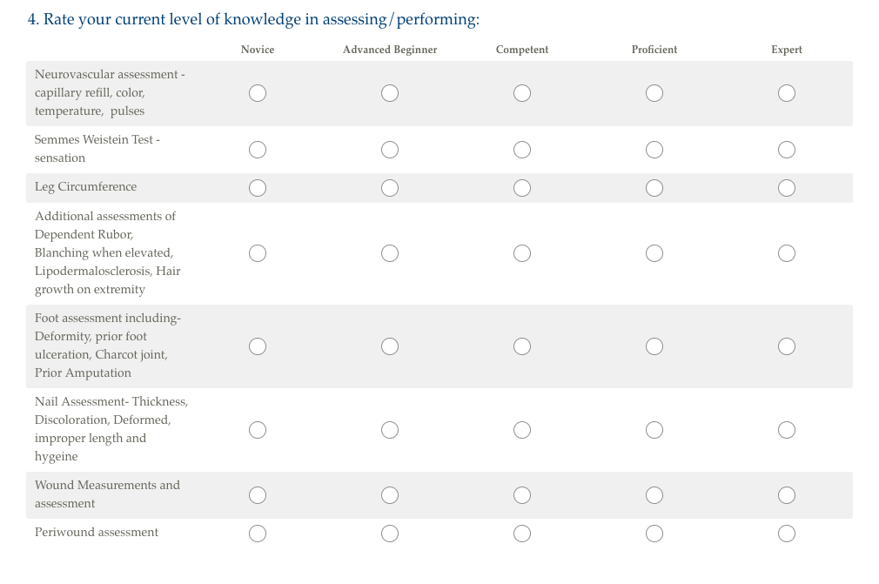

Figure 1: Chronic Wounds & Clinical Practice Survey based on Benner's Novice to Expert theory.

Phase II of this project occurred at the time of the scheduled nurse-education and training day. The education program was provided to wound-care nurses to support best practices and staff development. Prior to the start of the education program, nurse participants were given the pre-test on vascular ulcers and diabetic foot ulcers (Figure 2), developed from the evidence-based resources available to the nurses and evidence-based practice standards [15-18]. This pre-test was delivered in paper format and took participants approximately 10 minutes to complete. The delivery of the formal education program immediately followed. The structured education program for this project was part of a six-hour, scheduled-education day for the wound-care nurses. The program included the following components: delivery of education via lecture format on the content areas of statistics, assessment, and documentation of vascular ulcers, diabetic foot ulcers and wound care [15-18], application of a wound-care case study to the EHR practice environment, and utilization of the documentation audit (Figure 3). After this experiential-based, formal education program, the participants completed post-test 1 (Figure 2) and documentation re-evaluation to assess nurse content-knowledge recall and performance immediately following the program.

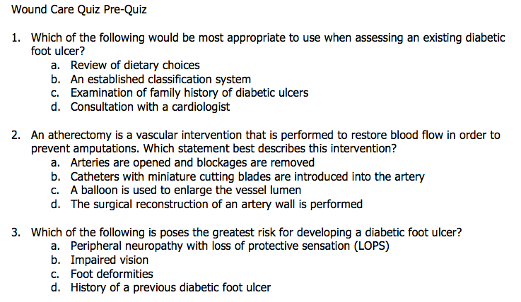

Figure 2: Wound care quiz pre-quiz.

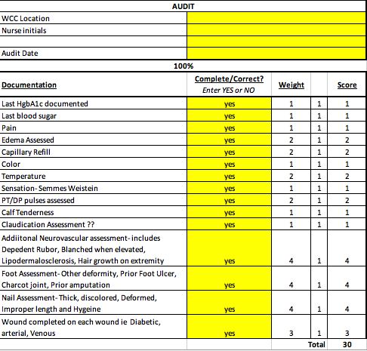

Figure 3: Application of a wound-care case study to the EHR practice environment, and utilization of the documentation audit.

Phase III occurred approximately three months following the delivery of the formal education program. The PI met 1:1 with each participant for follow-up evaluation. Post-test 2 (Figure 2) was given at this time along with participant assessment demonstration and assessment of EHR documentation practices, utilizing the simulated EHR. The case study from Phase II in the simulated EHR was used for documentation demonstration and took approximately 10 minutes per nurse participant to complete.

Analysis of Results

Data was coded, securely stored, and entered in a password protected Excel spreadsheet. All data was double-checked for accuracy prior to the conduction of any statistical analysis. Missing data, patterns, and extreme observations were analyzed. Descriptive statistics of means, percentages, and ranges were run on all variables. A paired t-test was conducted to evaluate if the difference between pre-intervention and post-intervention scores were statistically significant. The level of significance for the analysis was p <0.05.

Outcomes

The objective of part one and two of Phase I was to determine the learning needs of the nurses. Skills that were scored as a novice, advanced beginner, or competent were included in the educational intervention (Figure 4). Documenting the assessment components that nurses identified as a novice, advanced beginner, or competent were included in the educational intervention (Figure 5). The participants rated the skills lab as their preferred learning modality. Twenty-four percent of the participants found it the most useful. Twenty-three percent of the participants rated the CE offering as the most useful. Nineteen percent rated the self-study module as the most useful. All participants rated the journal club, didactic lecture, and education posters as least useful (Figure 6).

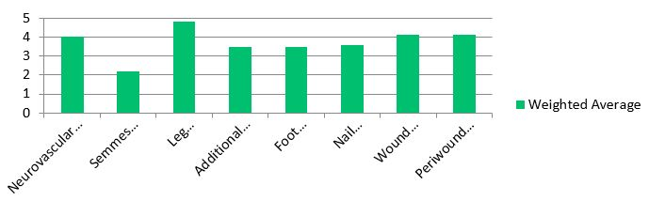

Figure 4: Rate your current level of knowledge in assessing/performing.

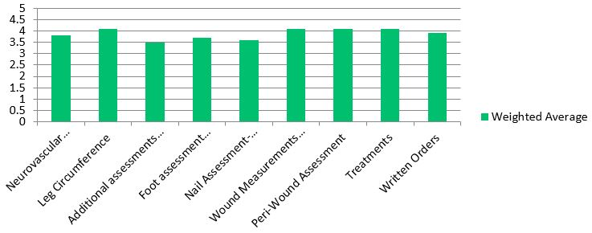

Figure 5: Rate your current level of knowledge in documenting in HER.

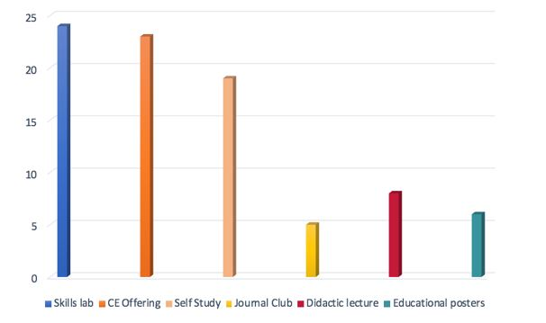

Figure 6: Knowledge self-assessment: chronic wounds & clinical practice survey.

The first objective of Phase II and III of this project was to determine whether the educational intervention had a statistically significant effect on nursing knowledge over time. The findings of the data analysis were not statistically significant for improvement over time (p=<0.05). Paired t-tests were used to determine significance. The mean knowledge test score on the pre-test was 80 percentage points with a range of 70 to 90. The knowledge test score on the post-test was 100 percentage points. A 20-point increase on average from pre-intervention to post-intervention was observed (Figure 7). A paired t-test was conducted to test if this increase was statistically different from 0 and resulted in a p-value of 0.0001, which meant there is statistical evidence to conclude that the intervention would increase scores. A three-month follow-up quiz was given to test retention of the intervention material. All subjects scored the same (100%) as they had three months prior.

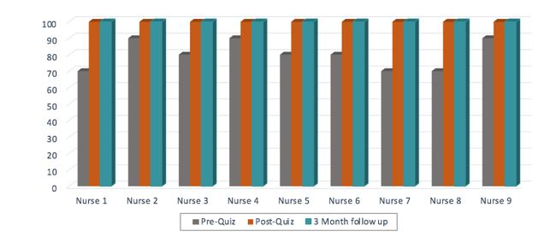

Figure 7: Program evaluation pre/post test.

The second objective of Phase II and III of the project was to determine whether the educational intervention had a statistically significant effect on nursing documentation performance over time. The mean performance score on the pre-test was 14 percentage points. The mean performance score on the post-test was 29 percentage points with a range of 28 to 30. Paired t-tests were utilized to determine significance. The findings of the data analysis were not statistically significant for improvement over time (p=<0.05).

From pre-intervention to post-intervention, a raw increase of 15 points (p-value<0.001) on average was observed, which corresponded to a 107% increase (Figure 8). The organizations have continued to monitor performance with random monthly documentation audits on new patients.

Figure 8: Program evaluation documentation audit.

Discussion

This quality improvement project reinforced the findings from Aalaa, Malazy, Sanjari, Peimani, Mohajeri-Tehrani [3] study on the nurse’s role in diabetic foot care. The authors offer that improving the quality of nurses’ clinical performance can lead to improvement in the patient. This project also identified the same gaps in knowledge about the integration of evidence-based practice for the nursing care provided to patients with diabetic foot ulcers or venous stasis ulcers that Ylonen, Stolt, Leino-Kilpi, & Suhonen [10] identified.

Strengths of the project included the use of a variety of teaching methods: lecture, CE, and 1:1 training to cater to a range of learning styles and availability of the nurses. In addition, the 1:1 portion of the educational intervention provided each nurse with an opportunity to practice assessment and documentation techniques with the PI in a safe environment before applying the newly learned techniques to patient care. The design provides opportunities to expand the project or apply the principles to the wound-care facilities in the health system. This type of intervention can also be replicated easily and deployed in a variety of settings. There were some limitations inherent to a project focused on nursing education in two settings. One such weakness was the small sample size. The number of nursing staff participants available from the two target facilities limited the sample size, and such a small number threatens the validity of the study. The second limitation was the conversion of the didactic lecture to 1:1 training. This format of the program made it time-consuming and resource-dependent.

The implementation of evidence into practice has far-reaching benefits for patients and nurses. While this project's findings cannot be generalized, the results are indicative of the possibility of value-added learning. Research has supported the value of the educational methodology in nurse education with implications for high-quality, evidence-based, effective nursing education. Some suggestions, such as offering educational sessions at a variety of times and using a variety of teaching methodologies, require little more than creativity. However, some changes, such as the implementation of skills labs as a teaching modality, require financial and human resources. The described training project as well as additional wound care related topics were expanded to include other wound-healing centers in the Midwestern, suburban, community hospital system. Furthermore, the prospective advantages of insurance reimbursement that regulatory compliance enhances and the empowerment of nursing staff are far-reaching. The precedence of evidence-based practice and the involvement of nursing staff in this type of quality improvement project has the potential to impact patients and nurses positively. While not quantitative immediately following the completion of this project the wound care nurses identified a patient with decreased circulation and sensation (symptoms discussed in class) and encouraged patient to see vascular surgeon. This prompt action prevented the patient from amputation of their leg and maintenance of quality of life.

Conclusion

The shift toward improvements in the quality of care and the enhanced awareness of the devastating impact of the diabetic foot and vascular lower-extremity ulcers necessitated improved clinical nursing education. Such educational interventions must be well-planned, must be marketed to nursing staff deliberately, must be implemented carefully and, most importantly, must be theory-guided. High-quality, effective clinical nursing education is imperative to ensure that optimal patient outcomes are achieved. The results of this study show that it is possible to increase nurses’ knowledge levels using material that is readily available. The findings of this study can be applied to other nursing education topics. The findings also show that it is possible to increase nurses’ knowledge levels about diabetic foot ulcer and vascular leg ulcers nursing care with education. Nurses have been shown to have knowledge gaps in diabetic foot ulcer and vascular leg ulcers nursing care, and with training such as this, it is possible to bridge this gap. As new nurses come into the wound care centers, an evaluation of their baseline knowledge needs to be completed in order to individualize their orientation.

Key Points

Educational interventions must be well planned, deliberately marketed to nursing staff, carefully implemented and most importantly, theory-guided.
The design of this project provides opportunities to expand the project or apply the principles to other wound-care facilities in the health system.
The author developed a competency-based training that included diabetic foot and vascular wound assessment and documentation education.
More research is needed to evaluate optimal competency-based education.

Author Note

There are no known conflicts of interest associated with this manuscript, and there has been no financial support for this work that could have influenced its outcome.

References

- Nussbaum SR, Carter MJ, Fife CE, et al. (2018) An economic evaluation of the impact, cost, and medicare policy implications of chronic nonhealing wounds. Value in Health 21: 27-32.
- Armstrong DG, Boulton AJM, Bus SA (2017) Diabetic Foot Ulcer and Their Recurrence. The New England Journal of Medicine 376: 2367-2375.
- Aalaa M, Malazy O, Sanjari M, et al. (2012) Nurses’ Role in diabetic foot prevention and care; a review. Journal of Diabetes & Metabolic Disorders 11.
- Holloway S, Harding K, Stechmille J, et al. (2016) Wound Care essentials Baranowski S., Ayello E. Editors, Wolters Kluwer, Philadelphia, PA.
- Wo K, Van Den Kerkof E, Jimenez C (2016) Quality of Life and Chronic Wound Care Wound Care Essentials. Baranoski S, Ayello E (Editors) Wolters Kluwer, Philadelphia, PA.
- Stevens KR (2013) The impact of evidence-based practice in nursing and the next big ideas. Online journal of issues in nursing 18: 4.
- Beeckman D, Defloor T, Demarré L, et al. (2010) Pressure ulcers: Development and psychometric evaluation of the attitude towards pressure ulcer prevention instrument (APuP) 47: 1432-1441.
- Granick M, Long C (2004) Outcome assessment of an inhospital cross-functional wound care team. Plastic Reconstructive Surgery 113: 671-672.
- Esan DT, Fasoro AA, Ojo EF, et al. (2018) A descriptive, cross-sectional study to assess pressure ulcer knowledge and pressure ulcer prevention attitudes of nurses in a tertiary health institution in nigeria. OSTOMY WOUND MANAGEMENT 64: 24-28.
- Ylönen M, Viljamaa J, Isoaho H, et al. (2017) Internet‐based learning programme to increase nurses’ knowledge level about venous leg ulcer care in home health care. Journal of Clinical Nursing 26: 3646-3657.
- Ayanian JZ, Markel H (2016) Donabedian's lasting framework for health care quality. The New England journal of medicine 21: 205-207.
- Gardner G, Gardner A, O'Connell J (2014) Using the donabedian framework to examine the quality and safety of nursing service innovation. Journal of Clinical Nursing 23: 145-155.
- Donabedian A (2005) Evaluating the Quality of Medical Care. The Milbank Quarterly 83: 691-729.
- Ellman C, Garner L (2012) Assessing Knowledge Retention, Quality Patient Outcomes, and Empowerment of Nurses in Wound Care and Documentation via the Use of a Learning Management System. Poster session presented at the Symposium on Advances in Skin & Wound Care. Atlanta, GA.
Wound, Ostomy and Continence Nurses. Venous, arterial and neuropathic lower extremity wounds: Clinical resource guide. Mt Laurel, NJ: Wound, Ostomy and Continence Nurses.
- O’Donnell TF, Passman MA, Marston WA, et al. (2014) Management of venous leg ulcers: Clinical practice guidelines of the society for vascular surgery® and the american venous forum. Journal of Vascular Surgery 60: 59S.
Holt P (2013) Assessment and management of patients with diabetic foot ulcers. Nursing standard (Royal College of Nursing 27: 49.
- van Netten JJ, Price PE, Lavery LA, et al. (2016) Prevention of foot ulcers in the at-risk patient with diabetes: A systematic review. Diabetes/metabolism research and reviews 32: 84-98.
- Taylor MJ, McNicholas C, Nicolay C, et al. (2014) Systematic review of the application of the plan–do–study–act method to improve quality in healthcare. BMJ Quality & Safety 23: 290-298.
- Goodman D, Ogrinc G, Davies L, et al. (2016) Explanation and elaboration of the SQUIRE (Standards for Quality Improvement Reporting Excellence) guidelines, V.2.0: Examples of SQUIRE elements in the healthcare improvement literature. BMJ Quality & Safety 25: E7.
- Benner PE (2001) From novice to expert: Excellence and power in clinical nursing practice. Commemorative ed. Upper Saddle River, N.J: Prentice Hall.

