Case Report

Case Report: Wellens Syndrome - Preventing Myocardial Infarction through Urgent Cardiac Catheterization in Seemingly Low-Risk Patients

Madhuri P. Rao, MD#, Iman Ali, MD

#Department of Family Medicine, Cambridge Health Alliance, Malden, Massachusetts, USA

#Corresponding authors: Madhuri P. Rao, MD, Department of Family Medicine, Cambridge Health Alliance, 195 Canal St, Malden, Massachusetts 02148, USA

How to cite this article: Rao MP and Ali I (2023) Case Report: Wellens Syndrome - Preventing Myocardial Infarction through Urgent Cardiac Catheterization in Seemingly Low-Risk Patients. Int J Comm & Publ Healt 03(02): 2023-108.

Submission Date: 19 August, 2023; Accepted Date: 07 September, 2023; Published Online: 13 September, 2023

Abstract

Wellens syndrome is a clinical syndrome which predicts critical stenosis of the left anterior descending artery with high specificity. The syndrome presents as biphasic or deeply inverted T-waves on electrocardiogram (ECG) in the precordial leads in a patient with normal to mildly elevated cardiac enzymes and no corresponding chest pain. In this report, we describe two cases of Wellens syndrome in otherwise young and healthy individuals who presented to a community hospital. Recognition of this syndrome by primary care and emergency physicians should prompt immediate referral for cardiac catheterization and can prevent devastating events in patients, especially those with seemingly low risk for acute coronary syndrome.

Keywords: Acute coronary syndrome; Case report; Chest pain; Wellens syndrome

Introduction

Wellens sign is characterized by electrocardiogram (ECG) findings of deeply inverted or biphasic T waves in the precordial leads without signs of acute or prior myocardial infarction. This clinical syndrome is specific for critical stenosis of the proximal left anterior descending artery (LAD). This was first described in a retrospective study in 1989 [1]. Wellens syndrome is a crucial and life-saving diagnosis as it suggests impending anterior wall myocardial infarction [2]. Wellens Type-A presents as biphasic T-waves in V2 and V3 (positive, then negative) occurring in 25% of cases; this has a specificity of 99% for LAD stenosis [3]. Wellens Type-B presents as deeply inverted T-waves in V2 and V3 occurring in 75% of cases; this has a 97% specificity for LAD stenosis [3]. These changes may also involve other precordial leads (V1, V4, V5, V6) and may present as a spectrum [4]. A patient presenting with Wellens sign is generally chest-pain free while the ECG is captured and often reports anginal or atypical chest pain that occurred prior to presentation. While the patient is actively having chest pain, the ECG may appear normal. Cardiac enzymes are generally normal or very mildly elevated [2].

This syndrome is often considered rare; however, it was recognized in 18% of patients with unstable angina (up to 60% after 24 hours) in original study [1]. This report describes two cases, occurring about 6 weeks apart at our institution, in which Wellens syndrome presented in two young and otherwise healthy individuals without apparent cardiac risk factors. Our goal in writing this case report is to emphasize the importance of primary care and emergency department physicians being able to recognize this syndrome, particularly when a patient otherwise seems low risk. Prompt recognition and referral for intervention may prevent life-threatening cardiac events.

Case 1: 36-Year-Old Male
Chief Concern: Shoulder Pain

This patient, a 36-year-old male without a history of cardiac problems, presented to a family medicine office for evaluation of shoulder pain. Three days prior to his presentation, he had experienced sudden onset shoulder pain performing manual labor at work. His pain at the time of onset radiated into his chest and down the left arm accompanied by one episode of emesis. He denied any preceding exertional chest pain up. He was concerned for a shoulder injury which prompted him to make an appointment with primary care. At the time of the visit, he was no longer having pain. His family history was significant for a father who died of a heart attack in his 50s. He was otherwise very physically active and reported very occasional tobacco use. Physical exam revealed right-sided shoulder impingement. Given the atypical presentation for shoulder pain, an ECG was obtained, which showed biphasic T-wave inversions with positivity then negativity in V2, V3, and V4 (Figure 1).

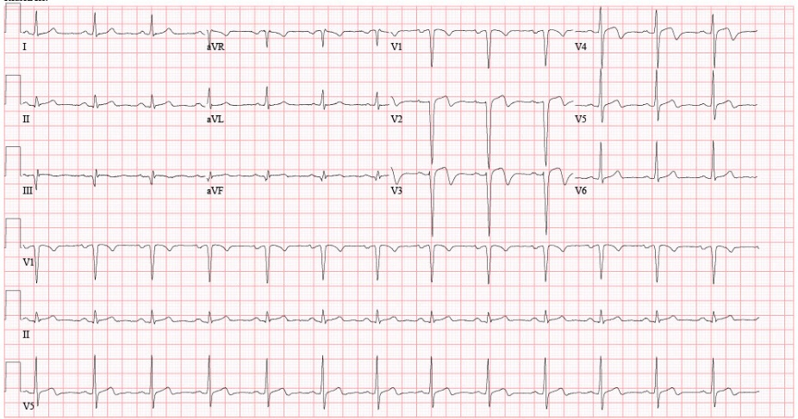

Figure 1: ECG of the 36-year-old male with biphasic T-waves in V2, V3, and V4 consistent with Wellens sign.

Suspecting LAD artery stenosis based on these findings, the patient was referred to a local hospital emergency department for further evaluation. On further work-up, the patient had normal cardiac enzymes and no classic anginal pain. The patient was admitted to “rule out” acute coronary syndrome.

On admission, an echocardiogram showed a left ventricular ejection fraction of 35%. The conclusion was made that a myocardial infarction had already occurred, and the patient was therefore out of the window for acute percutaneous intervention. While admitted, however, the patient complained of chest discomfort with worsening T-wave inversion in the same precordial leads as seen during admission. Heparin was started and the patient was transferred to a tertiary care center for catheterization due to the worsening ECG changes.

At the tertiary care center, this patient underwent a cardiac catheterization which showed 99% stenosis in the proximal segment of the LAD, in addition to disease in two other vessels (60% stenosis of right coronary artery, 80% stenosis of 1st obtuse marginal artery). This patient underwent a quadruple coronary artery bypass graft at the tertiary care center prior to discharge. He is continuing to recover after his surgery while exhibiting decreased exertional tolerance due his myocardial infarction.

Case 2: 44-Year-Old Male

Chief Concern: Chest Pain

This second patient was seen approximately six weeks after the first patient as an admission request to the same local hospital for chest pain. He was a healthy 44-year-old male in his with no significant medical history. He presented to the emergency department for chest pain that had awoken him twice from sleep and caused weakness in his left arm following two weeks of intermittent chest pressure occasionally associated with dyspnea, exacerbated when lifting heavy objects and was relieved with rest. He had no known cardiac risk factors (hypertension, diabetes, lipid disorders). He was not taking any medications at the time of presentation and had no family history of heart disease. He reported no drug, alcohol, nor tobacco use. Physical examination at the time was normal. Cardiac enzymes were normal, but ECG from the emergency department showed a biphasic T-wave inversion in V2 and deep T-wave inversions in V3 and V4 (Figure 2). The emergency department requested admission for “rule-out” of acute coronary syndrome.

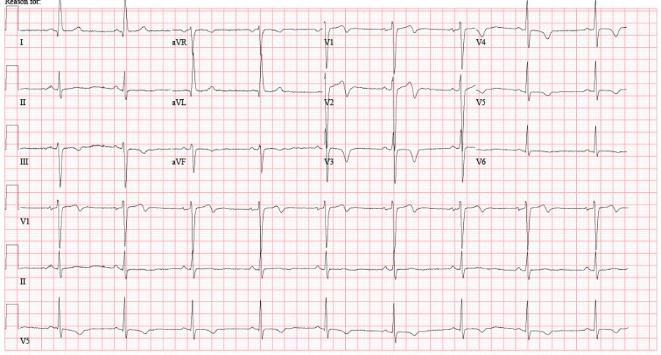

Figure 2: ECG of the 44-year-old male with biphasic T-wave in V2 and deep T-wave inversions in other precordial leads consistent with Wellens sign.

Out of concern for an impending myocardial infarction, the authors decided that this patient would need urgent catheterization and recommended that the patient be directly transferred from the emergency department to a tertiary care center. The next day, the patient underwent a cardiac catheterization showing 90% stenosis in the proximal segment of the LAD. He had a drug-eluting stent placed with resolution of symptoms. He is currently doing well after stent placement on dual antiplatelet therapy and myocardial infarction was prevented.

Conclusion

Given the specificity of this sign for critical LAD stenosis, it is imperative that both primary care and emergency department physicians quickly recognize this syndrome and ensure urgent cardiac catheterization, particularly in rural areas and in community hospitals without catheterization capabilities. Prompt intervention may effectively prevent impending anterior wall myocardial infarction. This is especially crucial for younger patients without apparent risk factors. These patients are more likely to be dismissed or admitted for “rule-out,” especially since cardiac markers are usually normal in this syndrome. Recognition and swift action are imperative in areas with geographical and infrastructural barriers to cardiac catheterization. The ability to recognize Wellens syndrome in primary and emergency settings and prompt direction to cardiac catheterization will undoubtedly prevent life-threatening acute cardiac events, especially in younger and seemingly low-risk patients.

Disclosures

Funding: None.

Conflict of Interest: None declared.

Ethical Approval: Informed consent was obtained by both presented patients prior to the publishing of this case report. The ECGs shown were directly taken from the patients’ charts with their permission.

Acknowledgements

The authors would like to give their sincere thanks to Dr. Allen Shaughnessy, PharmD for aiding in proofreading and revision of the manuscript and to and Dr. Kara Carew, MD for her role in caring for these patients.

References

- de Zwaan C, Bär FW, Janssen JH, et al. (1989) Angiographic and clinical characteristics of patients with unstable angina showing an ECG pattern indicating critical narrowing of the proximal LAD coronary artery. American Heart Journal 117: 657-665.
- Rhinehardt J, Brady WJ, Perron AD, et al. (2002) Electrocardiographic manifestations of Wellens’ syndrome. The American Journal of Emergency Medicine 20: 638-643.
- Kobayashi A, Misumida N, Aoi S, et al. (2019) Prevalence and Clinical Implication of Wellens’ Sign in Patients With Non-ST-Segment Elevation Myocardial Infarction. Cardiology Research 10: 135-141.
- Raheja P, Sekhar A, Lewis D, et al. (2017) Wellens’ syndrome over the past three decades. Journal of Cardiovascular Medicine 18: 803.

