Research Article

Enhanced Telehealth Service to Improve Self-Care and Quality of Life of Veterans with Heart Failure: A Pilot Study

Emmanuela Pierre-Charles, DNP, RN, APRN¹, Fabio M Lieonelli, MD², Ponrathi Athilingam, PhD, RN, ACNP, FAAN, FAANP, FHFSA^{1#}

^{1#}School of Nursing, University of South Florida, Florida, USA
²James A. Haley Veteran’s Hospital, Florida, USA

#Corresponding author: Ponrathi Athilingam, PhD, RN, ACNP, FAAN, FAANP, FHFSA, Associate Professor, College of Nursing, University of South Florida, 12901 Bruce B. Downs Blvd., MDC 22, Tampa, Florida 33612, USA

How to cite this article: Pierre-Charles E, et al. (2023) Enhanced Telehealth Service to Improve Self-Care and Quality Of Life of Veterans with Heart Failure: A Pilot Study. Int J Nurs & Healt Car Scie 03(12): 2023-272.

Submission Date: 22 July, 2023; Accepted Date: 13 September, 2023; Published Online: 18 September, 2023

Abstract

Heart failure (HF) affects 6.2 million Americans, resulting in significant symptoms and suffering, with 20% readmitted within 30 days. According to the Strategic Analysis for Improvement and Learning data from Veterans Affairs (VA), HF readmissions increased from 20.2% in 2019 to 33% in 2020 in the Tampa Bay area. Telehealth services with the Annie application are successfully used among veterans with mental health problems. A pre-post intervention study examined the use of the telehealth service with Annie and educational support among patients with HF. A total of 35 veterans aged 49-82 years attending the VA heart failure clinic completed the study. Data on self-care, quality of life, and readmissions were collected at baseline, 30- days, and 90 days. Results showed significant improvement in self-care maintenance, management, and confidence at 30- and 90-days compared to baseline (p= 0.001 for all). Although not statistically significant at 30 days, the quality of life improved at 90 days (p=0.05). The readmission rates were significantly lower, with one patient hospitalized at 30 days and two patients at 90 days supporting the intervention.

Keywords: Educational Support; Heart Failure; Mobile App; Quality of Life; Readmission; Self-care; Telehealth

Abbreviations

HF : Heart Failure
HSRD : Health Service and Research Development
HFSA : Heart Failure Society of America
IHI : Institute of Healthcare Improvement
MLHFQ : Minnesota Living with Heart Failure Questionnaire
SCHFI : Self-Care of Heart Failure Index
SAIL : Strategic Analysis for Improvement and Learning
VA : Veterans Association

Introduction

Heart failure (HF) affects an estimated 6.7 million American adults, and the prevalence is expected to reach over 8 million by 2030 [1]. About one in five Americans (20%) are hospitalized within 30 days after an index admission for HF [2]. The Strategic Analysis for Improvement and Learning (SAIL) data from Veterans Affairs (VA) reported an increase in HF readmissions among veterans from 20.2% in 2019 to 28% nationally [3] and 33% among veterans from the Tampa Bay area among veterans in 2020 [4]. The chronicity of HF requires patients to follow complex medication regimens, daily symptom assessment, weight and diet management, and early decompensation intervention to avoid hospitalization [5]. While people with HF live longer and, as they age, have difficulty engaging in treatment plans, resulting in delays in seeking treatment for HF symptoms [6], poorer quality of life [7], and increased hospital readmissions [8]. Hospital systems have identified novel strategies to improve patient empowerment and self-management to promote healthcare system efficiency gains [9]. The American Heart Association supports telehealth services like virtual clinic visits, home monitoring, and mobile health technology could collectively improve HF self-care, thus reducing costly hospital admissions [10]. However, these services were inconsistently used among veterans with HF.

The United States Veterans Affairs (VA) has been a leader in Telehealth. The VA delivered more than 2 million episodes of telehealth in 2019, of which more than 50% (1.1 million) were mental health appointments [11]. According to VA Health Service and Research Development (HSRD), telehealth allows veterans to stay connected to the hospital system and healthcare providers using resources such as regular telephone lines, cellular modems, and cell phones [12]. Technological breakthroughs such as an interactive voice response system among 331 veterans demonstrated 8.8% (p =.02) increased compliance with medication adherence at six months [13]. The American Heart Association supports telehealth services like virtual clinic visits, home monitoring, and mobile health technology could collectively improve HF self-care, thus reducing costly hospital admissions [10]. However, these telehealth services were inconsistently used among veterans with HF.

Although telehealth has become increasingly popular among VA healthcare entities during the Covid-19 pandemic [14], a large study of 3,449 veterans with HF reported that adherence to home telehealth monitoring was not associated with emergency room visits [15]. The VA uses a mobile application (Annie) to send short message service (SMS)/text messaging to patients on various topics, primarily for mental health. Using the Annie app with Telehealth showed promising improvement during the coronavirus pandemic for self-guided management of symptoms that enhanced knowledge, self-assertion, and more connection to their providers with their care [15]. Therefore, this quality improvement project aimed to explore the efficacy of an enhanced telehealth service with Annie App to provide educational support via text messages to improve HF self-care and quality of life and thus reduce readmissions for HF.

Materials and Methods

A pilot quality improvement project used a pre-post design to examine if enhanced telehealth service will improve self-care management and quality of life and thus reduce rehospitalization in 30 and 90 days. A retrospective chart review of 100 established veterans with HF were identified as potential participants. These participants were invited to participate in the enhanced telehealth clinic project. A convenience sampling of 35 HF participants who agreed to participate in the project was included. The project was approved by the local VA hospital where the project was implemented. All participants agreed to an online consent to be part of this project.

Conceptual Framework

This project was guided by the PDSA (Plan, Do, Study, Act) process improvement model framework of the Institute of Healthcare Improvement [16]. During phase one (Plan), reduced telehealth appointments at HF clinics and increased HF readmission indicated the need for the study to test the use of enhanced telehealth service at the HF clinics. In the second phase (Do), the study received approval for the project. Veterans with HF were invited, consented, and enrolled in the study. During the (Study) phase, enrollment of patients and data collection at baseline, 30 and 90-days were completed. Data were analyzed to determine the results of the intervention. In the fourth phase (Act), the results were presented to the leadership at the VA for adopting the enhanced telehealth system with the Annie App as a sustainable solution for the southwestern VA’s HF clinic (Figure 1).

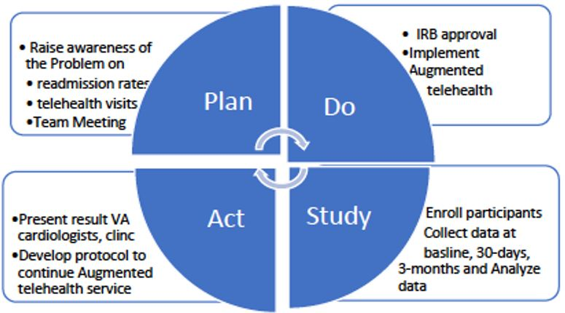

Figure 1: Framework for the project on Plan, Do, Study, and Act model.

Measures and Tools Used for Primary and Secondary Outcomes

Primary Outcome Self-Care: Primary Outcome self-care was measured using self-care of HF Index (SCHFI) [17]. This validated questionnaire includes three self-care domains: Self-Care Maintenance, Self-management, and Self-Confidence, with 15 items for a total score of 100. Cronbach’s alpha is .56 to .82. Test-retest reliability 0.90.
Quality of Life: Quality of life was measured using the Minnesota Living with HF [18]. The MLHFQ is a self-administered disease-specific quality of life questionnaire for patients with HF. It includes 21 items rated on six-point Likert scales, representing different degrees of impact of HF on quality of life with an acceptable validity (Cronbach’s alpha coefficient= >0.70). The southwestern FL VA HF clinic has permission to use this validated instrument until 2028.
Secondary Outcome: Secondary outcome on HF hospitalization was collected at 30- and 90 days by patient interview and confirmed by chart audit.
Demographic Data: Demographic data were collected at baseline using a prior validated questionnaire on Age, sex, race/ethnicity, marital status, education, socioeconomic data, and medical history.
Clinical Data: Clinical Data were collected at baseline on HF duration, HF class, ejection fraction, and medication list patient interview and confirmed by chart audit.

Intervention with Enhanced Telehealth Service

The enhanced telehealth service included the telehealth with Annie App and virtual educational support. All participants consented and enrolled were asked to download the Annie App on their mobile phones. Participants received motivational text messages every day on HF self-care. These daily text messages were sent automatically for the first 4-weeks. Participants were informed to refrain from replying to these messages. In addition to the daily text messages, the participants received telehealth virtual educational support each week. The virtual telephone support topics include information on diet, monitoring weight, activity, blood pressure, and warning signs based on modules published by the Heart Failure Society of America (HFSA) with permission. See (Figure 2) below for sample Text messages sent via Annie App.

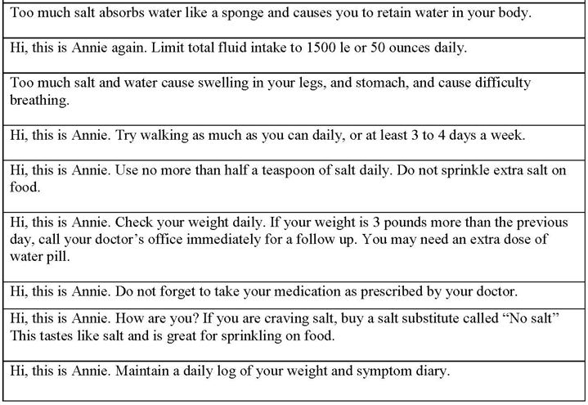

Figure 2: Samples of Text messages send daily vis Annie App.

Data collection and Follow-up

All consented participants completed a demographic and clinical questionnaire, and data was confirmed by chart review. In addition, the Self-Care of Heart Failure Index (SCHFI) and Minnesota Living with Heart Failure Questionnaire (MLHFQ) were also completed before the first virtual educational support meeting.

All follow-up visits with participants were conducted via telehealth. Outcome data on self-care and quality of life were completed by participants during the virtual visits at 30 and 90 days. The number of HF-related hospital admissions was obtained from patients during follow-up and confirmed by chart review.

Participants were identified with a subject number with no identifiable data. All hard copy data were secured at the PI’s office under lock and key. Electronic data were stored in a password-protected computer.

Data Analysis

This project used the Statistical Package for Social software for data analysis (SPSS). Univariate descriptive statistics were computed on baseline covariates on demographics (age, gender, race/ethnicity, and education) to describe the sample characteristics. Mean, and standard deviation were calculated for all continuous variables, including age, self-care, and quality of life scores. Pre-and post-implementation comparisons of baseline, 30, and 90-days were made using Paired t-tests on improved self-care and quality of life.

Results

A total of 35 participants completed the study. As indicated in (Table 1), participants ranged between 49-82 years of age (Mean 65.69 + 9.65); 97% were males, 63% white, and 77% were married. About 70% had a high school diploma, 54% were classified as NYHA group II, 37% had a low ejection fraction below 40% (Mean 43.77 + 13.64), and 57% had Ischemic HF.

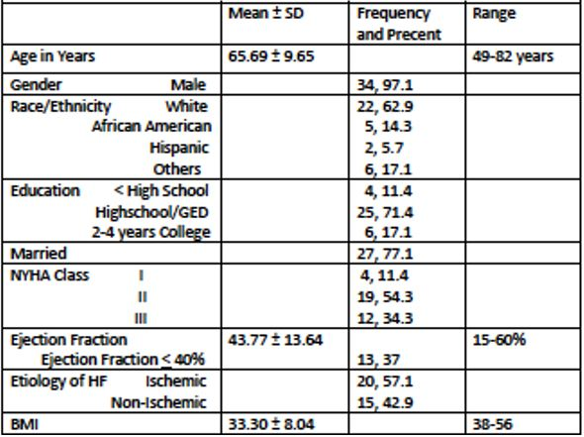

Table 1: Demographic and Clinical Data.

Primary Outcomes

As shown in (Table 2), Paired T-test showed significant improvement in all three domains of self-care, self-care maintenance, management, and confidence (SCHFI) at 30 and 90 days (p=0.001 for all). Although not statistically significant, the quality of life (MLHFQ) score was close to significantly improving at 90 days (p=0.055).

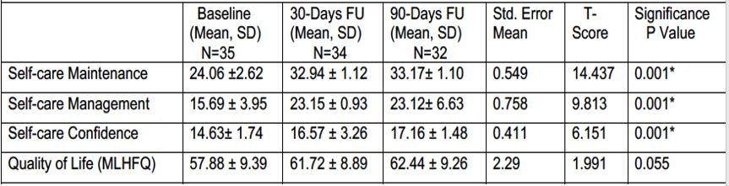

Table 2: Paired Sample T-Test Compared Mean Scores at Baseline with 30-days and 90-days.

Secondary Outcomes

Hospital admissions for HF at 30 days and 90 days were extracted from chart audits. One patient (3.13%) at 30 days and two participants (6.26%) at 90 days were hospitalized.

Although all participants actively used the Telehealth service, fifteen of the 35 patients actively used the Annie app. Most of the participants who inconsistently used the Annie App were older adults who reported needing help using the technology.

Discussion

Telehealth services mainly focus on predicting acute decompensation episodes usually associated with fluid congestion requiring therapy optimization. Clinical practice guidelines on chronic HF recommend daily weight measurements and include a warning alert when an increased weight of more than three pounds in a day is observed [5]. Conflicting results have been published in large randomized clinical trials on telehealth interventions in HF to reduce hospitalization rates [19,20]. A large study among veterans showed no association between adherence to home telehealth and ER visits [15]. On the other hand, evidence from research that used structured telephone support improved the self-care and quality of life of HF patients [21]. These findings are supported among veterans in this study that showed significant improvement in all self-care domains and close to being significant for quality of life and reduced readmissions. Our results are further supported by an earlier study of one-hour, nurse-led, in-person education and follow-up by telephone over three months that improved self-care and quality of life [7,22,23]. Similarly, a nurse-led HF clinic reduced HF readmission in Sweden [24].

Given the significance of improved outcomes in self-care, quality of life, and readmission rates, we propose that facilitating additional education to patients during each visit, Face-to-Face or virtual, by nursing staff is a feasible option in all HF clinics. Healthcare providers can facilitate and change practice patterns by establishing a short and straightforward educational template for ease of understanding by patients. The HF clinic staff can initiate early education, save lives, and prevent unnecessary readmission.

Limitations

Several unprecedented events impacted the outcome of the project. The most significant variable was Covid-19. Most Participants were older and had a hard time using the Annie app. It took much work to meet patients in person to help them with their questions about using the Annie app. Participants who were already enrolled in another telehealth program other than HF were the ones who found it easier to use telehealth. This study was conducted in one VA HF clinic and enrolled primarily male veterans; hence not generalizable.

Conclusion

The results of this project can help the facility save on the cost of unnecessary readmission, improve HF self-care, and save lives. The result of this pilot project was presented to the facility for proposed implementation at the local VA. The Annie App has been implemented along with the telehealth service for HF patients who will receive education after discharge via Annie App.

Acknowledgment

The authors acknowledge the veterans who volunteered to participate in this study. The author also acknowledges the staff and cardiologist at the Southeaster VA clinic.

Conflict of Interest

The authors declare no conflict of interest.

Funding

The authors received no funding to carry out this study.

References

- Tsao CW, Aday AW, Almarzooq ZI, et al. (2023) Heart Disease and Stroke Statistics-2023 Update: A Report From the American Heart Association. Circulation 147: e93-e621.
- Virani SS, Alonso A, Aparicio HJ, et al. (2021) Heart Disease and Stroke Statistics-2021 Update: A Report From the American Heart Association. Circulation 143: e254-e743.
- Nair R, Lak H, Hasan S, et al. (2020) Reducing All-cause 30-day Hospital Readmissions for Patients Presenting with Acute Heart Failure Exacerbations: A Quality Improvement Initiative. Cureus 12: e7420.
- SAIL (2022) Strategic Analytics for Improvement and Learning (SAIL) Veteran Affairs.
- Heidenreich PA, Bozkurt B, Aguilar D, et al. (2022) 2022 AHA/ACC/HFSA Guideline for the Management of Heart Failure: Executive Summary: A Report of the American College of Cardiology/American Heart Association Joint Committee on Clinical Practice Guidelines. J Am Coll Cardiol 79: 1757-1780.
- Ivynian SE, Ferguson C, Newton PJ, et al. (2020) Factors influencing care-seeking delay or avoidance of heart failure management: A mixed-methods study. Int J Nurs Stud 108: 103603.
- Moradi M, Daneshi F, Behzadmehr R, et al. (2019) Quality of life of chronic heart failure patients: a systematic review and meta-analysis. Heart Fail Rev 25: 993-1006.
- Madelaire C, Gustafsson F, Kristensen SL, et al. (2019) Burden and Causes of Hospital Admissions in Heart Failure During the Last Year of Life. JACC Heart Fail 7: 561-570.
- Silva-Cardoso J, Juanatey JRG, Comin-Colet J, et al. (2021) The Future of Telemedicine in the Management of Heart Failure Patients. Card Fail Rev 7: e11.
- Takahashi EA, Schwamm LH, Adeoye OM, et al. (2022) An Overview of Telehealth in the Management of Cardiovascular Disease: A Scientific Statement from the American Heart Association. Circulation 146: e558-e568.
- Gorodeski EZ, Goyal P, Cox ZL, et al. (2020) Virtual Visits for Care of Patients with Heart Failure in the Era of COVID-19: A Statement from the Heart Failure Society of America. J Card Fail 26: 448-456.
- VA (2022) Health Service Research and Development: Spotlight on Telehealth.
- Piette JD, Striplin D, Marinec N, et al. (2015) A Mobile Health Intervention Supporting Heart Failure Patients and Their Informal Caregivers: A Randomized Comparative Effectiveness Trial. J Med Internet Res 17: e142.
- Saleem JJ, Read JM, Loehr BM, et al. (2020) Veterans' response to an automated text messaging protocol during the COVID-19 pandemic. J Am Med Inform Assoc 27: 1300-1305.
- Guzman-Clark J, Wakefield BJ, Farmer MM, et al. (2021) Adherence to the Use of Home Telehealth Technologies and Emergency Room Visits in Veterans with Heart Failure. Telemed J E Health 27: 1003-1010.
- IHI (2020) Model for Improvement: Plan-Do-Study-Act (PDSA) Cycles. Institute for Healthcare Improvement.
- Riegel B, Carlson B, Moser DK, et al. (2004) Psychometric testing of the self-care of heart failure index. Journal of Cardiac Failure 10: 350-360.
- Bilbao A, Escobar A, Garcia-Perez L, et al. (2016) The Minnesota living with heart failure questionnaire: comparison of different factor structures. Health Qual Life Outcomes 14: 23.
- Koehler F, Winkler S, Schieber M, et al. (2012) Telemedicine in heart failure: pre-specified and exploratory subgroup analyses from the TIM-HF trial. Int J Cardiol 161: 143-150.
- Ong MK, Romano PS, Edgington S, et al. (2016) Effectiveness of Remote Patient Monitoring After Discharge of Hospitalized Patients With Heart Failure: The Better Effectiveness After Transition -- Heart Failure (BEAT-HF) Randomized Clinical Trial. JAMA Intern Med 176: 310-318.
- Johansson M, Athilingam P (2020) A Dual-Pronged Approach to Improving Heart Failure Outcomes: A Quality Improvement Project. JMIR Aging 3: e13513.
- Moon MK, Yim J, Jeon MY (2018) The Effect of a Telephone-Based Self-management Program Led by Nurses on Self-care Behavior, Biological Index for Cardiac Function, and Depression in Ambulatory Heart Failure Patients. Asian Nurs Res (Korean Soc Nurs Sci) 12: 251-257.
- Zamanzadeh V, Valizadeh L, Howard AF, et al. (2013) A supportive-educational intervention for heart failure patients in iran: the effect on self-care behaviours. Nurs Res Pract 2013: 492729.
- Liljeroos M, Stromberg A (2019) Introducing nurse-led heart failure clinics in Swedish primary care settings. Eur J Heart Fail 21: 103-109.

