Case Report

Diagnosis and Treatment of Antiphospholipid Antibody Syndrome: A Single Case Report

Lisa A. Batten, DNP, APRN, ANP-C, FNP-C#

#College of Nursing and Health Sciences, Valdosta State University, Georgia, USA

#Corresponding author: Lisa A. Batten, DNP, APRN, ANP-C, FNP-C, Assistant Professor, College of Nursing and Health Sciences, Valdosta State University, 1500 N. Patterson St., Valdosta, Georgia 31698, USA

How to cite this article: Batten LA (2024) Diagnosis and Treatment of Antiphospholipid Antibody Syndrome: A Single Case Report. Int J Nurs & Healt Car Scie 04(02): 2024-303.

Submission Date: 09 January, 2024; Accepted Date: 05 February, 2024; Published Online: 08 February, 2024

Introduction

B. L. is a 41 year old client who was diagnosed with antiphospholipid antibody syndrome after two 10 week gestation miscarriages and an elevated cardiolipin antibody also known as anticardiolipin antibody; she was 39 years old when she was diagnosed. The purpose of this paper is to explain what antiphospholipid antibody syndrome is, how B.L. came to be diagnosed and her experience and treatment associated with the syndrome.

Pathophysiology

Antiphospholipid Antibody Syndrome (APAS) also referred to as just Antiphon Spholipid Syndrome (APS) is an acquired autoimmune disease that causes a hypercoagulable state [1]. APAS is characterized by autoantibodies against plasma membrane phospholipids and phospholipid-binding proteins which places the patient at risk for both arterial and venous thrombosis and a variety of obstetrical complications, including pregnancy loss and pre-eclampsia/eclampsia [1]. The pathophysiology behind the disease is related to these autoantibodies directly reacting with platelets or endothelial cells, increasing the risk for thrombosis, or the placental surface, resulting in damage to the placenta [1]. The proteins normally bind to phospholipid membrane constituents and protect them from excessive coagulation activation [2]. The autoantibodies displace the protective proteins and, thus, produce procoagulant endothelial cell surfaces and cause arterial or venous thromboses [2].

Ferri [3] characterizes antiphospholipid antibody syndrome by arterial or venous thrombosis and /or pregnancy loss and the presence of antiphospholipid antibodies (aPL). The three types of aPL have been identified as: lupus anticoagulants, anticardiolipin antibodies, and anti-B2 glycoprotein I antibodies [3]. Further pathophysiology of the effects of aPL on pregnancy is described in the diagnosing section of the literature review.

Sharma et al. [4] reports APAS as a disorder of recurrent vascular thrombosis, pregnancy loss and thrombocytopenia, associated with persistently raised levels of antiphospholipid antibodies. These phospholipids are recognized by the body as foreign, causing the body to develop antibodies against them [4]. The most significant of these antibodies are lupus anticoagulant (LAC), anticardiolipin antibodies (aCL) and anti-B2 glycoprotein-I antibody (anti-B2 GP) [4,5]. Antiphospholipid antibodies have been shown to alter the maturation, movement, and invasiveness of trophoblast cells [6]. Trophoblastic cells play a very important role in the formation of the placenta and stabilization of the pregnancy. Trophoblastic cells help facilitate implantation and eventually formation of the placenta, assist in the development of the amniotic sac, and formation of villi, which penetrate the uterus and develop into the placenta [2]. Defective placentation was found on histopathological examination of products of conception in women with APAS and pregnancy losses between 7 and 10 weeks gestation attributing these losses to abnormal endovascular trophoblast invasion [6]. Alijotas-Reig, 2013 [5] conducted a review of studies that demonstrated the ability of aPL to affect the maternal side of the placenta by directly binding human endometrial endothelial cells (HEECs). As a result, aPL induced a significant decrease in both the number and total length of capillaries formed by HEECs, therefore interfering with placentation and explaining the APS linked complications of pregnancy [5].

The predominant diagnostic tests measure prolongation of blood coagulation related to the antibody inhibitor (lupus anticoagulant) and specific ELISAs for antibodies against phospholipids (anticardiolipin antibody) or proteins that bind to phospholipids (B2-glycoprotein I) [1]. Unfractionated heparin (UFH) or low-molecular-weight heparin (LMWH) along with low-dose aspirin is available for treatment of APAS and is considered to be highly effective therapy when used to prevent obstetrical complications [1].

Client Presentation

Chief Concern: At the time of her diagnosis, B.L.'s chief concern was infertility and recurrent early miscarriages.

History of Resent Illness: B.L. is currently being seen in the office for pregnancy. She is G6P2032. She is currently 23 weeks 3 days gestation and presents for a routine 4 week OB follow-up. Her blood type is O+ and genetic testing was done at Savannah Perinatology Associates (SPA). She chose to have the MaterniT21 PLUS test done due to advanced maternal age. . B.L.'s MaterniT21 Plus screening was negative for all three trisomy 13, 18 & 21, nuchal translucency measured 2.0mm and no fetal abnormalities were observed. Fetal movement is present and quickening was noticed at around 18 weeks gestation. Fetal heart rate is 148 on today's visit. Urinalysis is WNL, no evidence of protein, glucose or infection. She denies any pain, problems or concerns at this time. Her current medications include prenatal vitamins, i capsule po qd; ASA 81mg po qd; heparin 5000u SQ bid.
MaterniT21 PLUS is the first noninvasive prenatal test that has the ability to diagnose trisomy 21, trisomy 13 and 18 through a small sample of blood taken from the mother [7]. The MaterniT21 Plus test is a two part exam involving maternal blood work in addition to a ultrasound to observe for any fetal abnormalities as well as obtain a fetal nuchal translucency (NT) measurement. After taking into account maternal blood work results plus results from fetal ultrasound a risk score is established for the possible risk of an infant with chromosome abnormalities. B.L. is considered low risk of having a baby with any chromosomal fetal abnormalities with negative results for any trisomies and NT measurement of 2.0mm. I like to tell patients that the genetic screening test does not tell parents if their infant will or will not be born with any genetic abnormalities but rather puts them in a risk category of low or high risk of having an infant with a genetic abnormality Families with fetal NT measurements between 2.5 and 3.5mm should be informed of chromosomal anomaly risk and karyotype analysis should be offered [8].

Location of her syndrome is systemic with duration being constant and severity is considered low-moderate risk for obstetrical complications. Evidenced based research for risk score is revealed and discussed in the review of literature. There is no timing, character, provocative or palliative factors to be identified with APAS.

Physical Exam: B.L. is a 41 year old female who is well nourished, well developed and appears her stated age. She is alert and oriented times three, cooperative, with no signs of acute distress. Her appearance, behavior and speech are appropriate. Her current weight is 148 pounds, pre-pregnancy weight was 134 pounds, giving her a current total of 14 pound weight gain thus far in her pregnancy. Blood pressure is 104/68, pulse 89, respirations 18. Great saphenous vein varicosity of the right leg was noted on exam with no significant swelling of right lower extremity. Patient has no edema of lower extremities bilaterally. Abdominal measurement is 26 centimeters, which is slightly more than patient's gestational age of 23 weeks 3 days. There were no other relevant objective data found on physical exam.

Obstetrical History: B. L.'s obstetrical history is a rather lengthy one. I will also include any pertinent past medical and/or family history as well as any relevant review of systems information in this section. Her past medical history only revealed her diagnosis of APAS, she has no history of hypertension or diabetes or other major medical problems. B.L.'s mother is still living, age 60, history of hypertension, dyslipidemia and type 2 diabetes. Patient's father is still living, age 65 and in good health with no medical problems. The review of systems was unremarkable with no significant subjective information pertaining to her diagnosis. She has no history of blood clots, no pulmonary embolus, no deep vein thrombus, no history of blood transfusions.

She conceived and delivered her first child without any problems in 2001 at the age of 27, this was also her first pregnancy. This pregnancy was uncomplicated with no history of pregnancy induced hypertension (PIH), pre-eclampsia or gestational diabetes. She delivered a seven pound term infant via scheduled cesarean section at 39 weeks 1 day gestation, due to breech presentation. In 2002, her second pregnancy ended in miscarriage at 10 weeks gestation, she was age 28. In 2003, she successfully delivered her second child via scheduled repeat cesarean section at 39 weeks gestation. This pregnancy as well was uncomplicated and resulted in the delivery of a healthy 7 pound infant. B.L. had her second miscarriage in 2013 at the age of 38; she was again 10 weeks gestation.

After trying unsuccessfully to conceived for another 13 months, she was referred by her obstetrician (Dr. M.) to a fertility specialist. At initial consultation with the fertility doctor (Dr. W.), B.L.'s obstetrical history was reviewed. Dr. W. felt that coagulation studies were warranted due to her history of two miscarriages at 10 weeks gestation. He felt that if the miscarriages were due to chromosome abnormalities, they would have occurred earlier in the first trimester. Mazza [9] states that approximately 12-16% of all pregnancies end in miscarriage, before many women even realize they are pregnant. There were three possible diagnoses considered for B.L.'s presenting concern of infertility and recurrent miscarriages: genetic or chromosomal abnormalities in the fetus, advanced maternal age, and antiphospholipid antibody syndrome.

Several laboratory studies were ordered including the main three involved in APS: lupus anticoagulant, cardiolipin antibody IgG/IgM and Beta 2 Glycoprotein I antibody IgG/IgM/IgA. Other labs were also reviewed as you will see from the inserted laboratory values below.

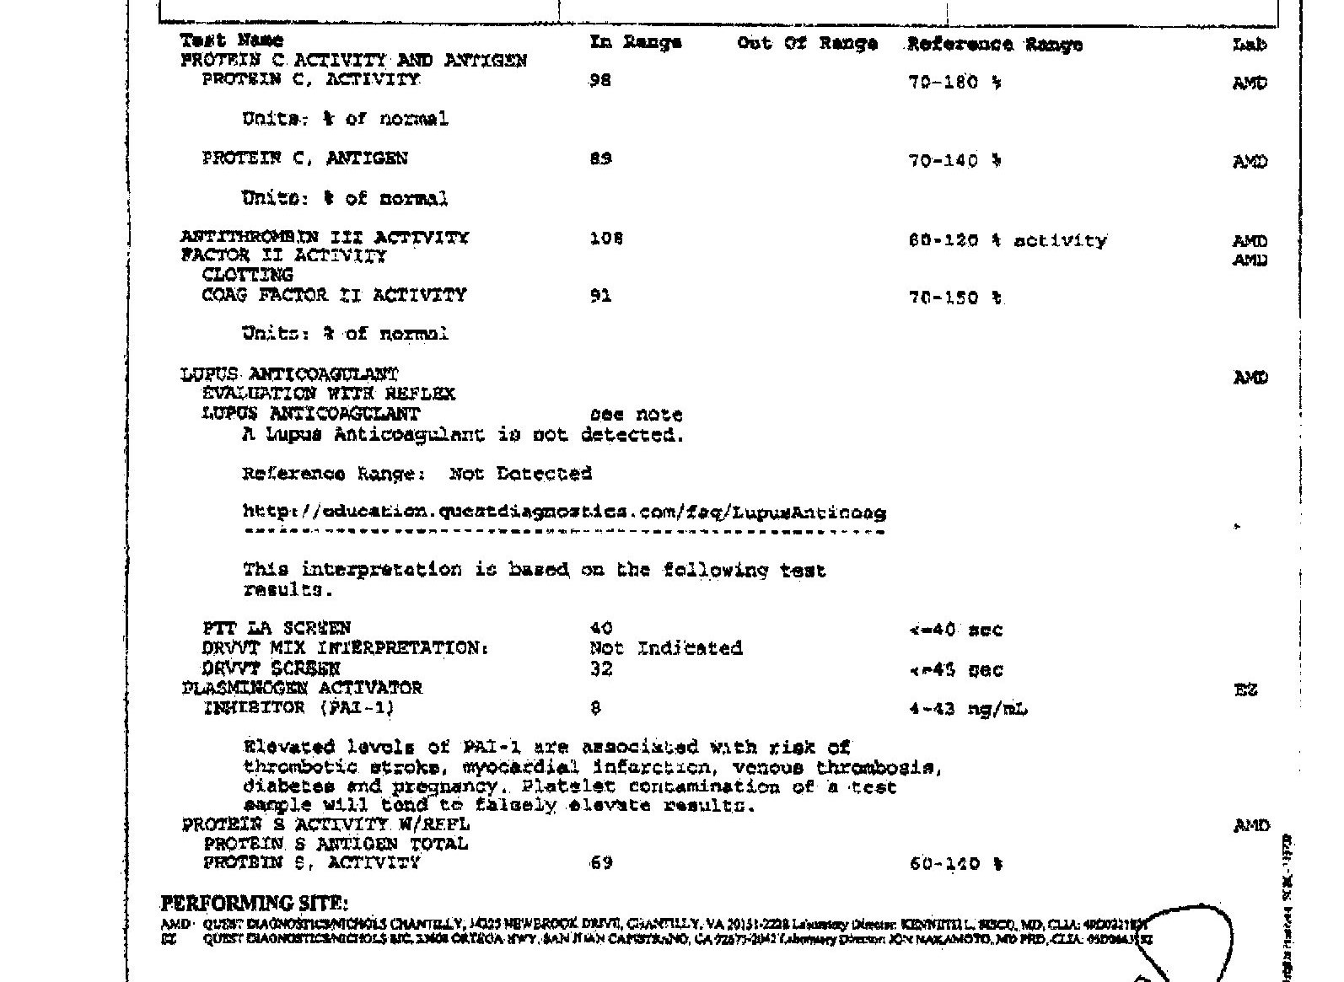
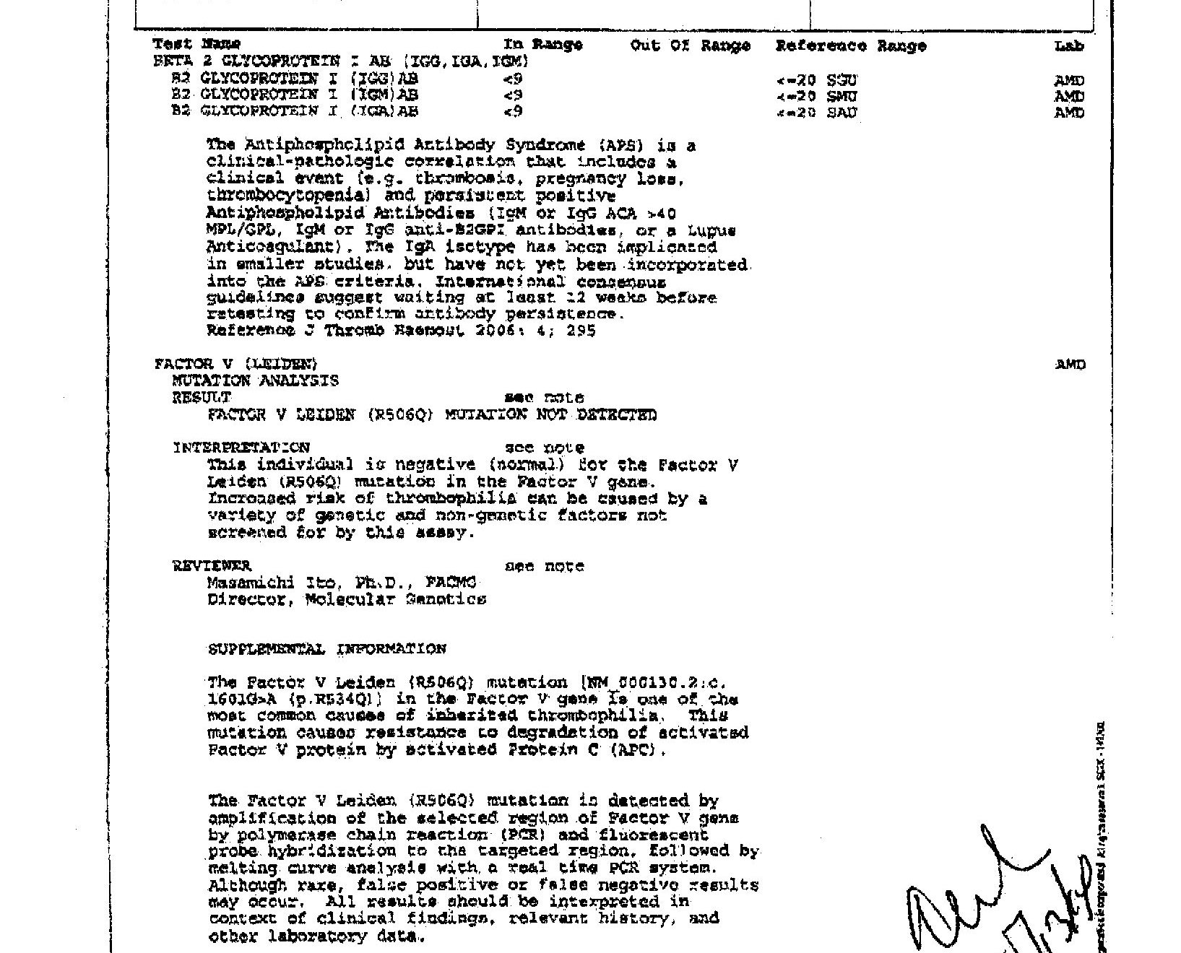
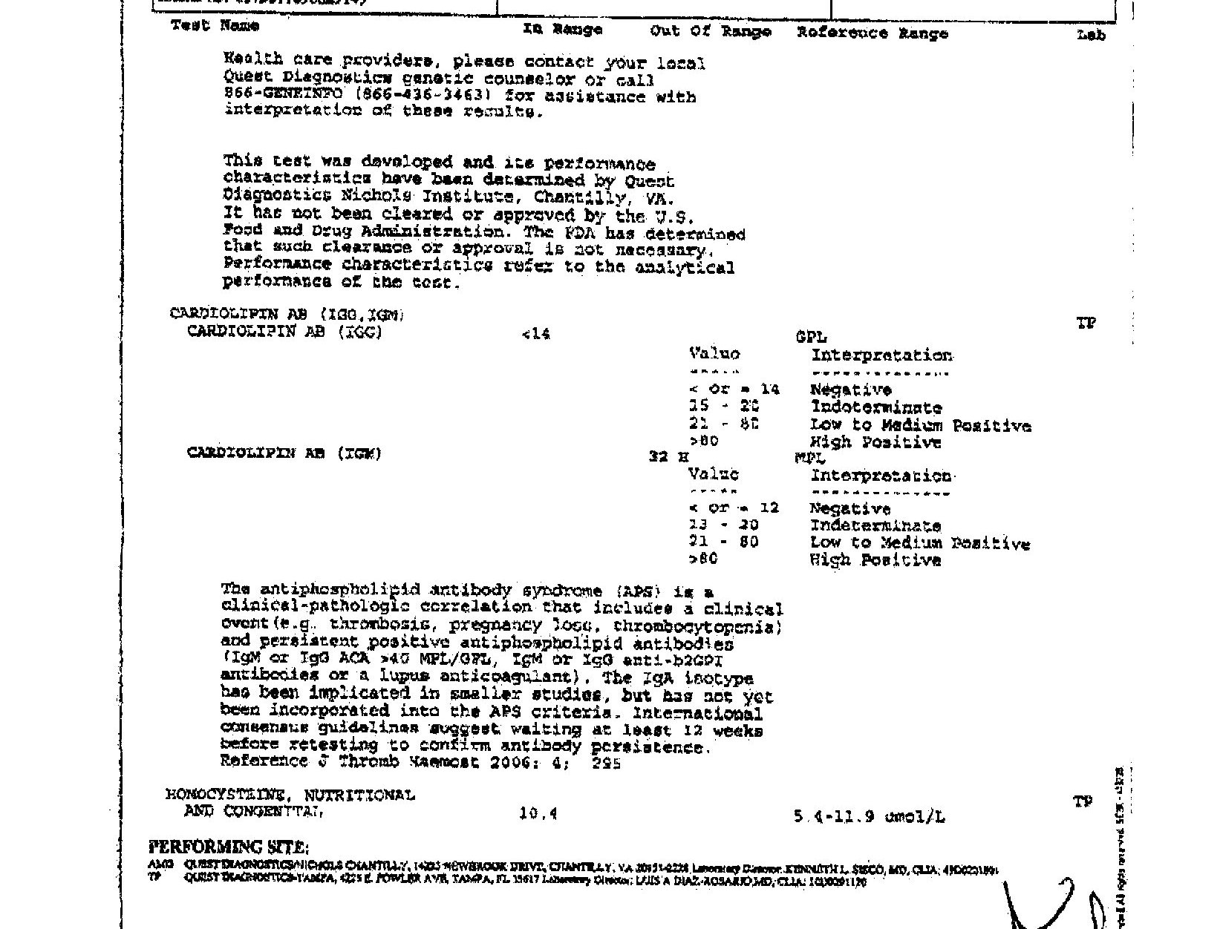

After Dr. W. reviewed B.L.'s lab values he confirmed the diagnosis of APAS. B.L.'s labs revealed lupus anticoagulant not detected, cardiolipin antibody IgG WNL, cardiolipin antibody IgM 32 (low to medium positive) and Beta 2 Glycoprotein I antibody IgG/IgM/IgA all WNL. She was at that time told that if she ever did become pregnant again she would need to start a low dose aspirin (ASA) regimen and possible heparin injections during the pregnancy to try and prevent any clotting abnormalities. A repeat lab of the elevated cardiolipin antibody IgM was repeated 12 weeks later which was 19 (indeterminate), results below.

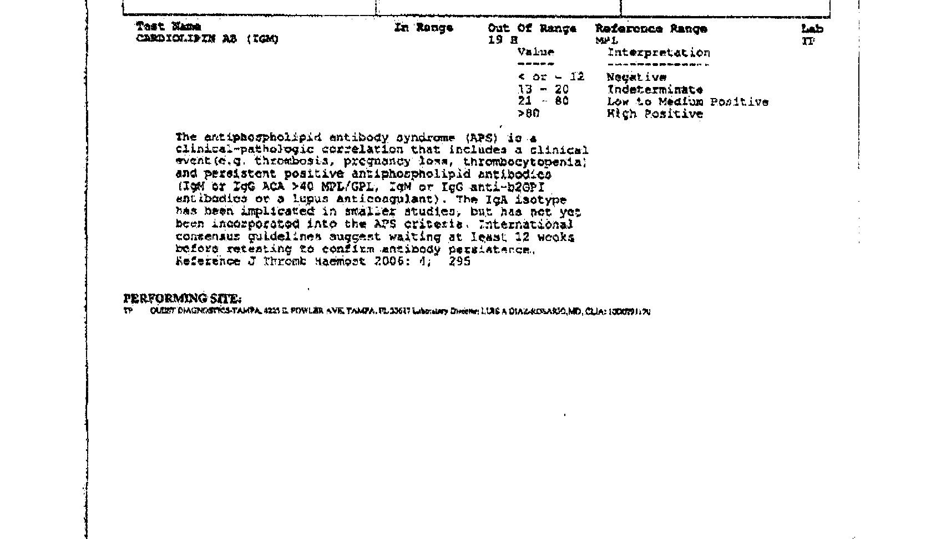

Her goal was to still try and conceive, so she was placed on Letrozole 2.5mg, ii tabs, po, days 3-8 of next cycle for infertility. B.L. continued the Letrozole for 4 months but was unsuccessful with conception during this time. She later became pregnant via conventional methods and was placed on 81mg ASA and heparin 5000u SQ bid. at 6 weeks gestation. B.L. had MaterniT21 Plus testing done at 12 weeks 5 days gestation, which revealed a chromosomally normal infant. She continued the ASA and heparin treatment regimen though her first trimester.

At 13 weeks gestation, she was told by her obstetrician, Dr. M., that the pregnancy had successfully made it through the first trimester and she should be able to come off of the heparin injections; but needed to maintain the 81mg ASA treatment regimen throughout the pregnancy. The recent HepASA Trial concluded that ASA plus heparin did not show any significant benefits compared to ASA alone in women with repeated pregnancy loss (RPL), including women with APAS [4]. Although, the Cochran data base review concluded that heparin and ASA may reduce pregnancy loss by 54 percent and is considered the standard of care for women with APAS and RPL [4]. Unfortunately, that pregnancy ended in miscarriage at 16 weeks gestation. This occurred in 2014, B.L. was 40 years old.

To both B.L. and her husband's surprise, she became pregnant again in February of this year via conventional methods. She is now under the care of a new obstetrician (Dr. B.) and was again started on 81mg ASA qd and 5000u heparin bid at 6 weeks gestation. She is currently 23 weeks 3 days gestation with a chromosomally normal infant and plan is to continue ASA and heparin therapy until closer time to delivery. Continuity of care is outlined in the evaluation section of this paper.

Literature Review

A GALILEO search was conducted browsing by subject, medicine and health, nursing and allied health. The search topics used were: antiphospholipid antibody syndrome, antiphospholipid antibodies, recurrent miscarriage, early pregnancy loss, MaterniT21 Plus test and nuchal translucency. A Google scholar search of the world wide web was also conducted using the same search topics. Articles chosen were limited to full text articles from scholarly peer reviewed journals with publication dates between 2010 and 2015. Relevant textbooks for were also used in the construction of this case report and review of literature. All resources used can be found in the reference section.

Diagnosis

The diagnosis of antiphospholipid syndrome requires the combination of at least one laboratory and one clinical criterion [10].

Laboratory Criteria: APAS is the most frequently acquired risk factor for thrombophilia leading to early or late pregnancy loss and complications like pre-eclampsia and fetal growth restriction [4,5]. In the studies reported by Sharma et al. (2011) [4] and Ruffatti, et al. [11] patients were placed into two categories according to positivity for one or more antibodies. In the Sharma et al. (2011) [4] studies reviewed the majority (78.6%) of the patients belonged to category II (single positive antibody) (LAC/aCL/anti-B2 GP), while the rest (21.4%) belonged to category I (double/triple positive antibodies). Category I patients showed poorer outcomes when compared to those in category II [4,11]. Wong, et al. [12] conducted a review of studies done on the relationship between antiphospholipid antibodies (aPL) and recurrent early miscarriage (REM) prior to 10 weeks gestation. Wong, et al. [12] concluded that the association between aPL and REM remained inconclusive and possibly misleading. These conflicting results may be partially explained by the varying definitions of REM and "positive aPL" among patients in the studies [12]. Levy, et al. [13] also conducted a meta-analysis on APAS classification criteria and found inconsistency among the definition of positive aPL. Both Wong, et al. [12] and Levy, et al. [13] recommended a standardization of laboratory criteria to help improve the quality of ANTIPHOSPHOLIPID ANTIBODY SYNDROME14 future studies. Tebo [14] reported that significant efforts to standardize and harmonize ELISAs for the detection of aCL and aB2GPI IgG and IgM antibodies are being made with encouraging results. It is likely that demands for improved, more reliable tests for APAS diagnosis will continue [14].

Several studies, Forastiero [15], 6, Matti, et al. [16] and Tebo [14], all identify current laboratory criteria for APAS classification as a positivity for at least one aPL test - lupus anticoagulant and or medium-high levels of IgG/IgM anticardiolipin antibodies ( titers > 40 units or the normal 99th percentile), and/or medium-high levels of IgG/IgM anti-B2 glycoprotein I antibodies (titers higher than the normal 99th percentile) all confirmed at least 12 weeks after initial positive test results. B.L.'s labs showed an elevated cardiolipin antibody IgM of 32 (low-medium positive) with a repeat lab 12 weeks later revealing 19 (indeterminate). Branch [17] reports on behalf of the Obstetric APS Task Force that the current strict laboratory definition of APAS may exclude patients who would benefit from diagnosis and eventual treatment of APAS.

Forastiero [15] proposed that the definition of APAS include risk stratification due to the increasing knowledge and occurrence of different combinations of aPL, which will likely improve the clinical management of patients with aPL. The proposal of risk categories for antiphospholipid syndrome presented by Forastiero [15] is noted below in (Table 1).

Definite APAS | Patients with at least triple aPL positivity (high-risk group)
Probable APAS | Patients with double aPL positivity (medium-risk group)
Possible or non-APAS | Patients with single aPL positivity (low-risk group)

Table 1: The proposal of risk categories for antiphospholipid syndrome.

Clinical Criteria: Mattia, et al. [16] recommends antibody testing for patients with clinical signs/symptoms of APAS but who may not necessarily meet conventional antiphospholipid antibody laboratory criteria. Ruffatti, et al. [11] reports recurrent pregnancy loss has been considered hallmark for APS and is part of the current classification criteria. The pregnancy morbidity guidelines for APS presented by Ruffatti, et al. [11] is noted in (Table 2) below.

A. | One or more unexplained deaths of a morphologically normal fetus at or beyond the 10th week of gestation and/or
B. | One or more premature births of a morphologically normal neonate before the 34th week of gestation due to eclampsia or severe pre-eclampsia, or recognized features of placental insufficiency and/or
C. | Three or more unexplained consecutive spontaneous abortions before the 10th week of gestation, with maternal anatomic or hormonal abnormalities and paternal and maternal chromosomal causes excluded

Table 2: The pregnancy morbidity guidelines for APS.

B.L. presented with one of these classifications, category A. Her third miscarriage was of a 16 week normal fetus which fits criteria for category A. With that pregnancy, she had the MaterniT21 Plus test done at 12 weeks 5 days which revealed a chromosomally normal fetus. Her first and second miscarriage was at 10 weeks gestation, but they were not consecutive and were not three or more. Levy, et al. [13] reported that APS classification criteria should included three or more REM, but many physicians choose to investigate aPL in women with two early miscarriages. The Obstetric APS Task Force stated that women with two miscarriages should be permitted in the studies to help achieve statistical significance [17]. According to Levy, et al.'s [13] review, APS or aPL was linked to approximately 15% of the REMs, meaning many times there is no identifiable cause.

Treatment

The current accepted first-line treatment for APS is low-dose aspirin (LDA) plus unfractionated heparin (UFH) or low-molecular-weight heparin (LMWH) [5]. This recommend treatment regimen is the consensus of all resources reviewed although there are some alternative treatments considered for APS that can be reviewed in the next section. Cetkovic, et al. [10] reports combination heparin and aspirin therapy represent the most frequently applied therapeutic protocol, resulting in a live birth rate of 70-80% of cases. Kwak-Kim et al. [6] reports a fetal loss rate of 50-90% for women with recurrent pregnancy losses in the presence of persistently positive aPL if no treatment is given. The antithrombotic properties of aspirin (ASA) may act to improve blood flow in the uterine vessels via inhibition of thromboxane A2, which is required for platelet aggregation [6]. Aspirin can also stimulate IL-3, an essential factor for implantation and placental growth, therefore providing for a more favorable embryonic implantation [6]. The anti-inflammatory actions of ASA may also have some beneficial effect in women with APS.

Heparin has various pharmacological actions including direct interaction with trophoblasts, which can result in a significant reduction in pregnancy complications in women with aPL [6]. As stated earlier, aPL has been shown to have a direct effect on trophoblasts and may induce direct cellular injury, apoptosis, inhibition of proliferation and syncytia formation, decreased human chorionic gonadotropin production, and defective invasiveness, which may all play a role in defective placentation [6]. Heparin was reported to suppress some of these aPL-related pathology [6].

LMWH has been shown to be able to reduce the binding of aPL to trophoblast cells [6]. Heparin also has anti-inflammatory actions; which counters trophoblast inflammation and enhances placental growth factor secretion from trophoblast [6].

Alternative Therapy

During the review of literature, alternative therapies for obstetrical antiphospholipid syndrome (OAPS) are mentioned but are still subject to much debate. Further research was suggested before these therapies be considered standard practice. The rest of this section identifies the most common alternative therapies found in the review of literature.

Antimalarials: Antimalarials have many anti-inflammatory, anti-aggregant and immune-regulatory properties: they inhibit phospholipase activity, stabilize lysosomal membranes, block the production of several pro-inflammatory cytokines and, in addition, impair complement-dependent antigen=antibody reactions [5]. Antimalarials do not have major bleeding side-effects and have been recommended as adjunct therapy in combination with LDA and LMWH, although there is limited clinical evidence for their efficacy in APS, [5]. Alijotas-Reig (2013) [5] suggests further controlled studies be required to establish their safety and efficacy in the management of obstetrical APS.

Corticosteroids: The role of corticosteroids for refractory OAPS is to help block immune pathways and has been studied for over 30 years [5]. Alijotas-Reig (2013) [5] reported that women with OAPS treated with early low-dose prednisone or prednisolone (0.5 - 1 mg/kg daily) in addition to LDA and heparin achieved 61% live births with no associated maternal morbidity reported. Large doses of corticosteroids (10-20 mg/kg daily) however, have been associated with an increased risk of gestational diabetes, infections, pregnancy induced hypertension and preterm deliveries [5].

Intravenous Immunoglobulins: In some studies intravenous immunoglobulins (IVIGs) have been shown to offer no additional benefit when given in combination with LDA plus LMWH when compared to LDA plus LMWH alone [5]. Other studies reported positive results and feel this may be due to the mechanism involved in aPL related placental injury, which can be blocked by immunoglobulin infusion [5].

Biologic Therapy: TNF-Targeted Therapies: TNF-alpha is a cytokine which plays a crucial role in causing inflammation by means of predominantly T-cell-mediated tissue damage and appears to be a critical effector in aPL-related placental injury and further miscarriage [5]. The three most commonly used anti-TNF-alpha drugs are infliximab, etanercept and adalimumab and are all classified by the FDA as pregnancy risk category B medications [5]. Each of these medications were used in women whilst pregnant and no significant fetal adverse effects were observed [5]. Anti-TNF-alpha medications have also been used to treat women with recurrent miscarriages or repeated in vitro fertilization (IVF) failure, both with good results [5]. More research is needed regarding the use of anti-TNF-alpha blockers in women with OAPS, but could prove to be useful due to their effectiveness in other autoimmune diseases [5].

Evaluation

According to the review of literature, B.L.'s case meets criteria for the diagnosis of APS. Her labs revealed a low-medium single positive antibody, anticardiolipin IgM with a repeat lab that was indeterminate plus one miscarriage of a 16 week chromosomally normal fetus. Although at the time of her diagnosis she only had the one elevated lab result and two miscarriages at 10 weeks gestation. Yingjian, et al. [18] suggest women with any pregnancy-related problem involving thrombosis or any positive antiphospholipid antibody be screened for APS as early as possible to allow for early prevention and treatment of obstetrical complications. In light of the qualifying criteria, the diagnosis APS was ruled in as primary. The possible diagnosis of fetal loss due to chromosome abnormalities was ruled out with the loss of a 16 week chromosomal normal fetus and advanced maternal age is still a consideration since she is 41 years old.

Currently B.L. will continue prenatal vitamins, ASA and heparin. She is scheduled to have an ultrasound next week for possible large for gestational age (LGA) baby, which is opposite of the concern of fetal growth restriction with APS. This ultrasound was scheduled as a precaution due to her abdominal measurement of 26 cm at 23 weeks 3 days gestation. Anti-thrombotic hose were considered in light of her varicose vein to prevent lower extremity edema as the pregnancy progresses. Although she currently has no warning signs of pre-eclampsia (BP 104/68, no proteinuria, no LEE), she will continue to be monitored for any obstetrical complications. Giddins and Ware Branch [19] reviewed an number of relevant studies that support an association between aPL and pre-eclampsia.

Recommendations for the continuity of care for B.L. are to continue 81mg ASA po qd, increase heparin to 10,000 units bid at 28 weeks gestation, start non-stress testing (NST) at 28 weeks gestation and add biophysical profile (BPP) screenings at 32 weeks. She is to continue the ASA and heparin until closer time to her scheduled c-section. The NST and BPP screenings are scheduled to be done every two weeks from recommended gestational age and continued until delivery. Cetkovic, et al. [10] suggested from the 24th week of gestation doppler analysis of fetal uteroplacental and cerebral circulation be performed and beginning at 32 weeks gestation cardiotocography be introduced as part of fetal monitoring. Ruffatti, et al. [11] conducted a review of studies that observed an abnormal doppler velocimetry of the umbilical artery as a predication of adverse pregnancy outcomes. Uterine artery doppler blood flow analysis provides a noninvasive indirect method of screening women with risk of uteroplacental insufficiency [10]. Early treatment with LDA and UFH or LMWH, combined with meticulous fetomaternal monitoring could be associated with a relatively high probability of favorable perinatal outcome [10].

Post-partum treatment for B.L. has been recommended to resume 48 hours post c-section and to be LDA plus 5000u bid UFH or LMWH for 6 weeks. After 6 weeks postpartum, she may discontinue the heparin but continue the LDA indefinitely. One of the main topics discussed by the Obstetric APS Task Force was how long to provide postpartum thromboprophylaxis [17]. Many members of the Task Force recommended postpartum warfarin for women who had been treated with UFH or LMWH during pregnancy, while others recommended only several days of additional UFH or LMWH postpartum, yet others recommended longer treatment of 6-8 weeks postpartum [17]. The safety of warfarin in the instance of breastfeeding mothers would also need to be addressed.

Teaching and Referrals

I did not come across any specific teaching or referrals recommended for patients with APS during my review of literature. Although none were encountered in my research, I did observe an interaction between B.L. and her obstetrician regarding patient education concerning APS treatment. B.L. was informed of bleeding risk associated with ASA and heparin therapy and was informed to present to E.R. or call office if any bleeding was noted or suspected. Warning signs of pre-eclampsia were also reviewed to include visual disturbances, headaches and edema. Some clues that suggest pre-eclampsia include headache, acute right upper quadrant or epigastric pain, visual disturbances and edema [2].

The possibility of a Rheumatology referral was also discussed if the need should arise since APS is considered an autoimmune disease. B.L. was referred to Savannah Perinatology Associates (SPA) to also be followed closely by a neonatologist. Her first appointment with SPA was for the MaternitT21 Plus testing. She was scheduled for another appointment at 19 weeks for a level two fetal anatomy scan.

Conclusion

Although some studies show inconsistencies among defining criteria for APAS, most were conclusive in the fact that there is enough evidence to show a positive association between aPL and obstetrical complications, including miscarriage, fetal growth restriction and pre-eclampsia/eclampsia. Standardized laboratory criteria was found by most studies reviewed as a much needed improvement for future studies. The mainstay of treatment was found to be low-dose aspirin plus unfractionated or low-molecular-weight heparin. Although other therapies were identified, recommendations were made to limit their use to patients who had poor pregnancy outcomes with the standard aspirin and heparin treatment. Some studies found no benefit with LDA plus heparin therapy vs. LDA alone, while other studies showed a more positive pregnancy outcome with LDA and heparin combined therapy.

Future studies proposed were a trial to determine whether UFH is superior to LMWH and a neonatal-childhood follow-up study [17]. The suggestion was made that for any treatment study to change practice, it would need to be large, multicentered, and randomized [11,17]. Inclusion and exclusion criteria, assay choice, and centralized laboratory use with repeat testing was also considered to be essential [17].

Conflict of Interests

The Author declare that there is no conflict of interest.

References

- Huether SE, McCance KL (2012) Understanding pathophysiology (5th Edition): St. Louis, MO: Mosby, Inc.
- Porter RS, Kaplan JL, Merck Sharp & Dohme (2011) The Merck manual of diagnosis and therapy. Whitehouse Station, N.J: Merck Sharp & Dohme Corp.
- Ferri FF (2010) Ferri's clinical advisor: Instant diagnosis and treatment. Philadelphia, PA: Mosby Elsevier.
- Dadhwal V, Sharma AK, Deka D, et al. (2011) The obstetric outcome following treatment in a cohort of patients with antiphospholipid antibody syndrome in a tertiary care center. Journal Of Postgraduate Medicine 57: 16.
- Alijotas-Reig, J (2013) Treatment of refractory obstetric antiphospholipid syndrome: the state of the art and new trends in the therapeutic management. Lupus 22: 6.
- Kwak-Kim J, Agcaoili ML, Aleta L, et al. (2013) Management of women with recurrent pregnancy losses and antiphospholipid antibody syndrome. American Journal Of Reproductive Immunology (New York, N.Y.: 1989) 69: 596-607.
- Levine BA, Goldschlag D (2014) Noninvasive prenatal testing: A new standard of care. Contemporary OB/GYN 59: 46.
- Ulkumen BA, Pala HG, Uyar Y, et al. (2014) Analysis of the distribution and the mean values of nuchal translucency in singleton pregnancies. Perinatal Journal / Perinatoloji Dergisi 22: 156-160.
- Mazza D (2011) Women's health in general practice. (2nd edition) St. Louis: Elsevier.
- Cetkovic A, Kastratovic B, Novakovic I (2014) Prospective study of perinatal outcome in pregnancies with primary antiphospholipid syndrome. Vojnosanitetski Pregled: Military Medical & Pharmaceutical Journal of Serbia & Montenegro 71: 742.
- Ruffatti A, Calligaro A, Del Ross T, et al. (2012) Risk-based secondary prevention of obstetric antiphospholipid syndrome. Lupus 21: 741-743.
- Wong L, Porter T, Jesus GD (2014) Recurrent early pregnancy loss and antiphospholipid antibodies: where do we stand? Lupus 23: 1226.
- Levy RA, Santos FD, de Jesus GR, et al. (2015) Antiphospholipid antibodies and antiphospholipid syndrome during pregnancy: diagnostic concepts. Frontiers In Immunology 1-4.
- Tebo A (2014) Antiphospholipid syndrome and the relevance of antibodies to negatively charged phospholipids in diagnostic evaluation. Lupus 23: 1313-1316.
- Forastiero R (2014) Multiple antiphospholipid antibodies positivity and antiphospholipid syndrome criteria reevaluation. Lupus 23: 1252-1254.
- Mattia E, Ruffatti A, Tonello M, et al. (2014) IgA anticardiolipin and IgA anti-B2 glycoprotein I antibody positivity determined by fluorescence enzyme immunoassay in primary antiphospholipid syndrome. Clinical Chemistry And Laboratory Medicine: CCLM / FESCC 52: 1329-1333.
- Branch W (2011) Report of the Obstetric APS Task Force: 13th International Congress on Antiphospholipid Antibodies, 13th April 2010. Lupus 20: 158.
- Yingjian S, Manhua C, Wanan Z, et al. (2014) A case report of a pregnancy-related death caused by primary antiphospholipid antibody syndrome. International Medical Case Reports Journal 7159.
- Gibbins K, Ware Branch D (2014) Pre-eclampsia as a manifestation of antiphospholipid syndrome: assessing the current status. Lupus 23: 1229.

