Dissertation

Trichomonas Intervention Project

Tamika Dowling DNP, FNP-c, PCCN#

#College of Nursing and Health Sciences, University of Massachusetts, Massachusetts, USA

#Corresponding author: Tamika Dowling DNP, FNP-c, PCCN, College of Nursing and Health Sciences, University of Massachusetts, 100 Morrisey Blvd Boston, Massachusetts 02125, USA

How to cite this article: Dowling T (2024) Trichomonas Intervention Project. Int J Nurs & Healt Car Scie 04(04): 2024-317.

Submission Date: 22 February, 2024; Accepted Date: 13 March, 2024; Published Online: 18 March, 2024

Introduction

Trichomonas Vaginalis has been reported as one of the most common sexually transmitted infections in the world, with prevalence greater than chlamydia and gonorrhea combined [1]. The World Health Organization has projected 180 million infections on a global scale; in addition, there are reports in the U.S. of approximately 5 to 8 million infections acquired annually [2].

Fule, et al. [3] stated Trichomonas Vaginalis is one of the most common sexually transmitted infections, and it is responsible for one-third of vaginal complaints; approximately 60% of individuals are asymptomatic. In the National Survey report in the United States, women between the ages of 14 and 49 had a 3% higher rate of Trichomonas Vaginalis compared with chlamydia and gonorrhea combined [1].

Trichomonas Vaginalis (TV) is not a reportable sexually transmitted infectious disease, and it makes it a challenge to understand the true prevalence [1]. The fact that TV is not reportable also makes it a challenge to control the sexually transmitted infection. Healthy People 2020 has a focus on changing behaviors with sexually transmitted infections, and there is also a focus on increasing access to healthcare; specifically, the focus is on chlamydia and gonorrhea, not TV. Health promotion behaviors can reduce the prevalence of TV, and increase knowledge about the STI. The aim of the Trichomonas Vaginalis educative intervention project is to assess if the exposure to TV education impacts the participants beliefs, feelings and intentions regarding sexually transmitted infections, which has been noted to have an impact on determining risks [4].

Education intervention on the topic of Trichomonas Vaginalis can increase knowledge, thus altering future behavior, which can decrease the overall prevalence of Trichomonas Vaginalis.

Keywords: Sexually Transmitted Disease Project; Trichomonas Vaginalis; Trichomonas Vaginalis Project

Predictive PICOT Question

Will non-pregnant female patients between the ages of 18 to 64 reporting for a gynecological visit, having a tailored education session on Trichomonas Vaginalis, as compared to those who receive the education session with the brochures should display an increase in knowledge and awareness, which can impact their post-education/questionnaire over a ten-week time frame?

Project Purpose

Trichomonas Vaginalis (TV) is a sexually transmitted infection. It is one of the most common STIs in the world, and it is the most neglected [5]. TV has a number of complications, which include cervicitis, urethritis, premature rupture of membranes during pregnancy, pelvic inflammatory disease, and it increases the transmission of human acquired immunodeficiency virus, due to the inflammatory nature of the disease. There are some inconsistencies with awareness of this sexually transmitted infection. At this juncture, further exploration of the effect of an educational intervention for Trichomonas Vaginalis is necessary. The proposed project will include an educational brochure for females between the ages of 18 to 64. The education will be provided with a goal to increase awareness, comprehension and knowledge about Trichomonas Vaginalis as well as reduce infection rates.

Background

With respect to incidence and prevalence, Trichomonas Vaginalis has been reported as one of the most common sexually transmitted infections on a global basis [1]. Most women are asymptomatic, and males tend to have transient symptoms; in addition, males are frequently asymptomatic, and males are least likely to be tested for TV [1]. Epidemiology is difficult to track since reporting is not mandatory, and TV is not a notifiable disease in the United States. The Centers for Disease Control and Prevention [5] noted that there are an estimated 3.7 million infected, and only 30% of those individuals will have symptoms.

Currently, women that have symptoms may have itching, burning, dyspareunia and erythema to the vaginal walls [5]. In addition, the vaginal discharge may be yellow, green, white or clear [5]. Males may report itching or burning inside the penis, burning after urination or sexual intercourse, and penile discharge [5].

The proposed site for the project is in Mandarin, Florida. The providers screen all patients with complaints, and those who present for well woman visits with the nucleic acid amplification tests. The aforementioned test is collected with a swab that absorbs vaginal secretions.

Significance

Trichomonas Vaginalis has a significant impact. Coleman, et al. [6] stated that TV’s annual infection rates of 7.4 million are greater than Chlamydia, Syphilis, and Gonorrhea combined. TV is also responsible for pregnancy-related complications, which include premature rupture of membranes, and it is also responsible for neonate complications; some of the complications include respiratory infections and reproductive tract infections [1]. TV has also been associated with up to 30% of acute salpingitis cases and 16% of postpartum endometriosis, and TV weakens the structural integrity of the tissue, which increases the risk for the acquisition of human acquired immunodeficiency virus (HIV). TV can cause urethritis in males, and rarely, TV can cause infertility in males [7].

Benefit of Project to Nursing Practice

The prevalence of Trichomonas Vaginalis increases with age and number of sexual partners [5]. Currently there aren’t any mandatory screenings or reporting guidelines in place. Educative and behavioral interventions have been shown to be efficacious in lowering risk for sexually transmitted infection and increasing education in various populations [9]. The project will examine the efficacy of an evidence-based educative intervention to increase knowledge and awareness, with a goal to decrease the rate of infections and sexual risk behaviors. The project will also examine attitudes towards sexually transmitted diseases. Nurse practitioners have a responsibility to implement evidence-based practices, as well as to address the issues in the community and public health. Evidence-based principles can be derived from randomized controlled trials, where evidence is gathered using scientific methods such as quantitative analysis. The expectation in this project is that individuals that receive the pamphlet combined with education will have a higher score on the posttest assessment. The data gained from the project can help providers with their management of care for TV, with regards to screening, health education and promotion. Education and health promotion increases the patient’s knowledge and awareness, and it decreases their risk of exposure. Ultimately, the project can have an impact on TV by decreasing the incidence. The American College of Obstetricians and Gynecologist recommends to screen and educate all women based on age and risk factor for TV [10].

Scope

Project Objective

To determine if there is an increase in knowledge after a Trichomonas Vaginalis educational intervention, and to determine if there will be a predictive change in safer sexual practices and attitude in this sample population.

Project Tasks

Approval from the IRB and gynecological clinic
Recruitment of willing participants for the sample
Informed consent
Creation of an approved education brochure
Specimen collection and review of test results
Identification of a Likert scale pre-test and post-test for the project
Collection of Data
Mann Whitney U and dissemination of results

Resources

The use of outside sources or external evidence, such as previous peer-reviewed journal articles, research articles, sources from the American College of Obstetricians and Gynecologists, and the CDC will be used for clinical practice guidelines.

The source for internal evidence will include information from the patient’s record with regards to results from TV testing, with informed consent. Also, the information from the Likert scale pre-test and post-test will be used for evidence to support the project. The data will be collected, and quantitative analysis will be conducted.

Synthesis of Evidence

Trichomonas Vaginalis is not a reportable STI, and the true epidemiology of the disease is not well understood. The current guideline issued by the CDC does not recommend routine screening for TV when compared with gonorrhea and chlamydia [5]. However, with the information reported, TV is more prevalent than chlamydia and gonorrhea, and it is also noted that over 70% of individuals with TV are asymptomatic [1]. The prevalence of Trichomonas Vaginalis in the United States is approximately 3.7 million individuals annually, and there is a two-to-threefold increase of acquiring human acquired immunodeficiency virus (HIV), and preterm birth [5]. Trichomonas Vaginalis can also increase the risk for pelvic inflammatory disease, infertility and neonatal complications, such as respiratory tract infections and genitourinary tract infections [11].

The American College of Obstetricians and Gynecologists [10] noted that well woman visits include screening, promoting prevention practices, evaluation and counseling. The research project will explore further health promotion practices with the educative intervention project, and it will assess if the knowledge level increased after the intervention. The goal is to increase awareness, decrease risky behaviors and decrease the prevalence of Trichomonas Vaginalis.

Literature Review

The PICOT inquiry was utilized to aid in establishing the search criteria for the topic. The review resulted in quantitative and qualitative studies, which included randomized controlled trials, longitudinal studies, and cohort studies. There was a range in the level of evidence provided. The primary sources were sought out to obtain the original evidence; however, secondary sources were yielded as well to help retrieve greater understanding of the literature. The databases searched included the Cumulative Index to Nursing and Allied Health Literature (CINAHL), PubMed and Cochrane Collaboration. The search included years 2010 to 2017 were searched using the terms Trichomonas Vaginalis, the prevalence of Trichomonas Vaginalis, Education “AND” Trichomonas Vaginalis, sexually transmitted education and Trichomonas Vaginalis health promotion. Each database yielded varying numbers of articles. There have been 30 articles obtained to support this scholarly project.

Results

The results of the studies concluded that males and females have misconceptions about the cause, cure, treatment and access for reproductive and sexually transmitted infections including Trichomonas Vaginalis [12]. Participants in a home-based sexually transmitted testing study, whom were asymptomatic, tested positive for Trichomonas Vaginalis, chlamydia and gonorrhea [13]. Normanswell, et al. [14] conducted a qualitative study with semi-structured questions for women between the ages of 16-25, and the results concluded that women would be more inclined to participate in preventive efforts if there are convenient, confidential and accessible.

Salawu and Esume [15] concluded Trichomonas Vaginalis has a significantly higher risk factor for the acquisition of HIV. The relative risk for women that were diagnosed with Trichomonas Vaginalis was 1.21 and p <. 0001 [16]. Kirkaldy et al. [17] noted that there was not a geographic variance in resistance to metronidazole treatment for TV, with resistance at 4.3%.

The evidence indicates there is a lack of understanding about Trichomonas Vaginalis and the complications associated with the STI. The evidence is also indicative that increased screening and education efforts are needed to increase awareness, provide health promotion for safer sex practices, and to decrease the prevalence of Trichomonas Vaginalis. ACOG [10] noted that screening, recognition of risk factors and promoting preventive practices are essential for wellness.

Strengths

Increasing knowledge and awareness can help eliminate misconceptions about the etiology, clinical manifestations, and treatments for sexually transmitted infections [12]. It may decrease reluctance to seek the appropriate healthcare, and it decreases a delay in retrieving the appropriate diagnosis and medication [12]. The actions above may decrease the prevalence of TV as well. Home based treatment with the use of the World Wide Web provides convenience, increased accessibility for screening and increased confidentiality, which assists to increase efforts towards screening and treatment [18]. The qualitative data for inquiry on participation in education and screening affords an increased understanding for healthcare providers and researchers on the barriers and perceptions from the patient with receiving healthcare for reproductive health [14].

By providing insight on the complications known about Trichomonas Vaginalis with the utilization of randomized controlled trials can increase insight on the seriousness of the matter. It is also essential to understand the nature of TV, it causes inflammation to epithelial tissue of the reproductive tract, which can increase susceptibility to HIV; increased susceptibility and acquisition of HIV in the presence of TV further supports the need for the educative intervention project on Trichomonas Vaginalis [15]. Understanding that there is growing resistance to the first-line treatment for Trichomonas Vaginalis helps provide understanding that TV is serious, and it also asserts further efforts are necessary to help increase awareness, which can help reduce the prevalence. The ACOG guidelines support screening, examination, risk assessment and health promotion [10].

Weaknesses

The weakness in the research included limited information about treatment of the partner or partners. One of the studies proposed treatment of the partner as well, but this would be at the discretion of the provider; also, treatment of partners is based on state-law. The self-report information from the studies may not be completely reliable. The sample size and heterogeneity is not consistent in each study, which may not provide accurate data. Another weakness is the method of testing and/or screening is not universal amongst providers. Van Der Pol [19] reported some clinicians are based only on observation when the data suggests that approximately 60% of women with TV don’t have symptoms, such as discharge or dysuria. Methods such as culture, antigen testing and nucleic acid amplifications tests are necessary [19].

The CDC recommends screening for TV in individuals that are symptomatic or individuals that have high-risk behaviors, which include multiple partners, sex worker and drug use [5]. Again, approximately 70 % of individuals infected with TV are asymptomatic [5]. Also, we are relying upon the self-report of the patient to advise if the high-risk behavior is present. The literature reports that communication efforts between the provider and patient are a factor that requires improvement to increase awareness regarding sexually transmitted infections [12].

Significance

ACOG recommends that there are annual health assessments for the Well-Woman visit that consists of screening, recognition of risk factors, identification of problems, health promotion and building a rapport during the establishment of the clinician-patient relationship [10]. The focus of the DNP scholarly project is education as an intervention to increase awareness and knowledge, increase the likelihood of future safer sex practices, and to decrease the prevalence of Trichomonas Vaginalis. These recommendations are set by ACOG, but the CDC has different guidelines. There is no available data on what type of methodology is being used by each provider. Well-Woman visits are conducted in the primary care and gynecology settings.

Additional attention is needed on Trichomonas Vaginalis, without mandatory reporting the true epidemiology is unknown. There is a plethora of complications associated with TV, which includes premature labor, neonate complications, increased acquisition of HIV, pelvic inflammatory disease (PID), persistent human papillomavirus in the presence of TV, and increased likelihood to acquire herpes simplex virus 2 (HSV-2) [11].

Conclusion and Recommendation
The CDC has noted that TV is the most prevalent non-viral STI in the United States, and on 3.7 million individuals are infected, and the individuals with the highest infection rate are black women [5]. Prevention efforts from the CDC are focused on consistent and correct condom use [5].

At this juncture, there is more understanding about the consequences and complications of TV if left untreated; however, the literature supports that there are a large number of infected individuals that are asymptomatic, and there are no mandates set in place for mandatory reporting. The aim of the educative intervention scholarly project is to strengthen education and health promotion at a private clinic. Health education about the cause, prevention, access to healthcare and treatment of TV is aimed to increase knowledge, and it is necessary.

Theoretical Framework

Nola J Pender developed the Health Promotion Model. The Health Promotion Model (HPM) is the framework selected to guide this project. Nola J. Pender’s background encompassed nursing, education, and experimental psychology, which led the use of a holistic perspective in nursing [20]. Pender believes that the experiences of the individual and their characteristics will have an impact on their subsequent actions, which can have an overall impact on their health [20]. The health promotion model guides with the explanation of disease prevention behavior [20]. The model also expands with a focus on behaviors that enhance health [20]. Alligood [20] stated that the health promotion model is beneficial with identifying factors, such as cognitive and perceptual, which are major aspects of health-promoting behaviors.

Major Concepts and Definitions of Health Promotion Theory:

Prior Related Behavior: Frequency of past behaviors will have an impact on the probability of the participating engaging in health-promoting behaviors [20].
Personal Factors: Categorizing biological, psychological and sociocultural factors are predictors of behavior [20].
Perceived Benefits of Action: These benefits of action are projected outcomes that will result in positive behavior [20].
Perceived Barriers to Action: Anticipated roadblocks that can have an impact on the behavior [20].
Perceived Self-Efficacy: Is the conclusion of personal abilities to act upon health-promoting behaviors are being observed, which can have an impact on perceived barriers to action and self-efficacy [20].
Activity-Related Affect: Activities that are related to feelings before, during and after the behavior [20]. The more positive the feeling, the greater the efficacy [20].
Interpersonal Influences: Influences that can have an impact on behaviors, beliefs and attitudes, and these types of sources have an impact on interpersonal influences [20].
Situational Influences: Cognitions and personal perceptions can augment or impede future behavior, with regards to engaging in the health-promoting behavior [20].
Commitment to Plan of Action: This describes the aspects of intention [20].
Immediate Competing Demands and Preferences: Alternative behaviors over individuals, to which they may not have control, and there are competing preferences present [20].
Health Promoting Behavior: The conclusion or outcome that is directed towards achieving positive health outcomes [20].

The goal of using the health promotion model is to expand upon behaviors, which are focused on enhancing the health of the patient and the community throughout the course of the lifespan [20]. Incorporating the health promotion model (HPM) aides with a paradigm, which can be utilized to develop instruments to test the model, in which the purpose is to measure the lifestyle. In this instance responsibility and interpersonal relationships are being assessed in the DNP scholarly project [20].

Application of Selected Theory

The health promotion model is beneficial for the DNP scholarly project as it aids with understanding the patient and community are multidimensional and holistic. Application of this model promotes engagement of the patient to become an active participant in the goal, which is to achieve a healthier state [21]. The conceptual model of health promotion has been utilized in the past to help examine and predict health-promoting behaviors amongst various populations [21].

The health promotion model will allow the assessments of the variables [21]. Understanding the health promotion model for the DNP scholarly project provides some perspective and guiding tenets to assist the participants with adopting new behaviors, which can have an impact on decision-making, planning, motivation and goals [22]. Previous studies have indicated with sex education that individuals are less likely to engage in unprotected sex if they have been given the skills that promote healthy behaviors [22]. Evidence-based programs that have been intended to promote these skills have been efficacious for the impact on sexually transmitted infections [22]. Condran, et al. [23] noted health promotion interventions for sex education should focus on behavior, knowledge and the attitudes of the participants and as well as the influence in the environment should be targeted to promote change. The health promotion model will guide the project to examine if the participants have the capacity to reflect on self-awareness and to determine the direction of their value growth, with regards to regulation of future behavior [20].

Trichomonas Vaginalis Health Promotion Model (Figure 1)

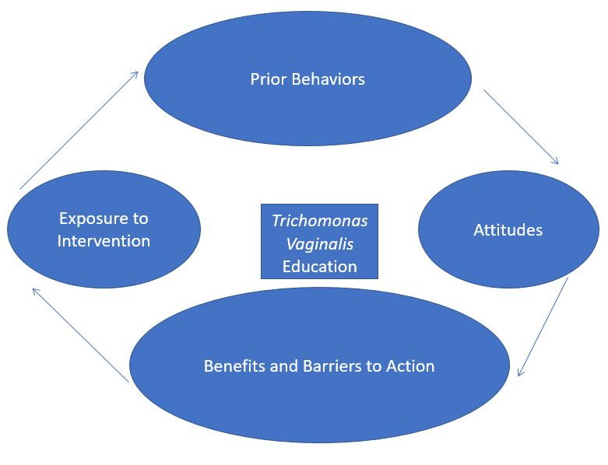

Methods

Overview of the Approach/Design

The DNP scholarly project utilized a quasi-experimental design. The participants were recruited through flyers posted in the Obstetrical/Gynecological (OB/GYN) clinic where the project was conducted. The participants in this project were placed in small groups, and the sample size goal was 50. A conference room at the OB/GYN office in Mandarin, Florida was used for the presentations. Participants were asked to thoroughly read and sign the consent form. The consent included the details and purpose of the project, as well as expectations from the participant. After signing the form, they were permitted to participate. The participants were assigned a participant number for confidentiality and Health Insurance Portability and Accountability Act (HIPPA) compliance. After checking in for their appointment, the participant was provided the pre-test/questionnaire to complete in the waiting room. Subsequently, the participants were placed in a conference room and given the presentation. After the completion of the presentation, participants received convenience assignment for the education pamphlet, and this group was the intervention group. The post-test was given to the participants at the completion of their examination, and the post-test/questionnaire was completed prior to the completion of the participants visit.

The questionnaire/assessment tool utilized is the Sexually Transmitted Disease Attitude (STD) Attitude Scale developed by Yarber, et al. [4]. The scale assesses the beliefs, attitudes and feelings towards STDs, and attitudes are an important factor for determining health risk behavior [4]. The questionnaire has 27 items. The items are all rated using a five-point Likert scale. The points are calculated, and the higher the number of the score, the stronger the participants attitude will predispose them to risky sexual behaviors [4].

Site, Agency or Participant Information

The practicum site is an obstetrical/gynecology (OB/GYN) Florida Women’s Care clinic that is located in Mandarin, Florida. Mandarin is an urban community in Jacksonville, Florida. Jacksonville, Florida would be considered a Southeast section of the United States. The clinical site has two providers, which includes the physician and a family nurse practitioner.

Potential participants were recruited at the clinic utilizing the flyer. The dates of collection occurred during October 23, 2017 through November 6, 2017. The inclusion and exclusion criteria were carefully formulated to avoid any risk or unforeseen confounding variables. The participants inclusion criteria included females between the ages of 18 and 64, and the participants were non-pregnant.

On average, approximately 50 patients are seen daily. The clinic sees patients with gynecological, endocrine, obstetrical and infertility type conditions. The age range of patients is from 11-75.

Procedure

After IRB approval, recruitment flyers were placed in the front of the office for notification and recruitment. Participants were required to read and sign the consent. The consent was provided to the participants with the details and purpose of the project. After signing the consent form, the participant was then given the pre-test questionnaire to complete while they were in the waiting room. The pre-test questionnaire was then collected. The goal as previously stated for sample size is 50. Subsequently, in small groups the patients were taken to the conference in the clinic, and they will be given a 5-minute presentation on Trichomonas Vaginalis. Convenience sampling was used for the standard of care and educational intervention group selection. The standard of care group had 25 (N=25) participants, and the educational intervention group had 25 (N=25). The educational intervention group received the education pamphlet, once they were placed in their examination room to wait for their provider. After the participant had seen their provider, they were provided with the post-test questionnaire. The pre-test and post-test questionnaires both have 27 questions, and should not take more than 5 minutes to complete.

Instrument

Permission to use the STD Attitude Scale questionnaire was obtained from Dr. William Lee Yarber. The questionnaire was developed by Yarber, et al. [4] and used for part of a component project for assessing the efficacy of education for the Centers for Disease Control education program [4]. The STD Attitude Scale questionnaire consists of 27 questions. The questions are Likert type five-point scale questions. The responses have a numerical rating, and they are tallied. In the scale, the higher the score, the stronger the attitude that predisposes a person toward risky sexual behaviors [4]. Items 1-9 reflect the beliefs; items 10-18 reflect the feelings, and items 19-27 reflect the intention of acting [4]. The STD Attitude Scale was developed to measure beliefs, feelings and intentions to act regarding sexually transmitted diseases/infections [4]. The specifications of the items written for the test contain three conceptual areas, which include nature of STD, STD prevention, and STD treatment.

The reliability of the STD Attitude scale reported a test-retest reliability or a 5 - 7-day period to be the following: Total scale = .71, Belief subscale = .50, Feeling subscale = .57, and Intention to Act subscale = .63 [4]. Cronbach’s alphas were noted as Total scale = .73, Belief subscale = .53, Feeling subscale = .48, and Intention to Act subscale = .71 [4].

Yarber [24] reported the sale items have evidence of content and face validity as they were developed to a table of specifications reflecting the behavioral aspects of STD, with an emphasis on preventive health behavior. The scale was developed as a component of a project for assessment of efficacy for the Centers for Disease Control education program [4]. The evidence of construct validity is provided by the fact the participants exposed to the STD curriculum, in contrast to participants not receiving STD instruction, showed improvement in their scores from pretest to posttest [4].

Data Collection

The flyer was used for participant recruitment. Participants that were interested in participating were given an informed consent that provided the details of the project. The informed consent was read and signed by the participants. As noted previously, the pre-test questionnaire was given and completed while the participant is in the waiting room. All participants took part in the presentation. The educative intervention group was given a pamphlet after the presentation. The post-test questionnaire was given to the patient after the examination was completed, and the procedure for each participant was completed prior to discharge from their visit. The participants were assigned a number, and the information from the questionnaires was entered into the protected and encrypted computer utilizing Excel. The data from Excel was then transferred into SPSS after data collection was complete for the project. Sexually transmitted test results were collected once resulted, and they were entered into the excel spreadsheet utilizing a combination of letters and numbers that only the primary project coordinator will have the key to decipher. The primary project coordinator will be the only individual to have access to the encrypted software.

Demographic Data

The demographic data collected includes race, ethnicity, age, marital status and gender.

Questionnaire Data

The questionnaire data provided pre-and post-educative intervention effectiveness, as well as attitude regarding Trichomonas Vaginalis.

Data Analysis

Initially the data was entered into Microsoft Excel. Subsequently, the data was transferred to SPSS version 24.0. The data was given a variable name, designated as numeric, given a variable label, assigned variable values and assigned a level of measurement. The data was screened for incorrect or improbable data [25]. Ordinal variables have two or more categories, but the categories are ordered or ranked. Ordinal variables are unable to distribute normally [26]. The level of measurement on the questionnaire is ordinal and it is answered in five-point Likert scale (strongly agree to strongly disagree). A Mann Whitney U must be used to make independent two group comparisons on the ordinal variable [26]. So, four Mann Whitney U tests were used to compare the post tests of the two groups on the four variables. This was calculated to compare the median group differences on the four tests. The median score is the middle score in a set of data where 50% of the score occur above it and 50% occur below it [25]. A Non-parametric test such as a Mann Whitney U becomes equal to using a parametric tests such as the Independent t-test in findings at about 1000 participants.

The characteristics of the respondents: gender, race, ethnicity, marital status, and age were previously collected. Descriptive statistics are used to group data into more understandable sections. Ratio and interval variables will have the measures of central tendency (mean) and dispersion (standard deviation) calculated [25]. Ordinal and/or nominal variables will have frequency distributions calculated [25].

Data on the STD questionnaire was collected pre- post-test on the intervention group and the standard of care group, and the scores were calculated for the overall score and the three subscales. Ordinal variables have two or more categories, but the categories are ordered or ranked. Ordinal variables are unable to distribute normally [26]. The level of measurement on the questionnaire is ordinal and it is answered in five-point Likert scale (strongly agree to strongly disagree). A Mann Whitney U must be used to make independent two group comparisons on the ordinal variable [26]. So, four Mann Whitney U tests were used to compare the post tests of the two groups on the four variables. This was calculated to compare the median group differences on the four tests. The median score is the middle score in a set of data where 50% of the score occur above it and 50% occur below it [25].

Characteristics of Respondents

Intervention Group

The participants were divided into two groups: Intervention and Standard of Care Group. In the intervention group there was a total of 25 participants. The average age was 36 (SD = 11.281) years old with a minimum age of 18 and a maximum age of 64 for an age range of 46. As seen in (Table 1), on Ethnicity, most participants reported they were non-Hispanic (n = 22, 88.0%) and the rest reported they were Hispanic (n = 3, 12.0%). For race, the largest group of participants was Black (n = 14, 56.0%) and the smallest group was Dominican (n = 1, 4.0%). Most participants reported they were single (n = 11, 44.0%) and there was one widow (n = 1, 4.0%).

Characteristic |  | Frequency | Percent
Ethnicity
 | Hispanic | 2 | 8
 | Not Hispanic | 22 | 88
 | Total | 25 | 100
Race
 | Asian | 2 | 8
 | Black | 14 | 56
 | Other Dominican | 1 | 4
 | Other Puerto Rican | 2 | 8
 | White | 6 | 24
 | Total | 25 | 100
Marital Status
 | Divorced | 4 | 16
 | Married | 4 | 16
 | Unmarried Partners | 5 | 20
 | Widow | 1 | 4
Total |  | 25 | 100

Table 1: Intervention Group Demographics.

Standard of Care Group

In the standard care group there was a total of 25 participants. The average age was 36.16 (SD = 11.082) years old with a minimum age of 22 and a maximum age of 62 for an age range of 44. As seen in (Table 2), on Ethnicity, most participants reported they were non-Hispanic (n = 23, 92.0%) and the rest reported they were Hispanic (n = 2, 8.0%). For race, the largest group of participants was Black (n = 13, 52.0%) and the smallest group was Puerto Rican (n = 1, 4.0%) and Black/American Indian (n = 1, 4.0%). Most participants reported they were single (n = 11, 44.0%) and the smallest group was divorced (n = 2, 8.0%).

Characteristic |  |  | Frequency |  | Percent
Ethnicity
 | Hispanic |  | 2 |  | 8
 | Not Hispanic |  | 23 |  | 92
 | Total |  | 25 |  | 100
Race
 | Black |  | 13 |  | 52
 | Black/American Indian |  | 1 |  | 4
 | Other- Puerto Rican |  | 1 |  | 4
 | White |  | 10 |  | 40
 | Total |  | 25 |  | 100
Marital Status
 | Divorced |  | 2 |  | 8
 | Married |  | 8 |  | 32
 | Single |  | 11 |  | 44
 | Unmarried |  | 4 |  | 16
Total |  | 25 |  | 100

Table 2: Standard Care Group Demographics.

Belief Scale, Feeling Scale, Intent to Act Scale and Total Score

As seen in (Table 3), the results were that the intervention group (21.00) scored significantly higher than the standard care group (13.00) on median scores for the Belief Scale, U = 71.5, Z = -4.693, p < 0.0001. Next, the intervention group (29.00) scored significantly higher than the standard care group (17.00) on median scores for the Feelings Scale, U = 91.5, Z = -4.295, p < 0.0001. Then, the intervention group (20.00) scored significantly higher than the standard care group (13.50) on median scores for the Intent to Act scale, U = 102.5, Z = -3.980, p < 0.0001. Finally, the intervention group (71.00) scored significantly higher than the standard care group (47.50) on median scores for the Total Score, U = 64.0, Z = -4.723, p < 0.0001. These results mean that intervention group scored significantly higher median scores over standard care on all four scales and can be seen in (Figures 2-5).

 | Beliefs Scale | Feelings Scale | Intent to Act Scale | Total
 |  |  |  | Score
Mann-Whitney U | 71.5 | 91.5 | 102.5 | 64
Z | -4.693 | -4.295 | -3.98 | -4.723
Asymp. Sig (2 - tailed) | 0 | 0 | 0 | 0

Table 3: Mann Whitney U Tests.

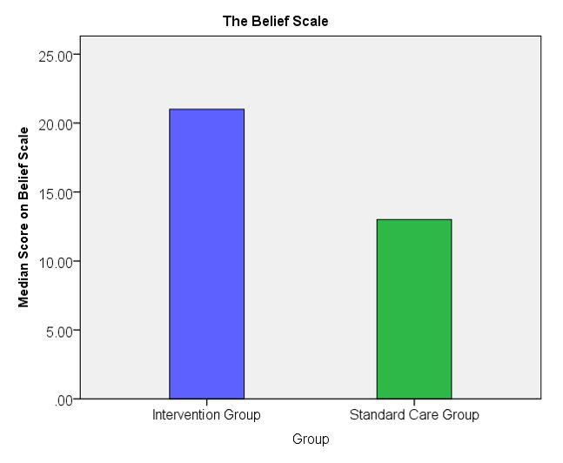

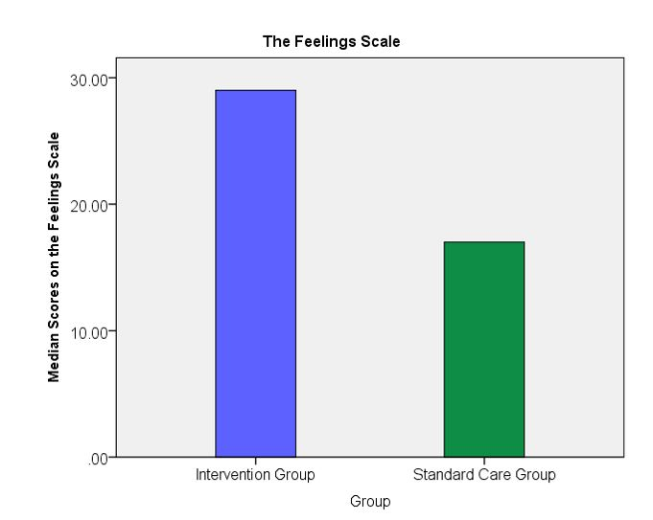

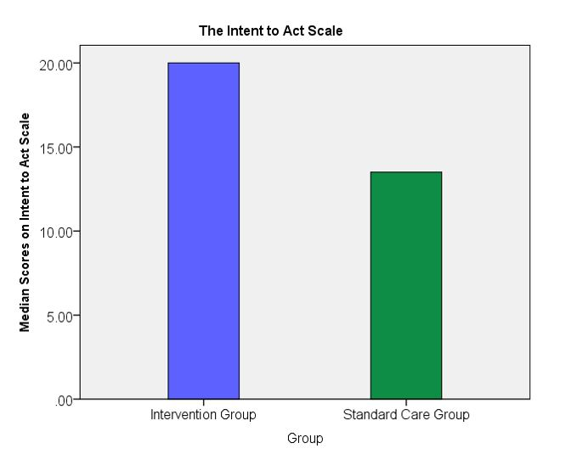

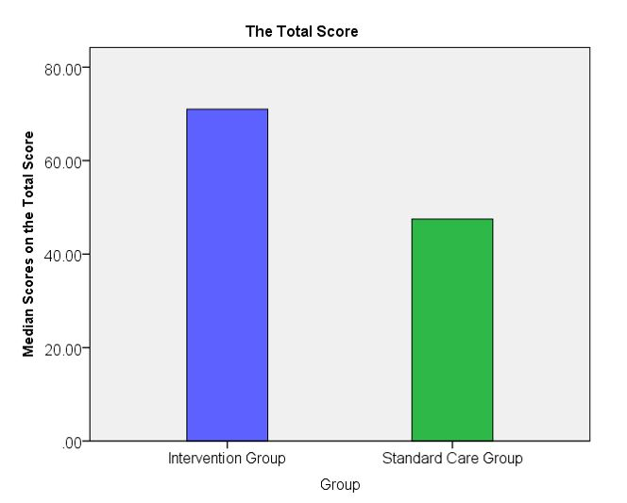

Rates of Sexually Transmitted Infection Occurrence

As seen in (Table 4), are the patterns and trends between the intervention and standard of care group in the prevalence rates of sexually transmitted diseases. The intervention group had ranges from 3 (12.0%) positive on Gonorrhea, Chlamydia and Trichomonas down to 0 (0.0%) Syphilis, HIV and Herpes 1. That standard care ranges were lower at 1 (4.0%) positive on Gonorrhea, Chlamydia and Trichomonas down to 0 (0.0%) Syphilis, HIV, Herpes 1 and Herpes 2.

Intervention Group

 |  | Positive Gonorrhea
 |  | Frequency | Percent
Valid | None | 48 | 96
 | Positive | 2 | 4
 | Total | 50 | 100
 |  | Positive Chlamydia
 |  | Frequency | Percent
Valid | None | 47 | 94
 | Positive | 3 | 6
 | Total | 50 | 100
 |  | Positive Syphilis
 |  | Frequency | Percent
None | System | 50 | 100
 |  | Positive Trichomonas
 |  | Frequency | Percent
 | None | 47 | 94
 | Positive | 3 | 6
 | Total | 50 | 100
 |  | HIV
 |  | Frequency | Percent
 | None | 50 | 100
 |  | Herpes 1
 |  | Frequency | Percent
 | None | 50 | 100
 |  | Herpes 2
 |  | Frequency | Percent
 | None | 49 | 98
 | Positive | 1 | 2
 | Total | 50 | 100

Standard of Care Group

 | Positive Gonorrhea
 | Frequency | Percent
None | 49 | 98
Positive | 1 | 2
Total | 50 | 100
 | Positive Chlamydia
 | Frequency | Percent
None | 49 | 98
Positive | 1 | 2
Total | 50 | 100
 | Positive Syphilis
 | Frequency | Percent
None | 50 | 100
 | Positive Trichomonas
 | Frequency | Percent
 | 47 | 94
Positive | 3 | 6
Total | 50 | 100
 | Herpes 1
 | Frequency | Percent
None | 50 | 100
 | Herpes 2
 | Frequency | Percent
None | 50 | 100

Exposure to the Intervention

Of the 25 participants in the Intervention group who answered the posttest (N=25), 100% were provided with the brochure. The result of the Mann Whitney U in Table three indicates that the median score was significantly higher than the standard of care group on each level with the belief scale, feelings scale, intent to act scale and the total score, which concludes that the intervention group would be least likely to engage in high risk sexual behavior. Yarber, et al. [4] the scale items provide evidence of content and face validity regarding the behavioral aspects of sexually transmitted disease, and the focus is preventive health behavior, in this circumstance sexually transmitted disease/infection education on Trichomonas Vaginalis.

Discussion

The focus of the project was to provide education regarding Trichomonas Vaginalis, and to determine the differences between the intervention and standard of care groups for with regards to attitudes and knowledge of sexually transmitted infection. The results indicated that the intervention group (21.00) was significantly higher than the intervention group (13.00) on the Belief Scale, the intervention group (29.00) was significantly higher than the intervention group (17.00) on the Feelings Scale, the intervention group (20.00) was significantly higher than the intervention group (13.50) on the Intent to Act scale and the intervention group (71.00) was significantly higher than the intervention group (47.50) on the Total Score (Figures 2-5).

The project indicated that sexual education in a gynecological clinic changed attitudes with regards to safer sex practices in both groups. According to the Health Promotion Model (HPM) self-efficacy is a central construct, and the HPM encompasses behaviors for improving health [20]. The intervention in the project was a pamphlet, and it was extensive enough to impact the knowledge, belief and attitudes of the participants in the intervention group.

Trichomonas Vaginalis has been noted to be one of the most common non-viral sexually transmitted infections worldwide. It has also been noted to have an increased prevalence. The lack of reporting makes it difficult to track, and over 60% of individuals are asymptomatic. Education is a necessary component to change behaviors.

Limitations of the Project

The project was limited due to time constraints, as it was completed during the Doctoral Nursing Program. The sample did not include pregnant participants, and this population was the majority of the clientele at the clinic. Adolescents were excluded from the project as well. Pregnant participants and adolescents are considered to be a vulnerable population. However, the sexually transmitted infection education on Trichomonas Vaginalis could have beneficial to both populations. The sample size was limited due to financial constraints. The questionnaire was broad with regards to sexually transmitted diseases; it could have been more specific to the project.

Conclusions

The Trichomonas Vaginalis Educative Intervention reached some very imperative goals. Most importantly the goal of improving knowledge and attitudes were displaced in the median scores of the Mann Whitney U test. Increased understanding about sexual health can be a future indicator of one’s actions. Yarber, et al. [4] reported that one of the most important factors in determining an individual’s health-risk behavior is their attitude. It was predicted that the intervention group, whom received the pamphlet/brochure would have less riskier behavior. Oakeshott and Graham [27] noted health promotion is the cornerstone of practice; however, restriction of time during office visits can make an intervention brief [28-31].

References

- McGowin CL, Rohde RE, Redwine G (2014) Trichomonas Vaginalis: Common, curable and in the diagnostic spotlight. Clinical Laboratory Science 27: 53-56.
- Odeh P (2009) Fast facts. Trichomoniasis: An emerging threat in HIV transmission. Journal of Continuing Education Topics & Issues 11: 80-81.
- Fule SR, Fule RP, Tankhiwale NS (2012) Clinical and laboratory evidence of Trichomonas Vaginalis infection among women of reproductive age in rural area. Indian Journal of Medical Microbiology 30: 314-316.
- Yarber WL, Torabi MR, Veenker CH (1988) Development of a three-Component sexually transmitted disease attitude scale. Journal of Sex Education and Therapy 15: 36-49.
- Arab-Mazar Z, Niyyati M (2015) Trichomonas Vaginalis Pathogenesis: a Narrative Review. Novelty in Biomedicine 3: 148-154.
- Centers for Disease Control and Prevention (2015) Trichomoniasis. Diseases Treatment Guidelines.
- Coleman JS, Gaydos CA, Witter F (2013) Trichomonas Vaginalis vaginitis in Obstetrics and gynecology practice: New concepts and controversies. Obstetrical And Gynecological Survey 68: 43-50.
- Ozdemir E, Kelestemur N, Kaplan M (2011) Trichomonas Vaginalis as a rare cause of male factor infertility at a hospital in East Anatolia. Andrologia 43: 283-285.
- Chambers R, Tingey L, Beach A, et al. (2016) Testing the Efficacy of a Brief Sexual Risk Reduction Intervention Among high-risk American Indian Adults: Study Protocol for a Randomized Controlled Trial. BMC Publish Health 16: 366-374.
- American College of Obstetricians and Gynecologists (2012) Committee Opinion. Well-Woman Visit.
- Broecker JE, Huppert J (2011) Trichomoniasis in Adolescents. Routine Screening Is Advised for Patients at Risk. Contemporary Pediatrics 4: 29-46.
- Sihavong A, Lundborg CS, Syakhang L, et al. (2011) Community Perceptions and Treatment-Seeking Behavior Regarding Reproductive Tract Infections Including Sexually Transmitted Infections in Lao PDR: A Qualitative. Journal of Biosocial Science 43: 285-303.
- Shafi T, Stovel K, Holmes K (2007) Association Between Condom Use at Sexual Debut and Subsequent Sexual Trajectories: Longitudinal Study Using Biomarkers. American Journal of Public Health 97: 1090-1095.
- Normanswell R, Drennan VM, Oakeshott P (2015) Exploring access and attitudes to regular sexually transmitted infection screening: the views of young.multi-ethnic, inner-city, female students. Health Expectations 19: 322-330.
- Salawu OT, Esume CN (2013) Frequency of Human Immunodeficiency Virus (HIV) in Trichomonas Vaginalis Infected Women in Badagry, Lagos, Nigeria. Journal of Reproductive Infertility 17: 61-63.
- Mann J, McDermott S, Zhou L, et al. (2009) Treatment of trichomoniasis in pregnancy and preterm birth: An observational study. Journal of Women’s Health (15409996) 18: 493-497.
- Kirkcaldy RD, Augostini P, Asbel LE, et al. (2012) Emerging Infectious Diseases 18: 939-943.
- Spielberg F, Levy V, Lensing S, et al. (2014) Fully Integrated e-Services for Prevention, Diagnosis, and Treatment of Sexually Transmitted Infections: Results of a 4-County Study in California. American Journal of Public Health 104: 2313-2320.
- Van Der Pol B (2013) Trichomonas Vaginalis reviewing the available diagnostic testing options. Medical Laboratory Observer 45: 18-20.
- Alligood MR (2014) Nursing Theorists and Their Work (8th Edition). St. Louis, MO: Elsevier Mosby.
- Alkhalaileh MA, Khaled MH, Baker OG, et al. (2011) Pender’s Health Promotion Model: An Integrative Literature Review. Middle East Journal of Nursing 5: 12-22.
- Schaalma HP, Abraham C, Gillmore MR, et al. (2004) Sex education as Health Promotion: what does it take? Archives of Sexual Behavior 33: 259-269.
- Condran B, Gahagan B, Isfeld-Kiely H (2017) A scoping review of social mediaas a platform for multi-level sexual health promotion interventions. The Canadian Journal of Human Sexuality 26: 26-37.
- Yarber WL (1985) STD: A guide for today’s young adults (student and instructor’s manual). Waldorf, MD: American Alliance Publications.
- McMillan JH, Schumacher S (2001) Research in Education: A Conceptual Introduction (5th edition). New York, NY: Addison Wesley Longman.
- Sheskin DJ (2011) Handbook of parametric and nonparametric statistical procedures (5th edition). Boca Raton, FL: Chapman & Hall/CRC Press.
- Oakeshott P, Graham A (2007) NICE guidance on one-to-one interventions to reduce Sexually transmitted infections and under-18 conceptions: a view from general practice. Sexually Transmitted Infection 83: 171-172.
- Arifin WN (2014) Calculating standard deviation of difference for determination of sample size for planned paired t-test analysis. Educational Resource 6: e62-e65.
- Fisher TD, Davis CM, Yarber WL, et al. (2011) Handbook of Sexuality-Related Measures (3rd Edition). New York: NY: Routledge.
- Moran K, Burson R, Conrad D (2014) The Doctor of Nursing Practice Scholarly Project: A Framework for Success. Burlington, MA: Jones & Bartlett
- Oermann MH, Turner K, Carman M (2014) Preparing Quality Improvement Research, and Evidence-Based Practice Manuscripts. Nursing Economic$ 32: 57-69.

